Audition and
Admission Requirements
2018-2019

Audition Information

Auditions are required for all students who plan to major or minor in music
at UAB. Audition dates for students entering in Fall 2018 or Spring 2019:
Sunday, January 28, 2018 (Application Deadline: Friday, January 12)
Sunday, February 25, 2018 (Application Deadline: Friday, February 9)
Saturday, March 24, 2018 (Application Deadline: Friday, March 9)

You might consider scheduling your audition during the week, and plan to spend
the day on campus so you can visit classes, lessons, and rehearsals. To arrange a
weekday audition, contact one of the following Music faculty members:
Brass, Woodwind, Percussion: Dr. Sean Murray (spmurray@uab.edu)
Voice: Dr. Kristine Hurst-Wajszczuk (khw@uab.edu)
Piano: Dr. Yakov Kasman (kasman@uab.edu)
Guitar and Strings: Dr. Patrick Evans (patricke@uab.edu)

All auditions will be held in the Hulsey Center. An accompanist will be provided for you if needed.
Under no circumstances will photocopied music be allowed in the audition.

After the audition, students auditioning to be a music major will be informed of one of three outcomes:
- Admission is granted and they may enroll as a Music Major;
- Admission is conditional, in which case they are admitted as a Pre-Music major
and have one year to gain full admission as a Music Major;
- Admission is denied.

In the case of number 2 above, students must re-audition in order to gain full admission as a Music Major. In the event they are not accepted, they will be advised to seek another major within the University. Students auditioning for admission as a Music Minor will either be fully admitted or denied. Once fully or conditionally admitted to the Department of Music, students will work closely with a music faculty advisor who will monitor their progress and advise in the selection of appropriate courses. Admission to UAB does not guarantee admission to the Department of Music.

The following pages list the specific requirements for auditioning on each instrument. Students wishing to major in music should use the listed repertoire as a guide; standard works of comparable quality are acceptable. Students wishing to minor in music will be expected to prepare the same technical material, but need only prepare one repertoire piece.

Scholarships
There are two types of Music scholarships at UAB: Music Major/Minor scholarships and Ensemble scholarships. All students auditioning to be accepted as a Music Major or Minor are automatically eligible for all available scholarships. No additional audition is required. Ensemble scholarships are awarded to students in any major for participation in bands or choirs, and auditions for these are held throughout the year.

Audition Information

Music Technology, Guitar, Piano, Voice

All works listed are only suggested pieces. Any standard work of comparable quality is acceptable.

Music Technology:
At UAB, Music Technology is a concentration within the BA in Music degree program. This program is for musicians who wish to add advanced technology to their musical skills. For the required audition, perform two short works which represent your abilities on your major instrument. One of the works must be classical; the other may be in any style.

To be considered for music technology scholarships, please add the following materials to your application and resume:
1) A paragraph describing any previous experience in music technology
2) A paragraph describing goals in the area of music technology
3) If available, a CD recording of examples of your work to date

All music technology materials must be received no later than the application deadline.

Guitar:
Scales - major and minor keys - two or three octaves
Knowledge of basic chords and bar chords (M, m, 7, m7)
Any etudes from Sor, Carcassi, Carruli, or Giuliani
One fingered classical piece
Sightreading

Bass Guitar:
Scales - all keys two octaves
Sightreading
Dizzy Gillespie - Night in Tunisia
(bass vamp - walking)
Oleo, Cottontail, I Got Rhythm - (rhythm changes)
Jerome Kern - All the Things You Are
(bow melody - walk - solo)

Piano:
Two contrasting classical pieces by memory
All major and minor scales - 4 octaves hands together
Sight reading

Voice:
Two contrasting classical vocal selections (art song or aria)
in the original language. All selections must be memorized.
Vocalize to determine vocal range.
Sight reading

Audition Information

Woodwinds

The instrumentalist should prepare one or two etudes, one solo work, and all major and minor scales with tonic arpeggios. Scales and arpeggios are to be played two octaves when practical, or three octaves when appropriate.
All works listed are only suggested pieces. Any standard work of comparable quality is acceptable.

Flute:
Etudes: Cavally: Melodious and Progressive Etudes, Book I
Mary Karen Clardy: Flute Etudes Book
Solos: A sonata for flute and piano by Bach or Handel
Mozart: Concerto in G Major
Chaminade: Concertino
Debussy: Syrinx
Any flute composition by a French composer edited by Louis Moyse
Oboe:
Etudes: Two of the 40 Progressive Melodies from the Barret Method book or
Two studies from Ferling 48 Studies, Op. 31
Solo: Two contrasting movements from a sonata or concerto by Marcello, Cimarosa, Handel, Vivaldi, Telemann, Albinoni, or Mozart; or a work of comparable difficulty.

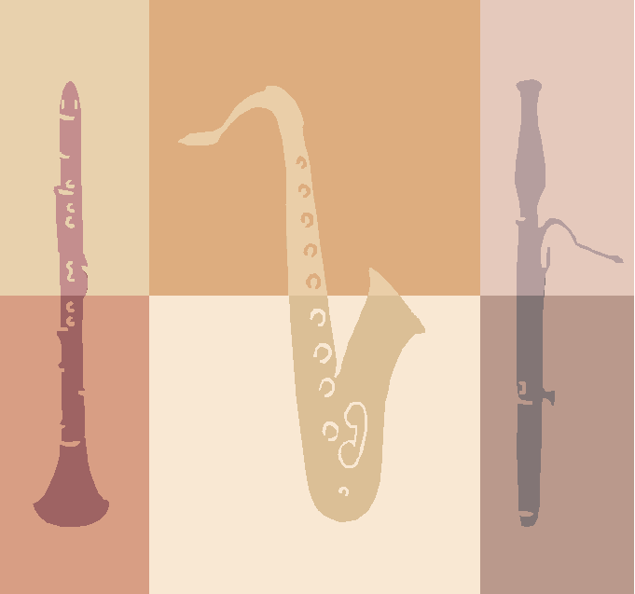
Bassoon:
Etudes: Weissenborn - Method for Bassoon
Milde - Concert Studies, Vol. I and II
Solos: Mozart - Concerto in B^{b}, K. 191
Weber - Concerto in F, Op. 75
Vivaldi - Concerto in D Minor

Clarinet:
Etudes: Rose - 32 Studies for Clarinet
Cavallini - 30 Caprices for Clarinet
Klose - Method for Clarinet
Solos: Weber - Concertino
Mozart - Concerto in A Major, K. 622
Saint-Saëns - Sonata for Clarinet and Piano

Saxophone:

Etudes: Fehrling - 48 Famous Studies for Oboe

The Universal Method for Saxophone
Solos: Bozza - Aria
Handel - Sonata No. 3
Eccles - Sonata
Creston - Sonata

Audition Information

Brass

The instrumentalist should prepare one or two etudes, one solo work, and all major and minor scales with tonic arpeggios. Scales and arpeggios are to be played two octaves when practical or three octaves when appropriate.

All works listed are only suggested pieces. Any standard work of comparable quality is acceptable.

Trumpet:
Etudes: Any vocalise etude by Giuseppe Concone
(Sawyer or Korak editions)
Voxman - Selected Etudes
Arban - 14 Characteristic Studies
Brandt - 34 Studies
Solos: Balay - Petite Piece Concertante
Corelli - Sonata VIII
Goeyens - All Antica
Goedicke - Concert Etude
Horn:
Etudes: Kopprasch - 60 Selected Studies
Pottag-Andraud - Selected Melodious, Progressive and Technical Studies
Gallay - 22 Studies or 24 Studies
Solos: Voxman - Concert and Contest Collection
Saint-Saëns - Romance
Beethoven - Little Rondo

Trombone (Tenor): (Bass):
Etudes: Rochut - Melodious Etudes Etudes: Rochut - Melodious Etudes
Tyrell - 40 Progressive Studies Also see listings for Tuba
Voxman - Selected Studies for Trombone Solos: Bozza - Allegro and Finale
Solos: Barat - Andante and Allegro Lebedey - Concerto
David - Concertino Lieb - Concertino Basso
Ostrander - Concert Album

Euphonium:
Etudes: Rochut - Melodious Etudes (any etude in book 1)
Arban - Characteristic Studies (any of the 14 etudes)
Solos: Guilmant-Morceau - Symphonique
Barat - Introduction and Danse
Barat - Andante et Allegro
Galliard - Sonata No. 1

Tuba:
Etudes: Uber - 25 Early Studies or Concert Etudes
Paudert -18 Etudes
Solos: Brahms/Little - Five Songs
Marcello/Little - Sonata No. I or Sonata No. V
Capuzzi - Andante and Rondo; Perantoni - Master Solos

Audition Information

Strings, Percussion

All works listed are only suggested pieces. Any standard work of comparable quality is acceptable.

Violin: All major and minor scales in three octaves
Two contrasting works on a comparable level to the following:
Etudes: Any etude by Dont or Kreutzer
Solos: Any concerto movement by Bach, Haydn, or Mozart

Viola: All major and minor scales in three octaves
Two contrasting works on a comparable level to the following:
Etudes: Any etude by Mazas, Kreutzer or Campagnoli
Solos: Bach - Cello Suite
Telemann - Concerto

Cello: All major and minor scales and arpeggios in three octaves
Etudes: Duport - 21 Etudes
Franchomme - Six Caprices
Solos: Bach - Six Suites for unaccompanied cello
Boccherini/Gruetzmacher - Concerto in B^{b} major
Saint-Saëns - Concerto in A minor, Op. 33

Bass: One octave scales - bowed
Sightreading
Solos: Bach - Solo Cello Suite # 1 (Prelude)
Saint-Saëns - Carnival of the Animals (The Elephant)

Percussion: All potential majors must demonstrate proficiency in at least one of the following areas for admission and at least two areas for scholarship consideration: General Percussion, Keyboard Percussion, or Timpani. Students should be prepared to sightread on snare drum and mallets.
General Percussion:
Any concert snare drum etude from a published collection by Cirone, Delecluse, Peters,
Goldenberg, or Firth
Any published multiple percussion solo
Demonstrate knowledge of snare drum rudiments
Keyboard Percussion:
Any published two or four mallet solo or etude
All major scales and arpeggios one octave
Timpani:
Any published solo or etude
Tuning: Perfect fourth, Perfect fifth, Major third

Proficiency on drum set may be included as well. Please demonstrate timekeeping and fills in several different styles (i.e. rock, funk, medium tempo swing, fast swing, and/or Latin-type grooves).

Placement auditions for the UAB Drumline will be held on Saturday May 5 and Friday June 8, 2018.
For more information and further details, visit www.uabpercussion.org

Music Ensembles

Marching Blazers
Dr. Sean Murray, Director of Bands
Audition required.
Contact 205-975-2263 or spmurray@uab.edu

Blazer Band
Dr. Gene Fambrough, Director
Audition required.
Contact 205-975-5823 or gfambro@uab.edu

Wind Symphony and Symphony Band
Dr. Sean Murray, Director of Bands
Audition required.
Contact 205-975-2263 or spmurray@uab.edu

Percussion Ensemble and
Steel Drum Band
Dr. Gene Fambrough, Director
Audition required.
Contact 205-975-5823 or gfambro@uab.edu

Jazz Ensemble and Jazz Combos
Dr. Steve Roberts, Director
Audition required.
Contact 205-934-6154 or jazztpt@uab.edu

Brass Ensembles
Dr. James Zingara, Coordinator
Audition required.
Contact 205-934-2265 or jzingara@uab.edu

Woodwind Ensembles
Dr. Denise Gainey, Coordinator
Audition required.
Contact 205-975-0558 or clarinet@uab.edu
Concert Choir and Chamber Singers
Dr. Brian Kittredge, Director
Audition required.
Contact 205-975-2599 or briank@uab.edu

Gospel Choir
Mr. Kevin Turner, Director
Contact 205-934-6155 or kturner@uab.edu

UAB Opera
Dr. Kristine Hurst-Wajszczuk, Director
Audition required.
Contact 205-934-8906 or khw@uab.edu

Guitar Ensembles
Ms. Maria Bitran, Director (Spring terms)
Contact 205-934-7376 or mbitran@uab.edu
Mr. Carlos Pino, Director (Fall terms)
Contact 205-934-7376 or eduardo@uab.edu

Piano Ensemble
Mrs. Tatiana Kasman, Director
Audition required.
Contact 205-934-8942 or kasman@uab.edu

Computer Music Ensemble
Mr. Matthew Bryant, Director
Contact 205-934-7376 or msbryant@uab

