**UAB Jazz Summit 2016**

**April 2, 2016**

***New Orleans Edition!***

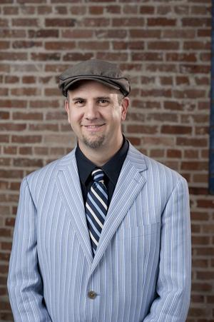

***With***

***Dr. David Phy***

***of the world-famous Dukes of Dixieland***

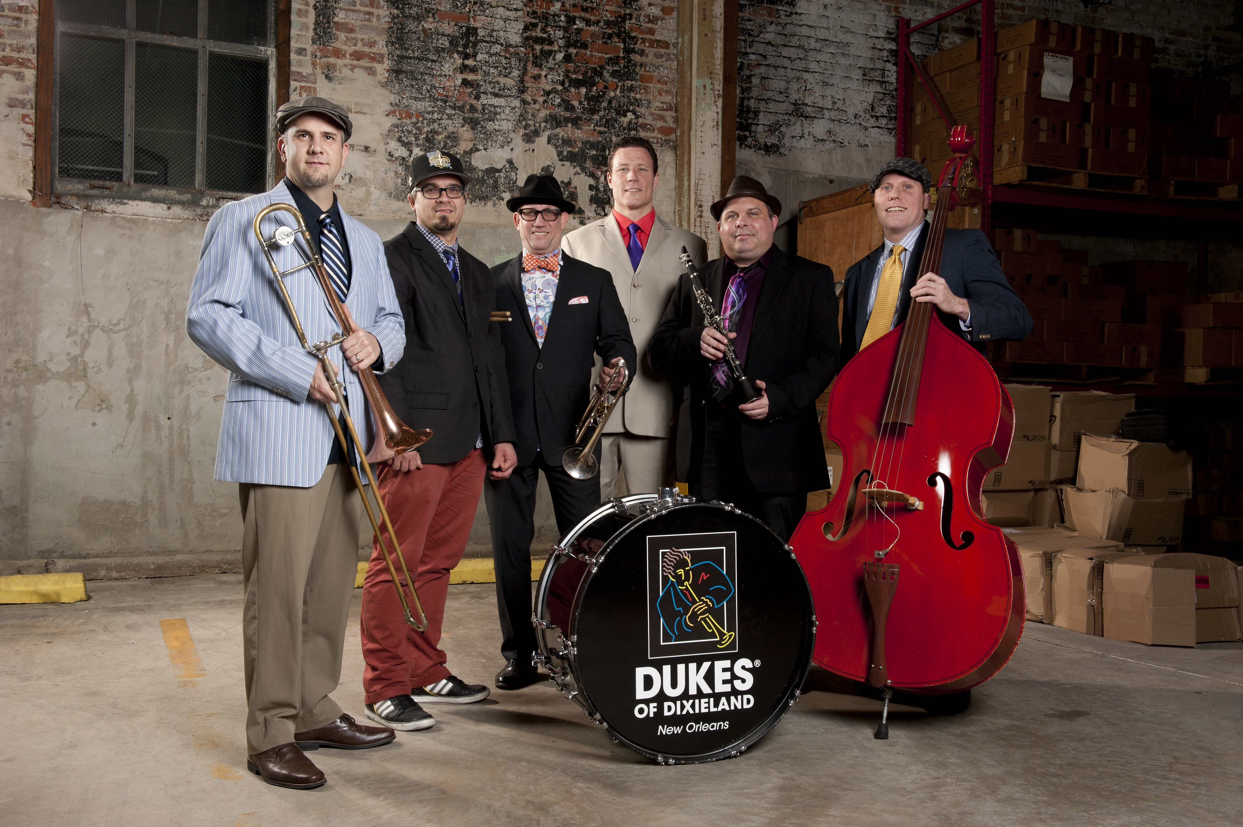

**Coordinator: Dr. Steve Roberts**

**Email: jazztpt@uab.edu**

**Phone: (205) 934-6154**

**Fax: (205) 975-1931**

**Event Dates:**

The 2016 UAB Jazz Summit will begin with registration at 8am Saturday, April 2nd in the Hulsey Center. Students will be placed according to their skill and experience, and will be mixed in with UAB jazz students in their various ensembles. The final concert will take place that evening (4/2) at 7pm.

**Eligibility:**

All students grades 9-12 will be eligible to participate in the Jazz Summit. Students of all levels are encouraged to apply and will be placed in classes and ensemble situations at a variety of levels determined by audition and band director recommendation. This year’s summit is based around New Orleans style jazz, so we are opening the summit to all wind players, not just trumpet, trombone, and saxophone. This is a great way for your flutists, clarinetists, tubists, etc. to get a valuable and fun jazz experience.

**Band Director Recommendations:**

Please use the enclosed form to submit your nominations for this event. We ask that you recommend students with experience or at least a heavy interest in jazz music and who are proficient on their instruments. After the student has completed the top half of their application, they are instructed to pass the form on to their band director. Please use the bottom half for a **confidential** evaluation and comments on the applicant. These band director recommendations are very important to the selection process. Please place these recommendations in order of your ranking by instrument.

**Applications:**

Applications can be returned in the following ways:

1. By mail **received** no later than March 28th, 2016 at 5pm to:

UAB Department of Music

UAB Jazz Summit 2013

231 Hulsey Center

950 13th Street South

Birmingham, AL 35294-1260

2. By Fax to 205-975-1931

3. Hand-delivered to the UAB Music Office (Room 231 in the Hulsey Center)

**Important Information:**

Notification of selection will happen on a rolling basis and will conclude with mailings on March 28th, 2016. Upon notification, there is a $50 non-refundable participation fee, which must be sent to reserve a spot. Please go on our website to pay through our touchnet payment system, or make checks out to the **UAB Department of Music.** All participating students will receive a UAB Jazz Summit T-shirt and lunch the day of the clinic.

**Schedule:**

**Saturday, April 2**

8:00am Registration in Hulsey Center Lobby

9:00 Rehearsals with ensembles

11:00 Sectionals

12:00 Lunch (provided)

1:00 Rehearsals with ensembles

2:00 UAB concert (Hulsey)

3:00 Masterclasses with UAB Jazz Faculty and Dr. Phy

4:30 Rehearsals with ensembles

5:30 Dinner on you own

7:00 Participant Concert (Hulsey)

**Clinicians**

**Dr. David Phy, Trombone**

**David Phy** was born in Elizabethtown, Kentucky. He was surrounded by music growing up due to his father being a professional pianist/organist and teacher. David attended the University of Louisville on scholarship from 1993-1998 working towards a Music Ed degree with Jazz emphasis. Following a year in the Cruise industry he spent 2 years at the New England Conservatory of Music completing a Masters of Music in Jazz Studies in 2002. While in Boston, he had the opportunity to study and work one on one with Boston Symphony trombonist Norman Boulter and jazz legends such as Bob Brookmeyer, Gunther Schuller, George Garzone, George Russell and Steve Lacey. From 2007-2010 David Phy was the Graduate Assistant to Jim Pugh at the University of Illinois. While at Illinois he also studied jazz theory and improvisation with Chip McNeil and John “Chip” Stephens.

As a private teacher David Phy has had many successes with his students. His grade school students have auditioned into top ranked all-state and district chairs and many have gone on to college music programs around the country. His college teaching experiences range from marching band low brass instruction at Tulane University to Adjunct Professor of Trombone at the University of New Orleans. David’s college classroom experience includes teaching Music Appreciation classes at Delgado Community College in New Orleans since 2011.

In New Orleans David has been featured on stage at the French Quarter and the New Orleans Jazz and Heritage Festivals. He is a New Orleans “Big Easy” award winner as a member of Jump Jive and Wail- The Music of Louis Prima. David has performed with national acts and jazz artists such as The 4 Tops, The Temptations, Bonerama, La India, Monica Mancini, Marvin Hamlisch, Bob Brookmeyer, Jim Pugh, Delfeyo Marsalis, Joe DeFrancesco, Tom Garling, Rodger Ingram, The Yin Yang Twins, Chip McNeil, Louis Belson, Lena Prima, Louis Prima Jr., Charo, and Ben Vereen. David joined the **Dukes of Dixieland** in December, 2014 from the National WW II Museum big band, and is their most recent member.

On the road he performed two years as the Lead Trombone and featured soloist for the national tour of “In The Mood, a 1940’s Review”. David was a cast member in the Emmy Award winning stage show Blast! and spent five years in Las Vegas, Nevada performing in venues all over the city including: The House of Blues, The Hilton Las Vegas, The Palms Hotel Casino, Las Vegas Blue Note Jazz Café, the Bellagio, The Paris Hotel and The MGM Grand Hotel Casino. He is a member of ITA, LJMEA and the local New Orleans Musicians Union.

**Dr. Steven Roberts, Trumpet**

**Dr. Steven Roberts** is associate professor of jazz studies and trumpet at the University of Alabama at Birmingham. Previously, he was assistant professor of trumpet and jazz at Mars Hill College after holding a similar position at Iowa State University. He is an active teacher and freelance musician and has performed with Kirk Whalum, Vincent DiMartino, Ryan Anthony, Jon Faddis, Allen Vizzutti, Cecil and Deedee Bridgewater, Chip McNeill, Jim Pugh, Charo and many others. His group “The Roberts Jazz Project” released their album Let’s Fall in Love in 2012. This album features Roberts on both trumpet and keyboard. He is also music director for Unity Church of Birmingham and Saint Junia United Methodist.

Roberts has premiered arrangements for trumpet ensemble at two International Trumpet Guild conferences, and in October 2012 premiered an original brass quintet arrangement on an Eastern European quintet tour. In the summer of 2014, Roberts toured Europe for a month splitting time with the UAB Faculty Brass Quintet, the rock band “Downright”, and completing the tour with his group “The Roberts Jazz Project.”

In the spring of 2011, Roberts presented with Dr. Andrew Wolvin (University of Maryland, College Park) at the International Listening Association Conference on a panel entitled “Musical Listening.” The project sought to explain the effect of musical techniques on speech. In the summer of 2013, Roberts was the scholar for the Birmingham Library film/discussion series “America's Music: A Film History of Our Popular Music from Blues to Bluegrass to Broadway.”

Along with jazz experience as a member of “the Roberts Jazz Project”, “Steve Roberts Jazz Quartet”, “Birmingham Seven”, and various jazz ensembles aboard Holland America and Royal Caribbean cruise ships, Roberts has also had extensive classical ensemble experience performing with the UAB faculty Brass, the Mountain Empire Brass Quintet, the Johnson City Symphony, the Champaign-Urbana Symphony and Sinfonia da Camera.

Dr. Roberts received his Bachelors in Music in 1999 from Oberlin Conservatory of Music where he studied classical music from members of the Cleveland Orchestra and Detroit Symphony Al Couch and Bill Lucas respectively, and studied jazz from Kenny Davis, Robin Eubanks, Wendall Logan and Neal Creque, freelance musicians from Cleveland and New York.

Dr. Roberts received his Doctorate of Musical Arts in trumpet performance and jazz at the University of Illinois (U.C.) in 2005, where he also received his Masters degree in 2001. He was a soloist with the University of Illinois Wind Symphony, served as principal of the University Orchestra, and filled the jazz chair in the top jazz band. At Illinois he studied trumpet from Ray Sasaki, Michael Ewald, and Ronald Romm, and jazz from Chip McNeill, Vern Sielert, Ron Bridgewater and Thomas Wirtel.

**Carlos Pino, Guitar**

**Carlos Pino** received his Bachelor of Arts in Music Technology from UAB and a Masters in Music in Jazz Studies from Rutgers University. He has studied guitar with Tom Wolfe, Vic Juris, and Brian Lutterbie. He is a well sought after guitarist in the Birmingham area music scene and a regular in musical productions such as Summerfest Musical Theater, the Alabama Shakespeare Festival, and the Rubicon Theater Company in Ventura, California. In addition to performing, Pino has been teaching private guitar lessons for nearly a decade.

**Brandon Peeples, Bass**

**Brandon Peeples** has been playing music since the age of 9. Starting out on Alto Saxophone, his talents developed quickly, and after only two years on the instrument, Brandon was selected to play with the Denver Youth Wind Symphony while living in Colorado. At the age of 13 Brandon began playing bass here in Birmingham. By 16 he was playing professionally in local clubs. Upon graduating from high school, Brandon received a music scholarship to UAB, but soon was getting calls to go on national and international tours with various groups. From 2002-2006 Brandon toured the U.S., Europe, and the Caribbean extensively, and recorded several albums with the swing band Band the Buzz. In 2006 he settled back to Birmingham where he has toured regionally with Frankie Velvet and The Mighty Veltones, as well as several different local bands. Starting 2010 Brandon has been touring nationally with American Idol Season 5 winner Taylor Hicks. Brandon has performed with Willie Nelson, John Fogarty, The Little River Band, Silverchair, Derek St. Holmes, Jeff Carlisi of .38 Special, Yonrico Scott, Tommy Talton from the Greg Allman Band and Cowboy, Georgia Music Hall of Fame member Jimmy Hall of Wet Willie, Rolling Stones keyboardist Chuck Leavell, and many other local and regional legends. While not on the road, Brandon can be found recording in Birmingham at Sound of Birmingham Studios, Boutwell Studios, and Gintown Studios, as well as playing live five nights a week. He is currently endorsed with Euphonic Audio Amps, Lakland Basses, and Thomastik-Infeld Strings. He teaches as an adjunct instructor for the UAB Department of Music in Applied Bass.

**Gary Wheat, Saxophone**

**Gary Wheat** has been performing and teaching professionally in Birmingham for 15 years. After studying with Dr. Jonathan Noffsinger at the University of Alabama and earning his Jazz Studies Bachelor’s degree, Mr. Wheat moved to Birmingham to play with his first band, Meteorite, and to travel across the country to play with national touring musical acts such as the Temptations, the Four Tops, the O’Jays, Percy Sledge, and Frankie Valli. At home, he has logged countless hours at gigs and jam sessions with local jazz names like Cleve Eaton, Bo Berry, Chad Fisher, and Tommy Stewart. Mr. Wheat has taught saxophone and jazz in private and in class settings since August 2000, building relationships with band directors at most Birmingham metro area public middle and high schools. He also has years of college-level teaching experience at the University of Alabama at Birmingham.

**Michael Glaser, Drum Set**

**Michael Glaser** is the first call for many of the finest sounds in Birmingham: String Theory, Chad Fisher, The Birmingham Seven, Choko Aiken, The Roberts Jazz Project, The Jason Bailey Band, Matthew DeVine’s Big Greasy Brass Band, and Rob Alley’s Alabama Songbook. He covers lots of styles with these groups: original modern jazz, ‘30s-‘40s swing, Afrobeat & funk, classic rock and pop arranged for a string quartet, Jewish folk music, New Orleans sounds, drums for African dance, and more.

He is also a bandleader, transcribing, arranging, and performing the music of his favorite jazz composers and performers. He has played in major music festivals in New York City and Lucerne, Switzerland, and did a six-city tour of Colombia with a UAB Jazz faculty group in November 2014. He has worked as a sideman with nationally and internationally-known artists like John P. Strohm (Blake Babies, Lemonheads), Johnny O’Neal (Art Blakey’s Jazz Messengers, Ray Brown, Lionel Hampton), Ron McCurdy (The Langston Hughes Project), musician & spoken word artist Malcolm-Jamal Warner, and Guinean dance master Youssouf Koumbassa.

Michael is a graduate of Davidson College (B.A.). He enjoys teaching drumset lessons in the jazz and Music Technology programs at UAB as well as playing in the UAB Jazz Faculty Quintet / Septet, and he teaches drummers of all ages in Birmingham. Visit www.MichaelGlaserMusic.com.

**2016 UAB Jazz Summit**

**Application/Recommendation Form**

**Application Deadline: March 28**

Student Name

Instrument

Grade

Home Address

C/S/Z

Home Phone ( )

E-Mail

School

**Please circle Y for yes and N for no.**

*Played in School Jazz Band? Y N*

*Highest Chair in School Concert Band? _____*

*Been selected to All-State Jazz Band? Y N*

**Please list any other jazz experience you have.**

1.

2.

3.

Band Director Portion

1. Of students I have taught in the past, this student is in the (check one)

___TOP 5% ___TOP 10% ___TOP 20% ___TOP 50% ___BOTTOM 50%

1. At the UAB Jazz Summit, this student should be (check one)

____A Lead player ____A Section player

____An Improviser ____Should not be accepted

Band Director Signature

Date

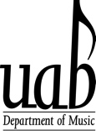

231 Hulsey Center

950 13th Street South

Birmingham, AL 35294

Phone: 205-934-7376

Fax: 205-975-1931