CCTS K Award FAQs
- Do applicants have to be Assistant Professors to apply?
No; postdocs can apply as long as they have a letter of support from their Department chair attesting to the fact that they will be appointed as an Assistant Professor should they receive the K award. Likewise, Associate Professors who are close to the end of their “Early Stage Investigator” designation should clearly elucidate why the mentored career development award is appropriate for them at their current career stage.
- If invited to submit a full application, can a research assistant’s time be included in the budget?
Yes; that would be a part of the annual $25,000 Training Related Expenses.
- Are the required elements (seminars, etc.) of the K Award available via teleconference?
Yes
- Where can I upload my Pre-Application materials?
On the K Award webpage: www.uab.edu/ccts/kl2
- Can co-mentors be from outside the CCTS Partner Network?
Yes; it is critical that a mentorship plan explains how the mentor/mentee relationship will succeed, especially if scholar and mentor are located at different institutions (i.e., how often they will meet and by what means).
- Do applicants have to be US citizens?
Applicants must be either US citizens, permanent residents, or citizen nationals (this applies to small number of people from US territories like American Samoa or Swains Island). If permanent residents, a notarized copy of the permanent resident card (“Green card”) will be required if selected for the award.
- Is any other federal support (i.e., roles such as Co-I or PI on smaller awards) allowed for K scholars?
Yes; see the following breakdown:
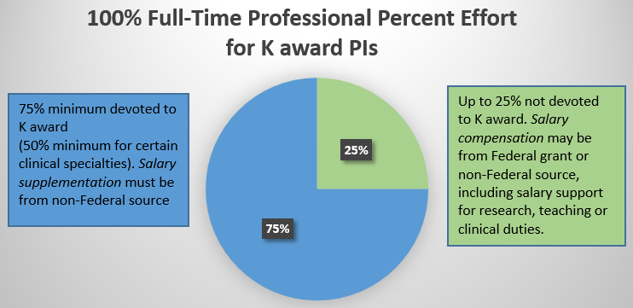
- Whom should I contact with questions?
Jeanne Merchant: jsmerchant@uabmc.edu or 205.996.9672.

