APPLICANT INFORMATION

LAST NAME: FIRST NAME:

TERMINAL DEGREE(S)
eRA COMMONS NAME BLAZER ID (UAB ONLY)

CAMPUS ADDRESS:

CITY: STATE: ZIP :

EMAIL ADDRESS: PHONE NUMBER:

INSTITUTION SCHOOL

DEPT/DIV (PRIMARY APPT:)
TITLE

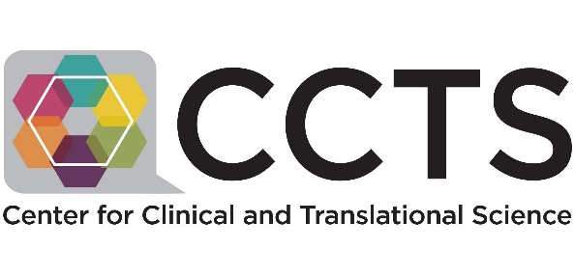

2018 Clinical & Translational Science Training Program Application
TITLE OF PROPOSED RESEARCH PROJECT

As a condition of enrollment, I agree to participate in annual surveys pertaining to the CTS Training Program during the 10 year period following completion of the program.
Yes, I agree

LETTER WRITER INFORMATION

- NAME: ROLE

- NAME: ROLE

For more information on this and other programs of the CCTS, please visit www.uab.edu/ccts

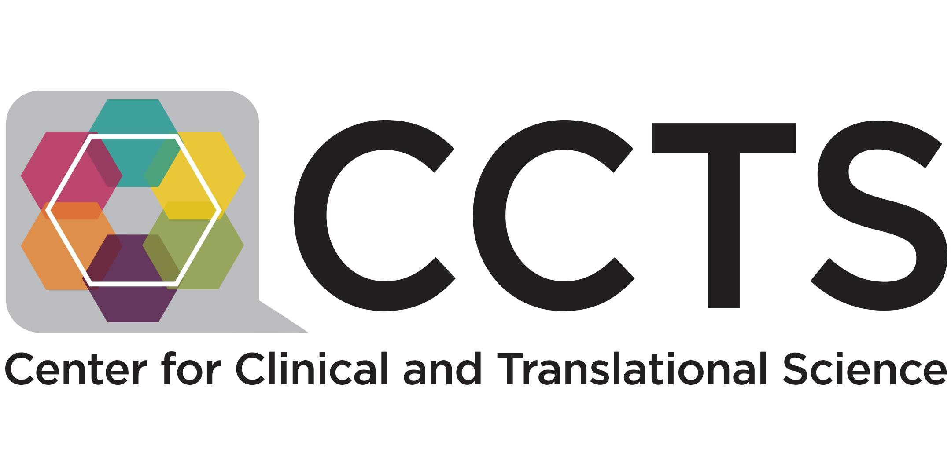

APPLICATION CHECKLIST

Completed application form Letter from applicant
Identification of a Clinical and/or Translational
Investigation Project(s) with one page concept description

Current CV and sources of financial support of applicant

Letter of support from mentor acknowledging support of research project

CV of mentor

Letter from applicant’s immediate supervisor and Division/ Program Director or Department Chair (if not immediate supervisor)

Physical Address: 1924 7th Ave S. Tel: 205.934.7442
Fax: 205.934.3749
Email: ccts@uab.edu
Mailing Address: PCAMS 111
1720 2nd Ave S. Birmingham, AL 35294-0007 Web: www.uab.edu/ccts

