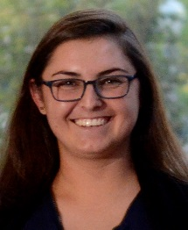
Join Rylie Hightower, BSN, RN, PhD Candidate, as she represents the Civitan International Research Center at the UAB Marchase Interdisciplinary Research Centers Symposium on Friday, August 17, 2018. As a Civitan Emerging Scholar, Rylie will discuss her poster during the poster session.
The event will feature keynote speaker Anthony S. Fauci, MD, Director, National Institute of Allergy and Infectious Diseases, National Institutes of Health, Bethesda, MD. Dr. Fauci’s presentation “Emerging and Re-emerging Infectious Diseases: From AIDS to ZIKA will begin at noon at the Margaret Cameron Spain Auditorium.
In addition to Dr. Fauci’s keynote address, the symposium will feature presentations from leading UAB researchers, posters, and discussion of interdisciplinary research, including the roles of the UAB University-wide interdisciplinary Research Centers.

