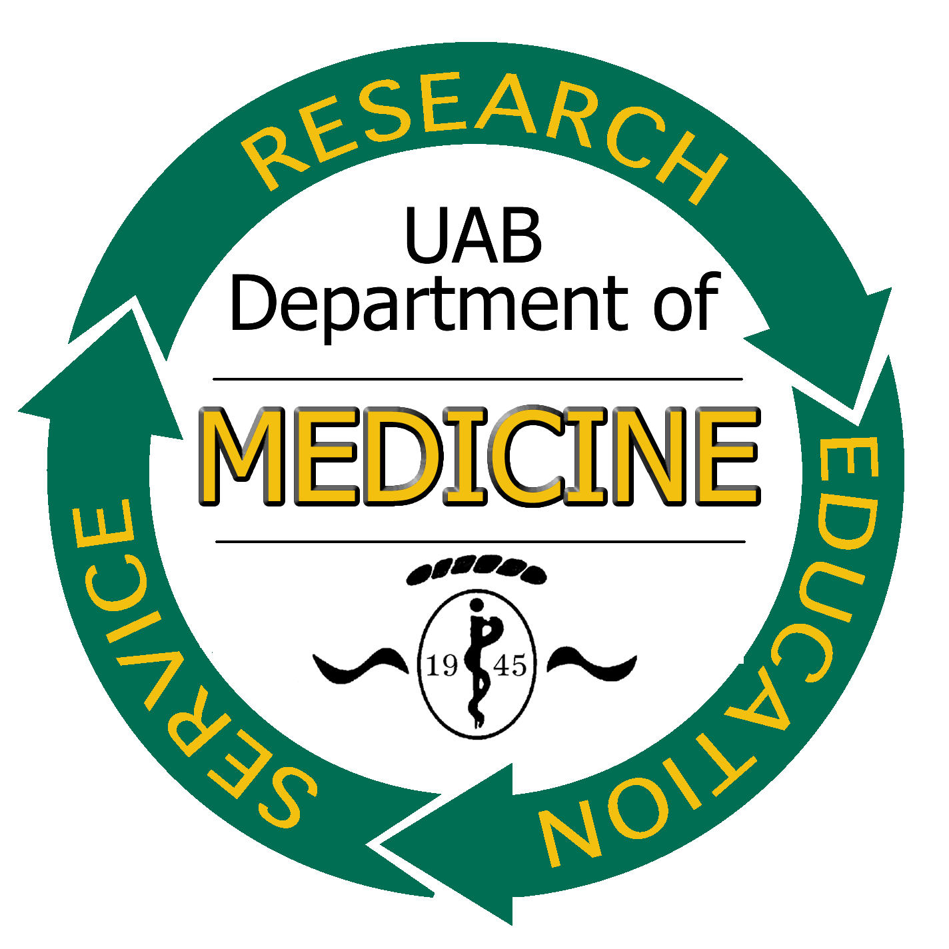
30th ANNUAL
TRAINEE RESEARCH
SYMPOSIUM

Wednesday, March 5, 2014
North Pavilion Atrium
(2nd floor, North Pavilion)

REQUEST FOR ABSTRACTS

ELIGIBILITY:
All trainees of the Department of Medicine: Residents (i.e. housestaff - PGY 1-3), Associate Fellows (i.e. subspecialty fellows – PGY 4-7), Post-doctoral Scholars (MD or PhD doing post-doctoral training in the Department of Medicine), Graduate Students with Department of Medicine mentors (must be currently enrolled at UAB) are encouraged to submit one-page abstracts describing their original basic or clinical research. Each trainee may submit one abstract as first author. Abstracts submitted to other meetings for presentation this Spring or presented at recent meetings are eligible.

Individuals holding a faculty appointment at the level of Instructor or above at the time of the Symposium are not eligible.

PRESENTATION AND REVIEW PROCESS:
All accepted abstracts will be presented in poster format at a Poster Session on WEDNESDAY, March 5th from 1-3 PM in the North Pavilion Atrium. Judges will review all posters and select finalists that day (March 5th) to present their research at the Department of Medicine Clinical Research Seminar on Monday, March 24th. Each poster will be judged on the basis of three major criteria: 1) scientific merit, 2) presentation and communications skills, and 3) evidence that the trainee truly understands the significance of his/her work and played the major role in obtaining the data upon which the poster is based.

PRIZES:
Winners will be awarded a stipend to be used toward travel expenses to one national conference approved by their mentors and the Research Development Group.

DEADLINE FOR SUBMISSION OF ABSTRACTS
Friday, January 31, 2014

Use the following Abstract Form. Do NOT ALTER the format or go over 1-page.
Contact: Paula Wood, 420 BDB 0012, 4-0700 E-mail: phwood@uab.edu

Abstract for Department of Medicine
30th Annual Trainee Research Symposium – Wednesday, March 5, 2014

POSTER TITLE:

Investigators/Authors:

Submitter's Name: ( ) PhD, ( ) MD
Title: ( ) Resident (i.e. housestaff PGY 1-3)
( ) Associate Fellow (i.e. subspecialty fellows – PGY 4-7)
( ) Post-Doctoral Scholar - MD or PhD doing post-doctoral training in the Department of Medicine
( ) Graduate Student with Department of Medicine mentors

Department/Division:
Campus Address: Extension:
Mentor:
This research should be considered ( ) basic (i.e. bench), ( ) clinical (NOT human participant)
( ) clinical (human participant or applied i.e., community-based).
Please return abstract form by January 31, 2014 to: Department of Medicine, Research Development Group, c/o Paula Wood, BDB 420 Zip 0012 or email attachment to phwood@uab.edu.

