|  |  |  |  |  |
| --- | --- | --- | --- | --- |
| C:\Users\dritchey.UAB-PEDIATRICS\AppData\Local\Microsoft\Windows\Temporary Internet Files\Content.IE5\V3NBRTFC\MC900446102[1].wmf |  | |  | | --- | | CASG Ebrief | | Fall 2015 | |
| Spotlight on Little Rock, Arkansas! |  |  |
|  |  |  |

The **Arkansas Children’s Hospital Research Institute** provides an on-site research environment for over 120 pediatric researchers with expertise and experience that span the breadth of medical disciplines to fulfill ACHRI’s mission to improve children’s health, development, and well-being through high-quality research. Many of our clinical researchers use the **ACHRI Coordinator Pool** to conduct their clinical trials at **Arkansas Children’s Hospital**.

**Richard Jacobs, MD**, and **José Romero, MD**, have been Principal Investigators and/or Sub-Investigators on CASG/DMID studies for over 30 years. Sub-Investigators are **Jin-Young Han, MD**; **Nada Harik, MD**; **Matt Linam, MD**; and **Vini Vijayan, MD**. Dr. Jacobs began working on CASG protocols as an Infectious Disease Fellow in Seattle with Dr. Larry Corey. Dr. Corey and Dr. Rich Whitley asked Dr. Jacobs when he joined the faculty of UAMS in 1982 if he wanted to establish a CASG site within the NIH/NIAID network at ACH. We joined the CASG soon after and have been a participating center in all pediatric protocols. Dr. Romero began working with the CASG in 1999 on a trial involving enteroviral sepsis while at the University of Nebraska for Medical Sciences in Omaha. Over the following decade the CASG provided him opportunities to participate in studies involving HSV, CMV, and influenza. Dr. Romero joined UAMS in 2008 and has continued his collaboration with CASG here.

The ACHRI Coordinator Pool was established in 2001 and currently has 10 RN Research Coordinators/Nurses of which 4 have obtained and maintain certification. The ACHRI Clinical Research Coordinators/Nurses have teamed with the Pediatric Infectious Disease physicians since 2008 to coordinate the CASG/DMID protocols. **Janet Storment, RN, CCRC**, is the Clinical Trials Administrator, and she oversees the ACHRI Coordinator Pool. **Robin Gibson, RN, MNSC, CCRC,** became the Lead Study Coordinator for the CASG/DMID studies in 2008. Our Study Coordinators are **Pat Brady, RN, BSN, CCRC**; **Kathy Hummel, RNP, MSN, CCRC**; **Melanie Mason, RN**; **Holly Pettit, RN**; **LeAnn Ramsey, RN**; **Andrea Ross, RN**; **Amy Smith, RN, BSN**; **Debra Walden, RN, MSN**; and **Jocelyn Wright, RN, CCRC**. In addition to CASG studies, our clinical investigators and ACHRI Clinical Research Coordinators/Nurses are involved with industry-sponsored and NIH-funded studies as well as with PI-initiated protocols.

We have a remarkable study staff that conducts and coordinates all study-related activities. All of our research coordinators/nurses work collaboratively with other hospital staff as needed to ensure the success of our research projects. This group also coordinates research studies for all medical specialties that seek our help. Currently, the group is coordinating over 50 actively enrolling studies.

To support our researchers conducting clinical trials, ACHRI created and maintains the **Pediatric Clinical Research Unit** (PCRU), a six-bed unit dedicated to research with pediatric subjects at ACH. Available 24 hours a day, 7 days a week, the PCRU provides a 4,000-ft2 facility for high-quality clinical pediatric research. It includes a laboratory, kitchen, offices, equipment storage, waiting area, and small conference room. In addition, ACHRI maintains a Research Pharmacy at the hospital to support our inpatient and outpatient trials.

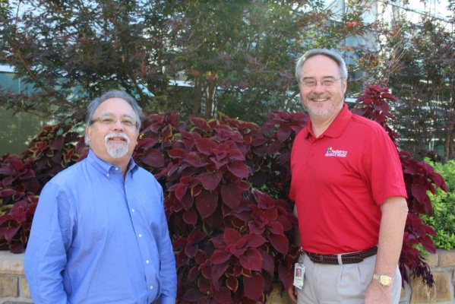Dr. Romero is one of our most active investigators and one of our favorite PIs! Our study coordinators appreciate the active role Dr. Romero plays in all aspects of conducting the research protocols for which he provides oversight. Dr. Romero is the Medical Director of ACHRI Clinical Trials Research and holds the Horace C. Cabe Endowed Chair in Pediatric Infectious Diseases. Dr. Romero states, “It has been an honor and privilege to participate in and contribute to clinical studies that have made major advances to our understanding and treatment of infectious diseases affecting neonates, infants, and children world-wide.”

(L-R) Study Coordinators Debra Walden, Andrea Ross, Holly Pettit, Robin Gibson, and Pat Brady

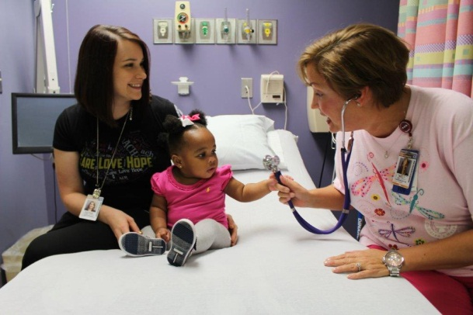Dr. Jacobs, Chairman of the Department of Pediatrics and the Robert H. Fiser, Jr., MD, Endowed Chair in Pediatrics, has served on the Executive Committee on protocols on neonatal HSV, congenital CMV, and enterovirus sepsis. Dr. Jacobs notes, “I am very proud of what the CASG has contributed to our understanding of the natural history, diagnostics, predictive variables, outcomes, and pharmacokinetics of antivirals for babies/infants and the clinical trials of treatment of these viral infections. The advances in our understanding of these neonatal/infant infections have been significantly impacted by the CASG.”

Study Coordinator Suzanne Godbold (L) and Holly Pettit (R) in the Pediatric Clinical Research Unit (PCRU) at Arkansas Children’s Hospital

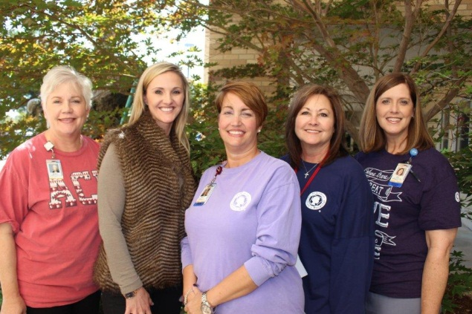

Dr. Richard Jacobs (left)

Dr. Jose Romero (right)



### eDES System Usage

Remember to consult your User Manual when you have a problem with the eDES system,   
a question about how to enter information,   
or are unsure of what information  
is being requested. The User Manual  
is easy to read, contains screen shots,   
and can help you solve almost any problem! Also, if you do need to call the CU, the manual page number you’re looking at gives us a reference point of where to start and can help us help you find an answer a little more quickly.

### *Our Studies – Updates on Progress*

|  |
| --- |
|  |

Gan Premie DMID 11-0067

We continue to hold with 10 subjects enrolled.  Since our last eBrief, we have generated a new protocol (version 2.0 dated 14 August 2015) which had the primary change of eliminating the restriction to enroll only 8 subjects in each of the 4 age groups identified in the protocol.  The 4 groups are defined as:

1) ≤ 27 weeks 6 days gestational age at birth and ≤ 30 days chronologic age at study enrollment; 2) ≤ 27 weeks 6 days gestational age at birth and > 30 days chronologic age at study enrollment; 3) ≥ 28 weeks 0 days gestational age at birth and ≤ 30 days chronologic age at study enrollment; 4) ≥ 28 weeks 0 days gestational age at birth and > 30 days chronologic age at study enrollment. After receiving an approval for version 2.0, sites are able to enroll in all age groups.  Until your site receives documentation of version 2.0 approval, enrollment is restricted to Groups 1, 3 and 4.   Currently, all sites are activated and capable of enrolling.

CMX001 DMID 11-0068

DMID 11-0068 seems to be our biggest challenge.  On Thursday, Oct 22, 2015, we learned that the study drug will be shipped to us in the next few weeks. Previously we discussed having a re-site initiation call in November 2015.  We are now changing that to December 2015 or January 2016 for such a call.  Version 2.0 of the protocol was distributed to site on October 19, 2015.  The changes included here were minor and primarily: 1. Description of the new study drug formulation and 2. Allow option for participants to participate in the Chimerix CMX001 Registry.

Valgan Toddler DMID 11-0069  
DMID 11-0069 protocol is the most recently activated study.  Today we have enrolled 2 subjects, both in the UK. Based on the rigorous and conscientious review and implementation of the protocol, our UK colleagues have spent a good bit of time critiquing and improving the data entry system (everyone will benefit from these changes).  To date we have 13 sites activated, with 1 in the UK and 3 in the US pending.  Over the course of the past few months, numerous Notes to File have been generated.  These Notes to File amend and /or clarify the MOP and provide additional instructions for the use of the electronic Data Entry System (eDES).  There have been 7 non-significant Notes to File generated to date.   ‘Non-significant’ means they are generally clarifications and we do not require confirmation that they were



submitted to your IRB.   A new version of the MOP is being prepared that will include all of the Notes to File. Also, a Recruitment Flyer template has been developed and is available on the portal for your use.

GeneXpert DMID 11-0070  
This is an update on the GeneXpert Study. Version 2.0 dated 30 September 2014 was submitted to investigational teams October 24, 2015. The study Version 2.0 remains the current active version for recruitment at this time. The first subject was enrolled in January 2014 by Louisiana State University Health Science Center investigational team under protocol version 1.0 dated 20 August 2013.

The patient population for this study is divided into two Cohorts. Cohort 1 are women who are not pregnant presenting to their healthcare provider or community health clinic with herpetic-like genital symptoms. Cohort 2 are pregnant women 34 weeks or greater gestational age without known herpetic-like genital symptoms at the time of presenting for delivery of their baby. The GeneXpert study enrollment projections are n=300 subjects in Cohort 1 and n=12,500 in Cohort 2. There are fifteen (15) investigational teams across the U.S. participating in this study. These investigational teams have recruited and enrolled approximately 5000 plus subjects in Cohort 2. Included in the fifteen investigational teams, there is a team recruiting for Cohort 1 as well as Cohort 2 and that has enrolled 5 subjects in Cohort 1.

Additional activities being initiated to help continue boosting enrollment and meet study projects are the following:

* The Lead investigator for the protocol has opened up the option for one or two other investigational teams to participate in recruiting for Cohort 1 in an effort to access a larger patient population.
* One investigational team is no longer participating in the study. The investigational team was replaced with a new investigational team which was activated for protocol recruitment on October 7, 2015.
* One investigational team has been very creative in brainstorming ways to recruit more patients by recruiting a satellite Obstetrical Team in their community. We are looking forward to activating the satellite.

*Just a reminder, the DMID contract research monitoring team will be preparing to schedule interim site visits to all active research sites as soon as 6000 subjects are enrolled in Group 2.According to the current rate of enrollment, we expect to reach 6000 study subjects in the first quarter of 2016.*

BK Natural History DMID 11-0071  
The NH-BKVV Study enrolled it first subject at the University of Minnesota on February 5, 2015 under Version 1.0 dated 8 April 2014. There are 63 (9.5%) subjects enrolled to date, 6 subjects have been identified as BK Viremic. There are 6 investigational teams recruiting from a patient population of renal and renal-pancreas post-transplant subjects that are 30 days post-operative. The Lead Principal Investigator is in the process of developing a version 2.0 protocol for approval by DMID. The new version in development was initiated as a result of discussion with investigational teams during monthly and bimonthly conference calls.

|  |
| --- |
|  |
| Informed  Consent Form |

When we ask for a copy of your IRB approval or amendment, please include the Informed Consent Form (ICF). The ICF goes along with an IRB approval or amendment. This eliminates another pesky email from us asking for the copy after you’ve submitted the approval. Also, please make sure your IRB approval and ICF contain the three required identifiers, which are DMID #, Protocol Version # and Protocol Date. This will eliminate the need to complete the CASG/DMID IRB Approval Certification form.



From The LAB

1. For ALL studies, please pay attention to handwriting.  It takes additional time and effort for us to try to make out sketchy handwriting.  Please remember the importance of helping us on the receiving end to distinguish between 7 and 1, between 2 and Z, 5 and S.  Place a line thru the center of 7 and Z.  Make your Ss curvy and your 5s straight.  We receive every sample by its label and refer to form 52 mostly for confirmation on something we can’t make out.  What you input into form 52, we input into form 52B. We have one person, and sometimes 2, who receive ALL the samples from all the sites. If you send us 112 samples, someone else is sending just as many or more!

2.    If you’re sending samples on dry ice, please, please, please **DO NOT** tape the internal cooler…dry ice needs to breathe.  Taping the box goes against IATA shipping rules. Also taping the internal box makes it really hard for us to get into.

1. For BK-Natural History 11-0071 please DO NOT overfill or even fill the large blue-top conical tube with urine.  When these are frozen the urine expands and the tops break.  Leave about 2 ml empty for this reason.  Also make sure lid is seated well and tight.
2. You will begin to see some emails from Katherine (Kat) Jones in regards to receiving samples and any discrepancies between form 52 and 52B.  She will also be assisting in getting laboratory supplies to you.
3. For GeneXpert 11-0070 sites, the time is ***no longer required*** to be documented on Form 52!

**SHIPPING NOTES**

There have been some recent lost or mis-delivered shipments lately. Here are some tips to prevent that:

* Be careful how you complete the label because it is very difficult to make changes to delivery once a package has shipped. After the shipment” phone calls to change delivery information rarely get to the drivers. Drivers work off of what you put on that shipping label.
* Please check the cut-off time for shipping at your location. You may think you are sending specimens “next-day,” but if you have missed the cut-off, your package won’t arrive for 2-3 days. This is an especially sensitive issue close to the weekend. You may schedule shipment on Thursday, but if you missed the cut-off, it won’t go out until Friday, and then will be delivered and sit unattended on the weekend.

QUESTIONS? CALL THE CENTRAL UNIT!

C:\Users\dritchey.UAB-PEDIATRICS\AppData\Local\Microsoft\Windows\Temporary Internet Files\Content.IE5\V3NBRTFC\adamtglass-com[1].jpgC:\Users\dritchey.UAB-PEDIATRICS\AppData\Local\Microsoft\Windows\Temporary Internet Files\Content.IE5\V3NBRTFC\adamtglass-com[1].jpg

|  |
| --- |
|  |

|  |  |  |
| --- | --- | --- |
|  |  |  |