PEDIATRIC RESEARCH OFFICE
Children’s Harbor Bldg 302
uab.edu/peds/pro

What is SIP?
The Shared Investigator Platform (SIP) is a collaboration of pharmaceutical companies to create an online platform to help clinical trials progress more efficiently to eliminate redundant work for sponsors and clinical sites (PIs, study coordinators, regulatory staff, etc.). Used for activities of clinical trial site selection, start-up communications and management, Cognizant is the technology vendor that is developing and operating the Shared Investigator Platform on behalf of the industry sponsors including Amgen, Bayer, Bristol Myers Squibb, Lilly, Merck, Pfizer and Roche.

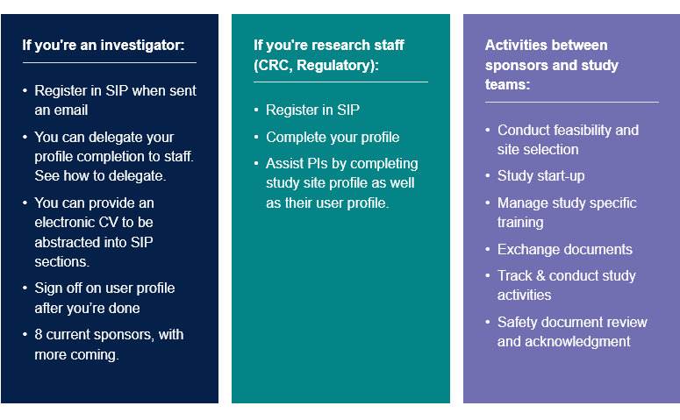

How do I register and set up delegates in SIP?
You will receive an invitation email to register with SIP. Follow the instructions to complete your registration. You will not be able to self- register without an invitation. How-to resources and FAQs about SIP registration, delegation, etc. are available https://www.sharedinvestigator.com/home and select the Resources button to view menus. Once logged into your SIP account, hover over the Admin tab (far right of main navigation ribbon) and click on Manage Delegation. Users can delegate their user profile and/or study specific survey to another registered user. This video may be helpful as well.

Which facility do I choose for my user profile?
University of Alabama at Birmingham - School of Medicine
510 20th Street South, FOT 1203
Birmingham, Alabama, 35233
FC092220182020022711

Do not develop a new facility profile for Children’s of Alabama.
Research at Children’s of Alabama is conducted by UAB faculty and staff under legal agreements and regulatory oversight of UAB (Office of Sponsored Programs, Institutional Review Board, etc.). Children’s of Alabama is a performance site and not the entity with whom industry sponsors have legal agreement.

Which department do I choose for my user profile?
Pediatrics
1600 7th Ave South,
Lowder Building, Suite 600
Birmingham, Alabama, United States of America, 35233
FC120920202002204356

Do not develop a new department profile for Children’s of Alabama or your division/area.
UAB designated contacts to develop general departmental profiles. For the Department of Pediatrics’, the contact is Melissa McBrayer (mmcbrayer@uabmc.edu) of the Pediatric Research Office.

If you need to add information to the Pediatric departmental profile, please contact Melissa with the information to add for your division or area.

