|  |  |  |  |  |
| --- | --- | --- | --- | --- |
|  |  | |  | | --- | | CASG Ebrief | | Spring 2016 | |
| *Spotlight on Magee Women’s Hospital!* |  |  |
|  |  |  |



**Magee-Womens Hospital of UPMC** is a world-class center for both women’s health and comprehensive medical-surgical care. Approximately 10,000 babies are born at Magee each year, accounting for 45 percent of all births in Allegheny County.

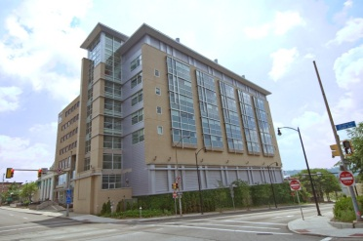

**Magee-Womens Research Institute** is a nationally and internationally recognized center for women’s health research. Our Department of Obstetrics, Gynecology and Reproductive Sciences is among the nation’s top OB/GYN departments in funding from the National Institutes of Health.



**Dr. Harold Wiesenfeld** is the Director of Reproductive Infectious Diseases and Immunology at Magee, and is the Vice Chair of Gynecologic Specialties at the University of Pittsburgh Medical Center. Dr. Wiesenfeld oversees the clinical research team, which is comprised of three Advanced Practice Providers, a Nurse Recruiter, two Research Assistants, a Regulatory Affairs Coordinator, and a QA/QC Reviewer.

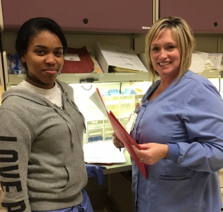

**Tationna and Heather**

**Heather Bocan** is a Registered Nurse and has been a Research Coordinator/Nurse Recruiter at Magee for 9 years. Prior to working in research, Heather was a Labor and Delivery Nurse at Magee for 10 years. As a full time Nurse Recruiter, she spends most of her days in L&D recruiting participants for the GeneXpert Study. What she enjoys most about her position is the patient contact. In her free time, Heather enjoys spending time with her family.

**Tationna Smalley** is a Research Assistant who has been with our team for 8 months. Tationna has her BS degree in BioChemistry from the University of Philadelphia. Her responsibilities for the GeneXpert Study include processing, storing and shipping specimens, and performing the telephone follow up calls. Her favorite part of her job is the laboratory aspect. She has created a very organized, systematic and streamlined process for tracking and verification of laboratory samples. In her free time, Tationna enjoys taking photographs, taking long walks on a beach, and exploring new restaurants.

*EXCITING NEWS FROM THE CENTRAL UNIT*

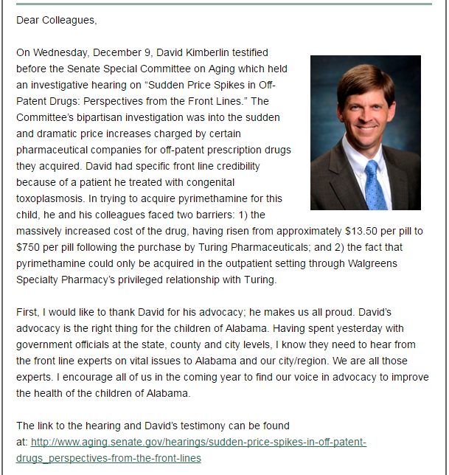

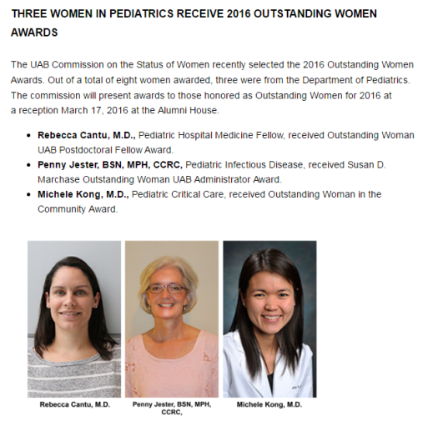





If you are enrolling study patients in the current group of CASG DMID protocols, you know that patient data is now entered into an electronic database entry system (eDES) using a website. You need to be certified in how to use the database before you can enroll a patient. The FDA also requires that you re-certify if you have not entered a patient over a period of six months.

Using the eDES system can be hard at first, and lots of people have questions about how to enter data. The group at the CASG has all received training in data entry, and we would like to offer a few suggestions to make the process of Certification a bit less painful.

1. Please have the User Manual open on your computer somewhere to refer to if you have a question or get stuck. It contains a lot of good screen shots and troubleshooting tips for your reference.
2. Pay close attention to the “colors”. Each protocol has its own unique color page. Valgan Toddler is orange and GeneXpert is pink. This may help you to make sure that you are doing your training in the proper place. Please also make sure that the word CERTIFICATION appears on the top of the page, so you are not entering data in the PRODUCTION area of the website, where live patient data is entered.
3. Speaking of colors, when you click on the link to the Data Entry Form menu, where all the padlocks reside, the padlocks all have their own unique colors, depending on the status of the form that the padlock contains. You want to see those blue padlocks open up for you, right? A blue padlock means that you can click on the lock and open up the form. When you put all the data in the form and lock the form, then the icon will turn gray. In certification training, keep looking for those blue padlocks.
4. Not all the forms are located on the Data Entry Form menu. There are forms that are kept in other areas of the website. To find those forms, it is important to use the “ribbon” near the top of the page. It is a bit darker than the background color of the page. Look for the word “FORMS”, click on the link, and you will find other menus that contain the forms that you need.

Remember the general, primary categories of forms:

* Data entry forms are for “per subject” inclusion/exclusion information, labs, other tests, etc. by treatment period.
* Unscheduled formsare for “per subject” unplanned events that may occur at any time during the study, e.g. adverse events, protocol deviations.
* Sitewide formsare for activities that may include multiple subjects (e.g. shipping logs) or relate to non‐subject, site factors such as the freezer temperature deviations.
* Subsequent forms are Forms 48 (SAE), A,B,and C, to enter data if there are SAE Lab test results (A), Diagnostic Test Results (B), or Concomitant Medications (C).

The main lesson to be learned during the certification process is how to navigate around the website, so the people who created the training packets placed the forms that you use for data entry in an order that makes you go from menu to menu so you know how to get around the site. Watch your pop-up windows for handy hints, and please don’t worry if you get a WARNING message or other strongly-worded advisory. Just proceed and follow the advice of the pop-ups and don’t be afraid to move from one menu to the next.

We are here to help you with any questions that you have, so please don’t hesitate to pick up the phone and call us, or send us an e-mail message and we pledge to reply as quickly as possible. Thank you for your support of the CASG DMID studies.

How to Navigate the eDES

And Certify on Your First Try!

### *Our Studies – Updates on Progress*

|  |
| --- |
|  |

***Gan Premie DMID 11-0067***

We have hit a “dry patch” with this study – our enrollment is holding at 10 subjects. For those sites that have enrolled, monitors are making additional visits. Thanks to everyone for your continued vigilance with this study!

***CMX001 DMID 11-0068***  
 Nothing new to report yet! We are still pending study drug and next steps!



***Valgan Toddler DMID 11-0069***

****Many, many thanks to our UK sites! They have enrolled our third study subject, with one potential subject pending. The US sites have not yet found patients to enroll, but they are still working hard on this study!

***GeneXpert DMID 11-0070***

The GeneXpert study teams are doing a fantastic job at recruiting and enrolling interested participants in the Group 2 study population for pregnant females. Collectively, study teams have enrolled over 50% of the protocol enrollment projections. Group 1 study population for non-pregnant females is being recruited by UAB at a local healthcare clinic. However, if there are other investigators with resources and a location to recruit Group 1 participants, please contact [idale@peds.uab.edu](mailto:idale@peds.uab.edu) for additional information. This study is expected to complete enrollment by the 3rd or 4th quarter of 2017.

***BK Natural History DMID 11-0071***

The BK Viremia study enrollment teams continue to recruit and enroll in the kidney and kidney-pancreas transplantation population. The protocol has been approved for Version 2 and is being prepared for submission to participating investigational teams. The projected number of participants to be enrolled is 450. Study teams have enrolled 88 subjects and identified 12 BK Viremia participants. This study is expected to complete enrollment by the third quarter of 2017.

|  |
| --- |
|  |
| Access  to the  CASG  Website  Portal |

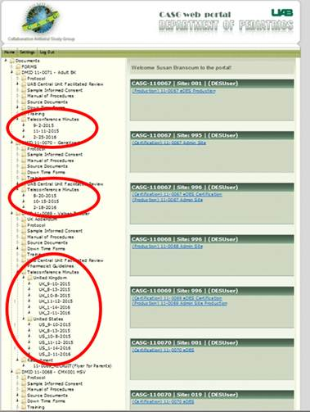

Many of you are familiar with the CASG Website and use it frequently if you are enrolling study subjects in the Electronic Data Entry System (eDES). However, if you are a Principal Investigator or other key person on the study, you might not have many opportunities to visit the site.

Recently, we began to make the minutes from our conference calls available on the CASG portal at <https://casgcu.soph.uab.edu/Portal/PortalLogin.aspx>. They will be located on the left-hand side of the welcome screen that appears immediately after logging in. They will be in folders called “Teleconference Minutes” that are under each study.

If you have not previously used the website and would like to receive a user name and password so you can go in and review the minutes from the protocol reporting teleconferences, please contact Sara Davis at [sadavis@peds.uab.edu](mailto:sadavis@peds.uab.edu). She will be happy to create a profile and user name for you so you can take a look at the resources that are located there. FYI, we recommend you use Internet Explorer version 8.0 or higher, or Mozilla Firefox to view the documents. We have experienced some difficulty viewing documents when using Google Chrome.



NOTE TO STUDY FILE

When generating a Note to Study File, please use the following format. The word template and guidelines can be downloaded from our website at https://www.uab.edu/medicine/peds/casg/.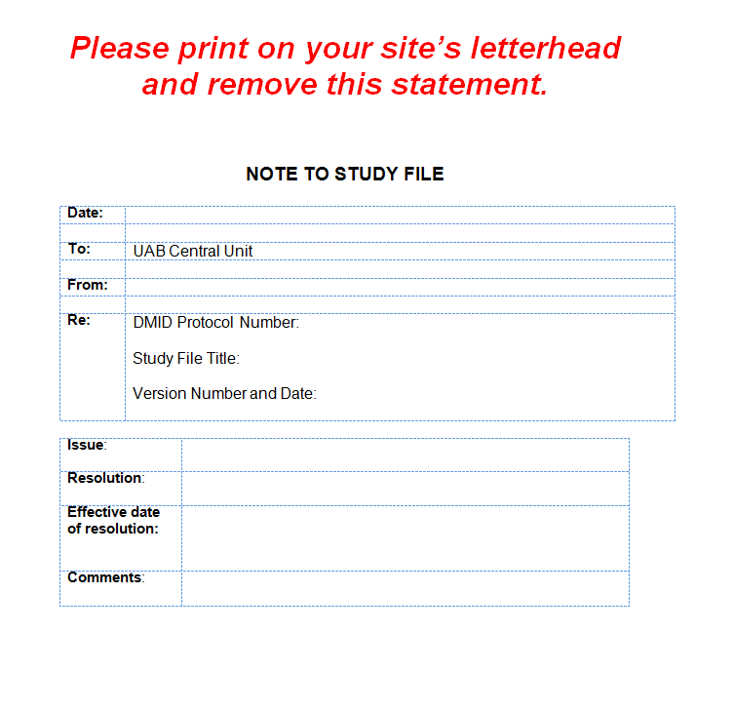

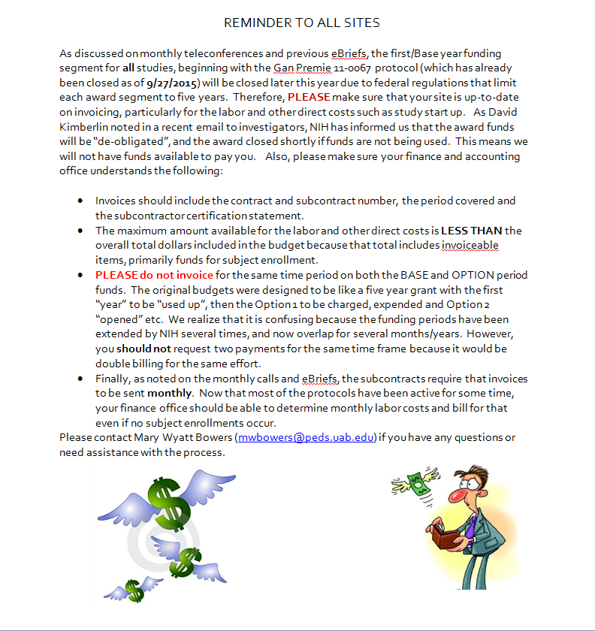

QUESTIONS? CALL THE CENTRAL UNIT!

877-975-7280

205-934-5316



C:\Users\dritchey.UAB-PEDIATRICS\AppData\Local\Microsoft\Windows\Temporary Internet Files\Content.IE5\V3NBRTFC\adamtglass-com[1].jpgC:\Users\dritchey.UAB-PEDIATRICS\AppData\Local\Microsoft\Windows\Temporary Internet Files\Content.IE5\V3NBRTFC\adamtglass-com[1].jpg