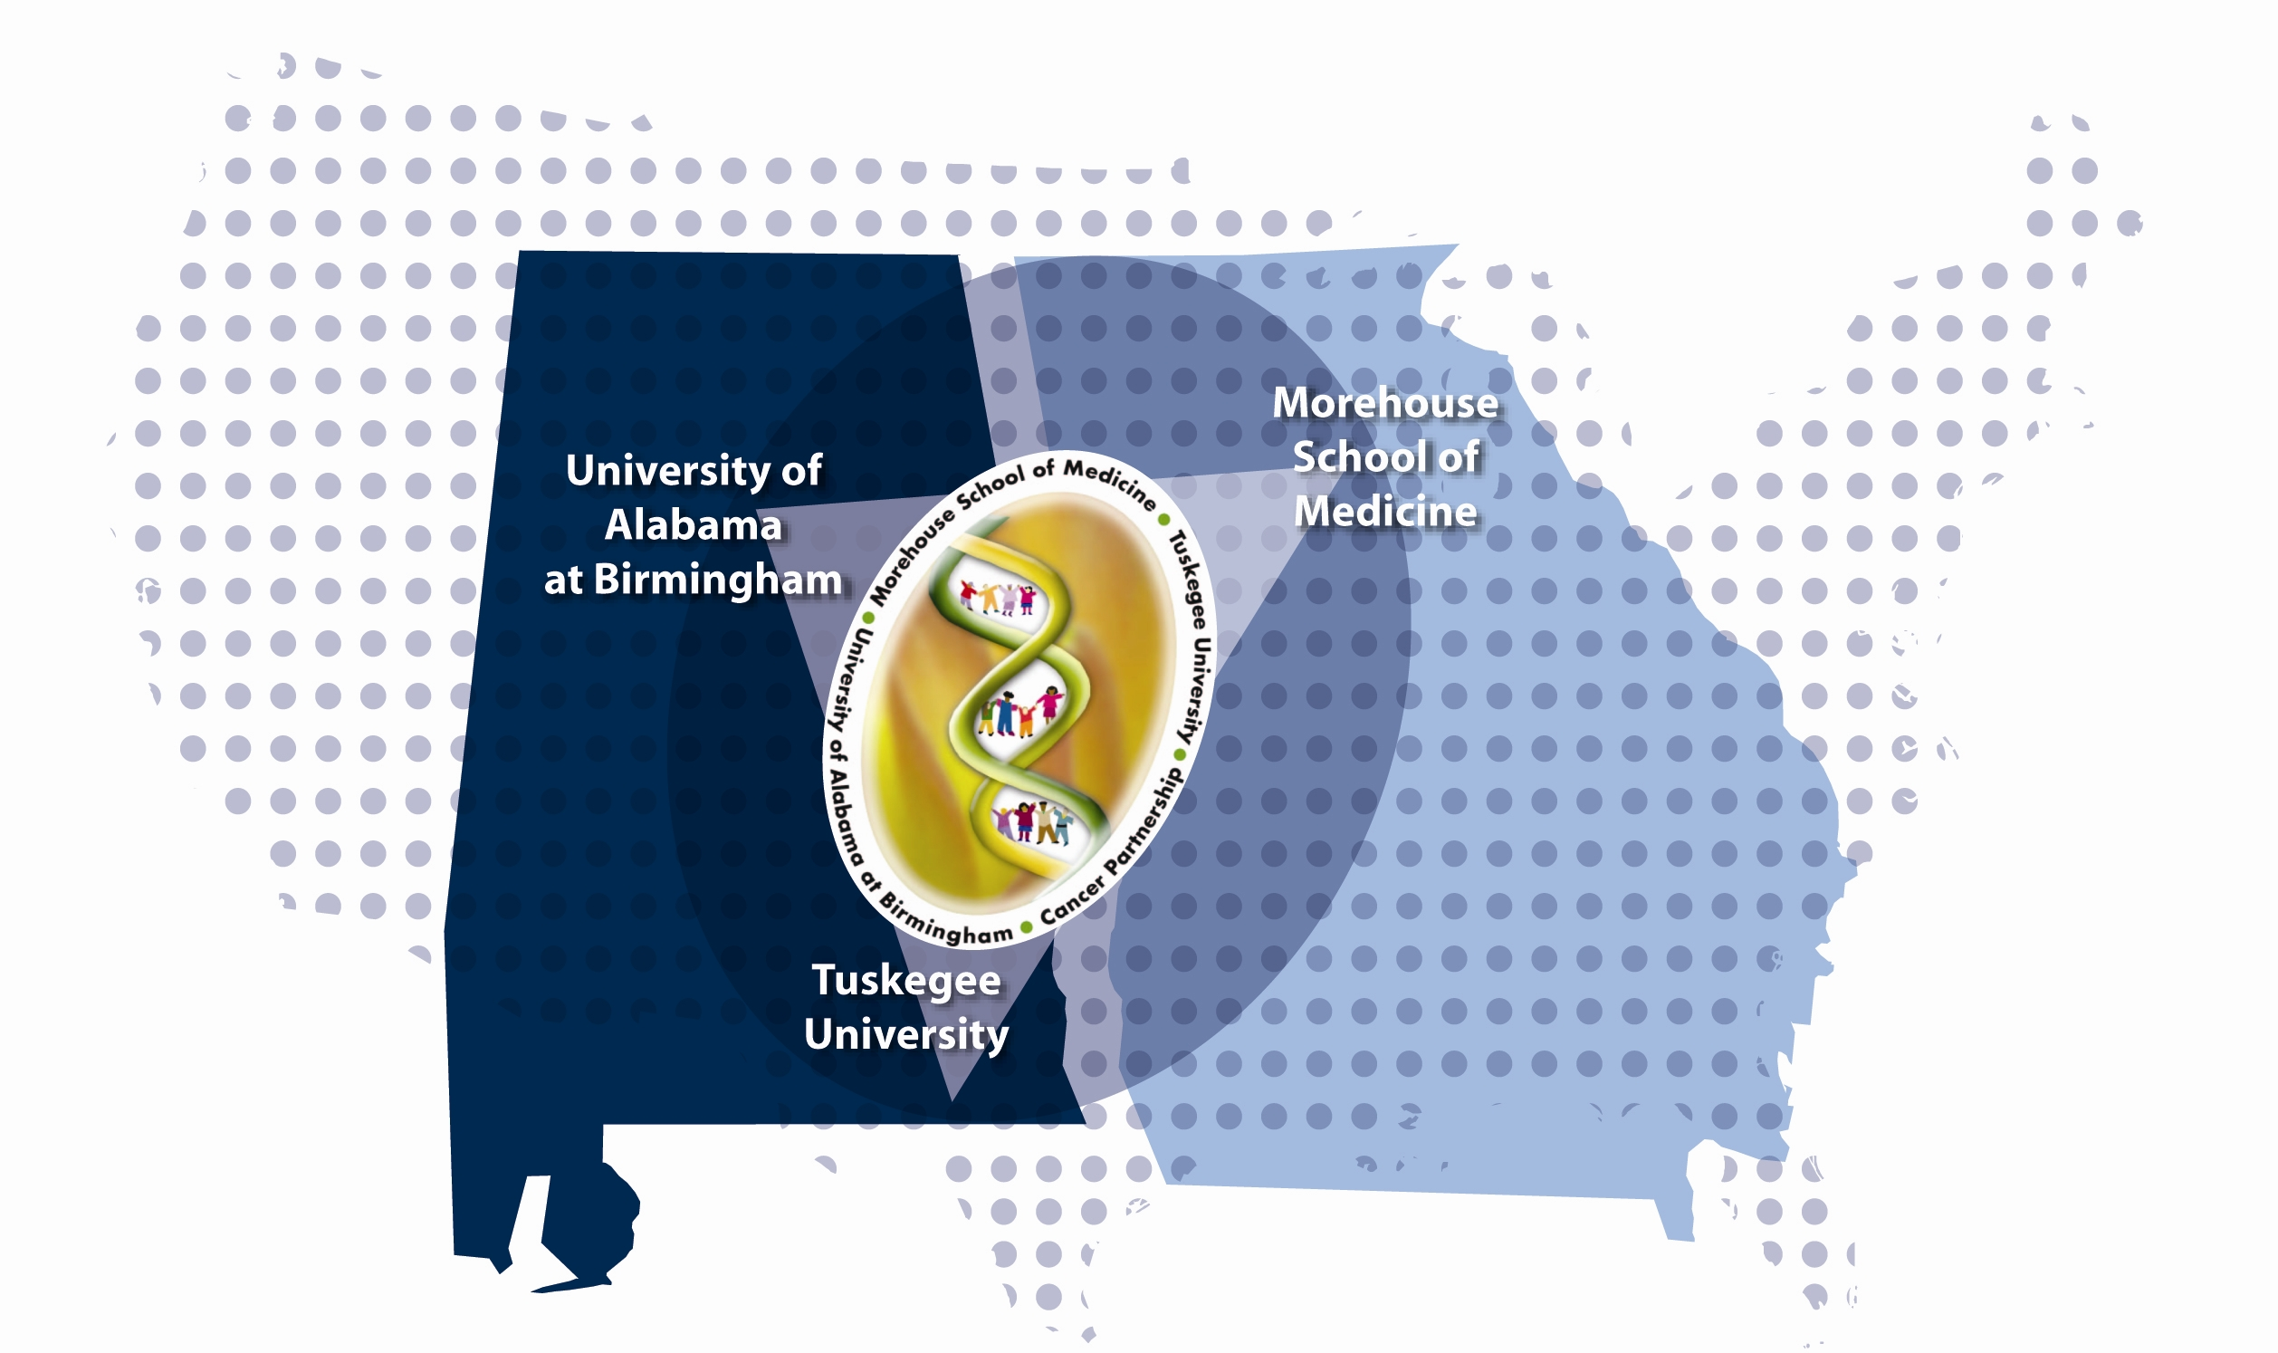
Morehouse School of Medicine/
Tuskegee University/
University of Alabama at Birmingham
Cancer Partnership

Summer Cancer Research Education Program 2018

The Morehouse School of Medicine (MSM), Tuskegee University (TU), and University of Alabama at Birmingham (UAB) Partnership invites graduate and medical students to participate in its eight-week Summer Cancer Research Education Program (SCREP), which takes place in June and July.

Eligible Applicants: We are accepting applications for these paid internships from graduate students currently enrolled in a masters or doctoral program, or medical school, at MSM, TU or UAB. Students must be US citizens or permanent residents. Selected students will receive a stipend for 20 hours a week. All applications must be received by Wednesday, April 4, 2018.

The overall goal of the MSM/ TU/ UAB Partnership SCREP is to establish a program that will encourage interest, and facilitate student training, in cancer research. Through attendance and participation in designated seminars and workshops, research students will be able to enhance their knowledge, scientific techniques, and expertise in cancer and cancer research. Participants in these activities will become stronger candidates to continue for advanced degrees in the field of cancer research and to progress to be independent investigators.

The Summer Cancer Research Education Program runs June 4 – July 27, 2018, and includes three components:

- Course work: Cancer Education provided by UAB faculty; Scientific Writing provided by MSM faculty; Bioethics in research provided by TU faculty. Travel to all three campuses is required for the one- to two-day courses for the dates to be scheduled listed on page 5 of this application.
- Practical/Field Training: Students will be linked with a mentor in their respective field to work on a cancer-related research project. The student may work with a specific research interest or an existing data set to identify ideas or proposals for future research.
- Seminars: Students will attend and present a research poster at the two-day Partnership Cancer Research Symposium and may participate in other weekly/monthly noon seminars at their respective institution.

We encourage qualified medical and graduate students of all majors to apply. All students are required to submit an application form, essay, undergraduate and graduate transcripts, and two reference letters. To be considered for this program, students must adhere to the procedures outlined in the application.

Applications must be completed and returned by Wednesday, April 4, 2018, to MSM/ TU/ UAB Partnership Summer Cancer Research Education Program at an address on the next page.

If you would like more information or assistance in completing the application, please contact:
At MSM:  Shailesh Singh, PhD  404-756-5718  shsingh@msm.edu | At TU:  Roberta M. Troy, PhD  334-727-8822  rtroy@tuskegee.edu | At UAB:  Ann S. Smith, MPH  205-934-9903  annsmith@uab.edu

We thank you for your interest and encourage you to return your completed application as soon as possible.

Shailesh Singh, PhD Roberta M. Troy, PhD Isabel Scarinci, PhD, MPH
Morehouse School of Medicine Tuskegee University University of Alabama at Birmingham
Co-Leader Co-Leader Co-Leader
MSM/ TU/ UAB PARTNERSHIP SUMMER CANCER RESEARCH EDUCATION PROGRAM
June 4 – July 27, 2018

APPLICATION FORM

INSTRUCTIONS: Applications must be received BY WEDNESDAY, APRIL 4, 2018.

- Complete ALL sections of this application – It is your responsibility to make certain that your transcripts, one page essay and recommendation letters are received by the date listed above. Incomplete applications will not be reviewed. Application may be sent via email.
- Transcripts – Contact your college registrar for an official transcript. Transcripts should be issued from ALL colleges attended.
- Letters of Recommendation – Request recommendation letters from two people familiar with your academic work. Each recommendation letter should be in a separate envelope and signed on the back across the sealed flap by the person making the recommendation, or it may be emailed to the below by the person making the recommendation.

Send or email your application and supplementary materials to one of the below:

MSM/ TU/ UAB Partnership Summer Cancer Research Education Program (SCREP)

Applicants at MSM: Applicants at TU: Applicants at UAB:
Attention: Shailesh Singh, PhD  Morehouse School of Medicine  Microbiology, Biochemistry & Immunology  720 Westview Drive, SW  Atlanta, GA 30310  shsingh@msm.edu | Attention: Roberta M. Troy, PhD  Department of Biology  107 Armstrong Hall  Tuskegee University  Tuskegee, AL 36088  rtroy@tuskegee.edu | Attention: Ann S. Smith, MPH  UAB Minority Health & Health Disparities Research Center  1717 11th Avenue South – MT 512  Birmingham, AL 35205  annsmith@uab.edu

I. PERSONAL INFORMATION (PLEASE TYPE OR PRINT)

Name
Last First Middle

Current Address
Street Apt. Number City, State Zip

Email Addresses: (Current) ____ ________ (Permanent/personal) _____________ _ __

Cell Phone ________ Are you a U.S. Citizen? Yes_____ No _____

If not a U.S. Citizen, are you a Permanent Resident? Yes No __

Race/ Ethnicity ___________ Place of Birth __ Date of Birth Sex: F___ M___ Age:___

Do you have a valid driver’s license? Yes_____ State License No.

Will you have use of a car if public transportation is not available? Yes____ No ____

Have you ever participated in a Summer Training/Enrichment Program in the past? Yes____ No ____

Do you have any special needs to be considered? Yes ____ No ____ If yes, please specify

Please list the names of people to be notified in case of emergency:

NAME Relationship

Email Address Telephone Numbers(s): Home ( ) Work ( )

Address

RECOMMENDATIONS

Give the names, positions and addresses of the two persons whom you have asked to write letters of recommendations.

Name Position

Email Address

Name Position

Email Address

II. EDUCATIONAL BACKGROUND

Colleges and Universities attended - please list most recent first. Expand table as needed.
Name and Location of College | Dates  Attended | Degree and  Graduation Date

Academic information for current enrollment
Major | Minor | Classification | GPA

Most recent courses
Courses | Credit Hours

III. HONORS, SCHOLARSHIPS, ACHIEVEMENTS AND AWARDS

IV. EXTRA CURRICULAR ACTIVITIES (College and Professional)

V. COMMUNITY ACTIVITIES

VI. ABILITIES AND SKILLS (Computers, laboratory techniques, licenses, etc.)

VII. AREA OF RESEARCH INTEREST

Indicate your 1st, 2nd, and 3rd choice(s) regarding the type(s) of research project, the research program area(s), and the type(s) of cancer which interest you. Write a 1, 2, or 3 on the line in front of the applicable item.

Category of Project:

___ Community-Based or Field Research ___ Laboratory or Basic Science Research
___ Analytical/Statistical Research ___ Clinical (Patient Care) Research
___ Animal Research
___ Behavioral Research (cultural influences of health seeking behaviors, intervals knowledge, attitudes and beliefs towards health care, life style modification interventions, etc.)
___ Other (specify):

Research Program Area:
___ Cancer Prevention and Control
___ Chemoprevention
___ Experimental Therapeutics
___ Immunology
___ Molecular Genetics
___ Neuro-Oncology
___ Structural Biology
___ Virology
___ Women's Cancer

Type of Cancer:
___ Breast
___ Cervical
___ Colorectal
___ Lung
___ Oral
___ Prostate
___ Skin
___ Other (specify): _

___ Other (specify):

Do you have a specific faculty member in mind for a mentor?
If yes, provide name and contact info:

Do you have a specific research project in mind?
If yes, please describe:

EXAMPLES of Previous Student Research Projects:
- Rural/Urban and Racial Differences in Breast Cancer Age and Stage at Diagnosis Among Women in Alabama from 2005-2015
- Influence of the LHRH Analog, Cetrorelix, on Cell Migration of the Human Prostate Cancer Cell Line, DU-145
- Role of Tyrosine Phosphorylation on MDH2 Enzyme Activity in Cancer Cells
- Effect of Practitioner Smoking Cessation Training on Patient Counseling Time
- Encouraging Compliance with Follow-up Appointments for Abnormal Mammograms: Factors that Community Lay Health Advocates Should Consider

VIII. AVAILABILITY FOR ASSIGNMENT

Student trainees are expected to work for the entire 8-week training period:
Monday, June 4, through Friday, July 27, 2018

Your schedule will include approximately 20 hours a week of required course work and time to work with your mentor to develop a research project. This schedule will be determined with your mentor during the first week of training.

SCREP required course dates are:
- Week 1 -- Bioethics Workshop at TU (Wed, June 6, 2018)
- Week 2 -- Cancer Education at UAB (Tues-Wed, June 12 & 13, 2018)
- Week 4 -- Scientific Writing Workshop at MSM (Proposed Tues-Wed, June 27-28, 2018)
- Week 8 – Cancer Research Symposium (Wed, July 25, 2018)

Travel to the other campuses is expected and will be reimbursed.

IX. RECRUITMENT INFORMATION

Have you participated in any type of internship program in the past? Yes_____ No_____
If yes, indicate when and where.

How did you learn about the MSM/ TU/ UAB Partnership Cancer Research Education Program?

X. STATEMENT OF INTENT ESSAY

Please submit a one-page essay (250 words double-spaced) attached with this document. It must be typed. Your writing will be evaluated for content, clarity, grammar, spelling and coherence. The essay should address the following:

- Why would you like to participate in the MSM/TU/UAB Partnership Summer Cancer Research Education Program (SCREP)?
- How does this training program relate to your academic and career goals?
- What qualifications distinguish you from other potential applicants?

The MSM/TU/UAB Partnership Summer Cancer Research Education Committee will review applications. Final selections will be made by Friday, May 4, 2018.

I certify that the information submitted in this application is true and correct to the best of my knowledge.
I give the MSM/TU/UAB Partnership SCREP permission to share this information for the purpose of recruitment and placement.

If selected, I authorize and release MSM/TU/UAB to videotape, photograph or otherwise record my participation in this program.

Signature Date

