Introduction
In case of emergency special, detailed plans are included which address such scenarios as fire, bomb threat, loss of electrical power, and severe weather. For more information on this plan or explanation of duties contact the Building Administrator, his designee or your floor captain. (See Appendix B).

Administrative Notification
In the event of a disaster such as fire or bomb threat, UAB Police should be contacted by dialing “911” from any UAB phone or by dialing 934-3535 from a cell phone or public phone.

Loss of Electrical Power
- Upon loss of power, remain calm and notify Campus maintenance dispatch immediately at extension “934-5353.” Plan and train all staff, in advance, on how your department will call out if loss of power disables your telephones.

- Where available, the emergency generator will transfer power upon loss of electricity. It is important that all staff are trained that the switch to emergency power is not instant. There will be a brief delay. Also, not all areas have emergency power. Lights and switches on emergency generators are red and easily identified. Critical equipment should be plugged into these red outlets.

  - Egress lighting - All areas have egress lighting at a minimum in order to maintain just enough light to navigate corridors and stairs. However, emergency lighting is either battery powered or generator powered and will only last a short time. Also this lighting is very dim compared to what you are used to. It is important to keep evacuation routes and corridors clear of all clutter that could pose a hazard in dim light and slow or obstruct evacuation.

- All non-essential equipment should be turned off until power has been restored.

- Some areas and buildings (i.e. animal areas) may require special measures in the event the loss of power interrupts air circulation, cooling and heating.

Loss of Communications
- If the telephone system is lost, avoid attempting to use the phone.
- Designate one individual to periodically check the phone.
- Use cellular phones to maintain essential communications.

Severe Weather
During any actual emergency or severe weather situation, this site -- www.uab.edu/emergency -- will be the official source of UAB information. In addition, the UAB Emergency Management Team will use B-ALERT, the university’s emergency notification system, to communicate through voice calls, SMS text messages and e-mails to the entire campus all at the same time. B-ALERT also integrates with Facebook and Twitter.
The UAB Severe Weather & Emergency Hotline at 205-934-2165 also will be updated as appropriate to provide official updates on the university's and UAB Hospital's opening and closing status.
Departments should purchase a battery powered emergency weather radio to be kept in a prominent place and monitored during inclement weather. The Building Administrator or designee will be responsible for monitoring the weather for changes that may require an upgrade in readiness. The Building Administrator is also responsible, in consultation with the Campus Safety Officer, for helping departments determine specific actions that should be taken to protect UAB employees, students, visitors and property.

Most buildings at UAB offer good protection from severe weather. Some areas of lesser construction, broad spans of roof, or areas with large amounts of glass will require special planning. Consult with your Building Administrator and the Campus Safety Officer.

Emergency Sirens
There are 5 emergency sirens located strategically around campus to help alert those outdoors in the event of a tornado warning or sighting (see below). These are activated by the Jefferson County Emergency Management Agency in cooperation with the National Weather Service.

Heavy Rain and Flooding
Maintenance will be prepared to handle sewer back-up and other problems associated with flooding in areas known to have problems. Environmental or Building Services is responsible for making sure door mats and wet floor signs are deployed and to assist with any needed cleanup.

Severe Lightning/Electrical Storms
While it is unlikely that such storms will result in serious damage to the University as a result of electrical activity, it is advisable to curtail certain activities that may present risks, such as outdoor or rooftop activities, or the use of any equipment that could cause injury or be damaged by sudden surges or interruptions in the power supply.
People who have been struck by lightning carry no electrical charge and can be handled safely. If they have stopped breathing, perform CPR.

Watches and Warnings

Watch
A tornado, severe thunderstorm, flash flood, etc. watch means conditions are favorable for the development of that particular weather event. The watch will be issued by the National Weather Service for a specified period of time. Specific information will be broadcast on the weather radio as well as commercial radio and television. Each department should develop a call tree or other method of notifying everyone of the potential for severe weather. Since this is not an immediate threat and no specific action is required, e-mail notification or a group page works well for this. Make sure to include when the watch will end.

Again, no specific action should be taken by staff during a watch except to stay alert to weather conditions and updates.

Warning
A tornado, severe thunderstorm, flash flood, etc. warning means a weather event has been positively identified in or near Jefferson County. Emergency sirens will sound. Everyone must stay alert for any sudden changes in weather conditions or weather announcements and should seek shelter immediately along the interior walls and enclosed windowless staircases, or in a basement area. (Insert your building specific areas here) With Doppler radar and other sophisticated electronic tracking systems we can more accurately track weather threats, so it is extremely important to monitor emergency weather services for the latest information on the exact location of the problem.

Stay away from the windows as much as possible. Do not attempt to monitor conditions by standing at a large window.

If a tornado has been spotted in close proximity during normal operations all building occupants should move away from all windows and take shelter immediately in the inner corridors.

Fire

If you detect FIRE or SMOKE, no matter how minor it may appear to be, do this at once:
STAY CALM and use common sense. Visitors will depend on your actions. Use the RACE response system:

1. REPORT THE FIRE. DIAL 911 (UAB Police/fire department). Identify yourself and provide the exact location of fire or smoke and what is burning, if known.

2. ACTIVATE THE FIRE ALARM. Fire alarm pull stations are located near the exits on every floor.

3. CONFINE the fire and smoke. As you leave the room where the fire is located, close the room door and fire doors located in the corridors.

4. EVACUATE staff and visitors immediately. Do not return to the building unless told to do so by the fire department, police, or the Safety Officer.

NOTE: In animal care areas, develop any special procedures concerning evacuation and protecting animals and include in this section.

Evacuation
Evacuation of staff and visitors will be carried out in a timely and orderly manner:
- whenever the fire alarm is sounded,
- if fire is detected,
- or if ordered to do so by management or emergency personnel.

A description of your building’s fire alarm system should go here. Below is an example.

The fire alarm in CH19 is both audible and visual. The audible alarm is a loud klaxon and the visual alarm is a flashing strobe light. Alarms are located in corridors, high on the wall.

Please delete the above and replace it with information specific to your building.

Evacuation will occur as follows:
            - All building occupants should proceed to the nearest exit, (NOT necessarily the way you usually exit), and move immediately away from the building entrances to provide unobstructed access for emergency personnel and equipment. All occupants should then assemble in the ***designated corral point, Insert your building’s designated safe corral point here. Example: parking lot across street. (If you need assistance in determining a safe corral point for your building contact the Campus Safety Officer at OH&S). Your supervisor will train you on evacuation procedures.
            - Do not return to the building unless told to do so by the fire department, police, or the Safety Officer. Emergency personnel, maintenance and/or building administration will be monitoring exits and will verbally notify groups in the designated corral point that it is safe to return to the building.
            - Floor Captains or their designees will be responsible for checking all restrooms and evacuating all visitors on their floors. (See attached list of Floor Captains-Appendix B).
            - Once in your designated corral point look for the person holding up a placard with your floor number and report in for headcount.

Headcount
Floor Captains will be responsible for maintaining an occupant roster which will be kept with the floor number placard and used to account for occupants after evacuation.

Provisions for individuals with disabilities:
The landings inside stairwells and protected elevator lobbies are considered areas of refuge for individuals with disabilities. In the event the building must be evacuated, individuals with disabilities located above or below the ground floor should proceed to their designated areas of refuge and remain until emergency personnel arrive. Any required assistance for individuals accessing the area of refuge should be coordinated in advance by their departments. The Floor Captain or designee must immediately report the location of disabled or injured individuals to emergency personnel. Each department is responsible for assisting visitors with disabilities in evacuation or accessing areas of refuge.

Fighting Small Fires
If you are certain that a small or contained fire does not pose an immediate threat to you, your co-workers, visitors, or the surrounding area, and you have been trained to use a fire extinguisher, you may be able to put it out with the appropriate fire extinguisher. The fire extinguishers located through out the building are ABC type dry chemical.
Fire Drills
In an actual fire, there will be a great deal of excitement and confusion. The confusion may be compounded by thick smoke and toxic gases. A normally well marked exit route may appear unfamiliar and disorienting. For this reason, it is essential that fire response procedures be practiced.
The training of personnel to respond effectively to a fire emergency is the heart of any fire safety program. Each person must know exactly what to do and must have enough practice to be able to perform quickly and efficiently. Fire drills should be conducted as follows:

1. Drills should be conducted in such a way as to ensure that all personnel participate.
2. Drills are to be conducted by the Safety Officer, Building Administrator or designee.
3. Drills are to be initiated through verbal notification of an employee or by activating a fire alarm pull station. If a pull station is used, maintenance should be on hand to reset the alarm and Birmingham Fire and Rescue must be notified of the exact time of the drill and when the system is back in service.
4. The Safety Officer, Building Administrator or designee will monitor and evaluate the fire drill response. Training will be held at that time if an employee is found to be unfamiliar with procedures.
5. All clear to be called by the Safety Officer, Building Administrator or designee.

Bomb Threat Procedure

Bomb threats are normally made over the telephone to an unsuspecting person and are primarily intended to disrupt and cause chaos. Historically, threats have strictly been threats, and usually that is all the caller intends.
Making a false bomb threat is a federal offense and punishable under United States Code 18-844e, with a penalty of up to ten years in prison, $250,000 fine, or both. This penalty also applies to juvenile offenders.
When a bomb threat is called in, record all the pertinent information using the bomb threat checklist.
Do not hang up the telephone. This is extremely important in conducting an investigation and in possibly locating the caller.
Be calm, be courteous and listen. Do not interrupt the initial message of the caller. If possible, notify your supervisor immediately by a pre-arranged signal while the caller is on the line.

ALWAYS CALL UAB POLICE. NEVER ASSUME THE CALL IS A HOAX.

Call 911 from any UAB telephone. If you use a cell phone, dial 934-3535.

Do not advise anyone else of the threat except for your immediate supervisor.

Stay calm and wait for the arrival of the Police. They will consider the facts and conduct a complete investigation.

UAB Police will evaluate the threat and determine if an immediate evacuation of the building(s) is required. If an immediate evacuation is not required, UAB Police will continue to evaluate the threat and in consultation with UAB Administration determine if an evacuation of the building(s) is required.

If you find a potential device, or are advised of a potential location of a device, immediately call the UAB Police. Don't touch or move the device.

If you suspect a letter bomb, follow the same procedure for finding a possible or real device.

Homeland Security
Purpose
Protecting the American people from terrorist threats is the founding purpose of the Department of Homeland Security and its highest priority. The Department's efforts to battle terrorism, include detecting explosives in public spaces and transportation networks, helping protect critical infrastructure and cyber networks from attack, detecting agents of biological warfare, and building information-sharing partnerships with state and local law enforcement that can enable law enforcement to mitigate threats.
The National Terrorism Advisory System

The National Terrorism Advisory System, or NTAS, replaces the color-coded Homeland Security Advisory System (HSAS). This new system will more effectively communicate information about terrorist threats by providing timely, detailed information to the public, government agencies, first responders, airports and other transportation hubs, and the private sector.

It recognizes that Americans all share responsibility for the nation's security, and should always be aware of the heightened risk of terrorist attack in the United States and what they should do.
Follow the link below to the Department of Homeland Security’s NTAS;

http://www.dhs.gov/files/programs/ntas.shtm.

Once on this page scroll down for alerts and current information.

Appendix A 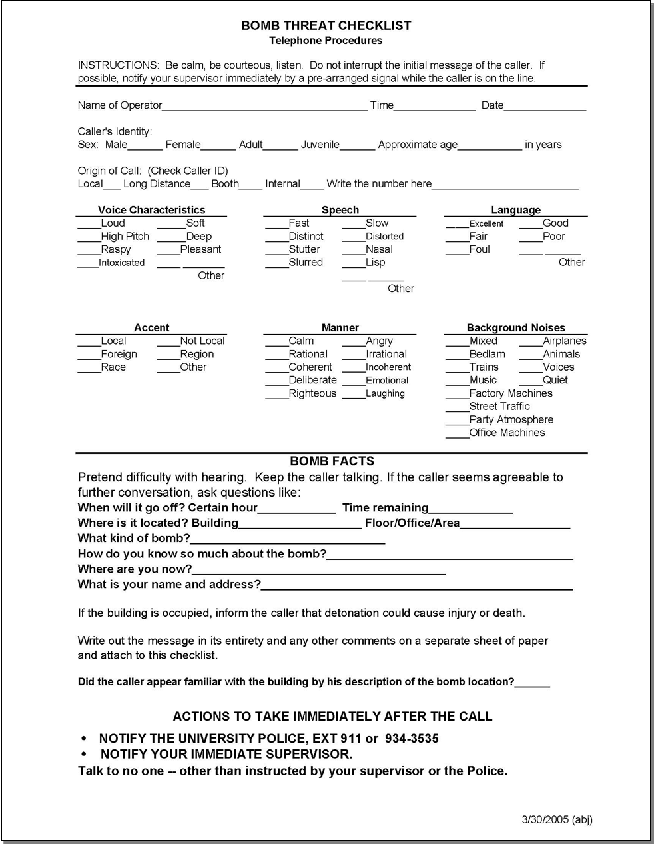

Appendix B
Designated Personnel

Building Administrator: __________
Other designees – in order

Floor Captains:
Responsibilities: Monitor severe weather conditions. Coordinate evacuation of staff and visitors. Get appropriate floor sign and floor/department roster. Lead people {designated corral point}

Floor Captain Alternate 2nd Alternate(optional)

Basement: Ms. Dependable 1-2345 Al Ternate 5-4321 Som Body 1-1111

First Floor:

Second Floor:

Third Floor:

Fourth Floor:
(etc. as needed)

APPENDIX C
Departmental Responsibilities

Each department/floor should develop:
- a call tree or other method of notifying personnel of the potential for severe weather or other emergency.
- a list of Floor Captains and alternates.
- headcount roster.

Supervisory responsibilities
Train staff on:
- Evacuation procedures.
- Call out procedures in event phones are lost.
- Designated personnel, eg. Floor Captains etc.
- Headcount procedures.

