Expedited Reviews
Most Expedited protocols will not be subject to continuing review; however, the UAB IRB will require an Expedited Status Update (ESU) at least every 3 years. The IRB or Expedited reviewer will determine and document the need for ongoing continuing review. The IRB may require continuing review under the following conditions:
- Research when required by other applicable regulations (e.g., FDA, International Regulatory Agencies).
- History of non-compliance
Expedited protocols that are subject to continuing review should follow the Application Process for Convened projects.
Any changes, additions, and/or deletions in Expedited projects must still be submitted to the IRB for review via Protocol Revision Amendment Form (PRAF) prior to implementation. Reportable events must be submitted via the Problem Report.

Expedited Status Update (ESU)
The IRB will require a status update of your Expedited project at least every 3 years. The Expedited Status Update (ESU) serves to keep the IRB aware of the project status.
Each time you submit a qualifying submission (i.e., PRAF or a Problem Report) to the IRB, you will be asked to provide the current status of the project (e.g., study has not yet begun, open to accrual) and the number of participants (or data/specimens) that have been enrolled up to that point, if any. This will serve as your ESU, and each time one of these documents is received, the timeline for the required 3-year ESU is reset.
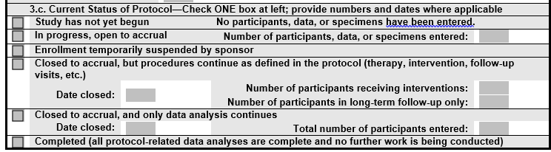
If there is no submission that qualifies as an ESU, the following email schedule will ensue:
At years 1 and 2 after initial qualifying submission - The Investigator and their delegate will receive an email from IRAP approximately 14 days prior to the first year after an ESU. The email will cite the currently known protocol status and state the approved participant enrollment. The Investigator will be advised as to how to respond if any of the IRB information is incorrect. The email will also provide a reminder of Investigator’s responsibilities for keeping the IRB abreast of any changes with the protocol, consent, or staffing. If the information in the email is correct, and no updates are needed, then no action is required by the PI.
At year 3 - The Investigator and their delegate will receive an email from IRAP approximately 30 days prior to the 3rd anniversary after an ESU and again at 14 days prior to the 3rd year anniversary. The email will request current status, current enrollment/current maximum enrollment and reminder of PI’s responsibilities for keeping the IRB abreast of any changes with the protocol, consent or staffing.
The Investigator must submit an ESU at this time, even if no changes have occurred. If you have no changes to make or problems to report, just submit a PRAF and check the ESU only box. If no response, the IRB office will assume the study is over and change the status to complete. Any work on the protocol after the study status is changed to complete is considered non-compliance.

