Create a web page on VSRC web site
To start designing and publishing page on the VSRC web site, you need to get a user account and a black web page to work with. Contact Alex Zotov in Computer Module, and he will be happy to help you. On the login page (URL), log in and then follow to the URL of your new web page that should be provided to you by email.
The new page has a banner and menus on the top and on the left side but free of content. To edit page, click Edit Article button that’s in the top right corner of the blank page. That takes you to the design page that looks similar to older version of MS Word that all of us are familiar with. Actually, you can design part of the page in MS Word and then copy and paste it into the designer window. The web page will be although not exactly like but very similar to the Word page.
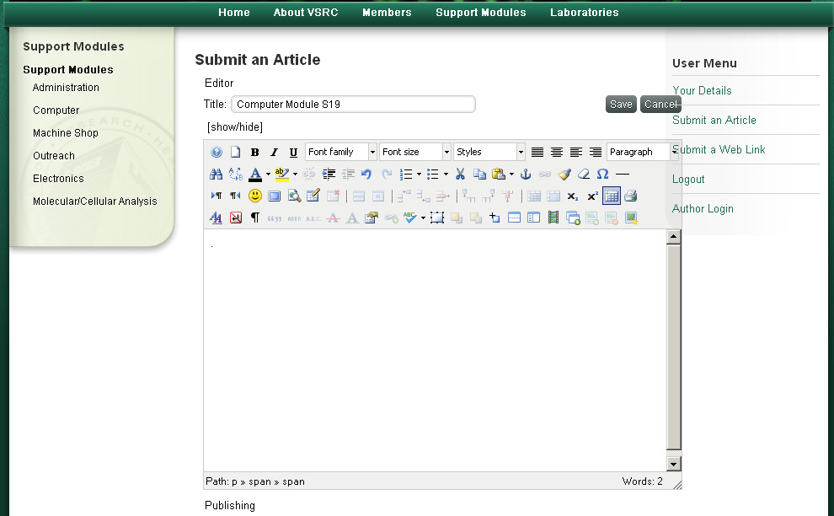
Insert link
Edit Table*
Type text and change font style and color
Create a table
Insert images
Fig 1. Design Page
* Edit Table buttons are enabled if a table is created and selected (type cursor is in one of the cells)

Insert an image
To insert an image, you have to upload the image file to the server first. To do that, click Insert Image button.
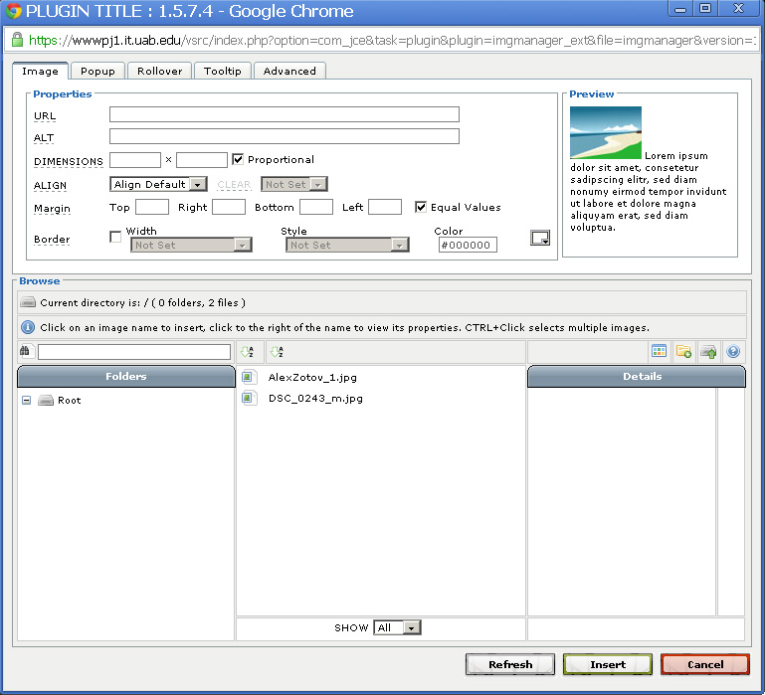  Choose file to upload  Files to upload  Upload image  Dimensions  List of available images | 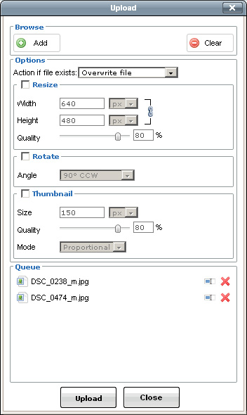
Figure 2. Insert Image Window | Figure 3. Upload Image Window

In the pop-up window (Fig 2), click Upload button that is in the right side. In the Upload window (Fig 3), click Add button in the top left corner, browse your hard drive and select an image in the file browser that appears, and click Open. That closes the file browser and takes you back to Upload window where you will see the selected file name in the Queue list in the bottom. You can add more images to the queue one at a time before uploading. Once all images were selected, click Upload.
Now that image is on the server, select the image in the file list in the lower part of the Insert Image page and click Insert.
Now the image is on the page. If it’s too big or too small for your page, you can select it and click Insert Image button again to adjust size and other properties. Change dimensions (Fig 2) and click Update.

Arranging items
Drag-and-drop works for vertical arrangement of items. So if you have an image on the top of the page and text following it, you can drag the image down and leave it right below the text. However, if you need to move an object and place it somewhere in empty space, you will have to create a table and insert items into separate cells.
Click Insert Table button. In the pop-up window, enter how many rows and columns you need to have. You can always add or remove rows and columns if needed after creating a table. Set cellpadding to 5, so that the cells of the new table will not appear too tiny. Entering width and height of a table is not adviced because then it does not auto-expand or auto-contract if you change dimensions of single cells.
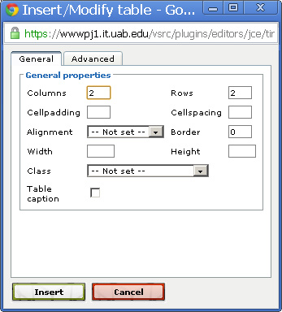
Columns and rows
Width and height
Cell padding
To adjust dimensions of a single cell (or height of a row), click a cell to place text cursor inside the cell and open Properties window by clicking Table Cell Properties. Dimensions of cells cannot be changed by dragging borders like in MS Word. If you don’t enter width of a column, you can just start typing or drag an image into it, and the cell auto-expands to some limits.
Items (images and text) can be dragged and dropped into cells.

Example. Creating the VSRC Computer Module page (URL)
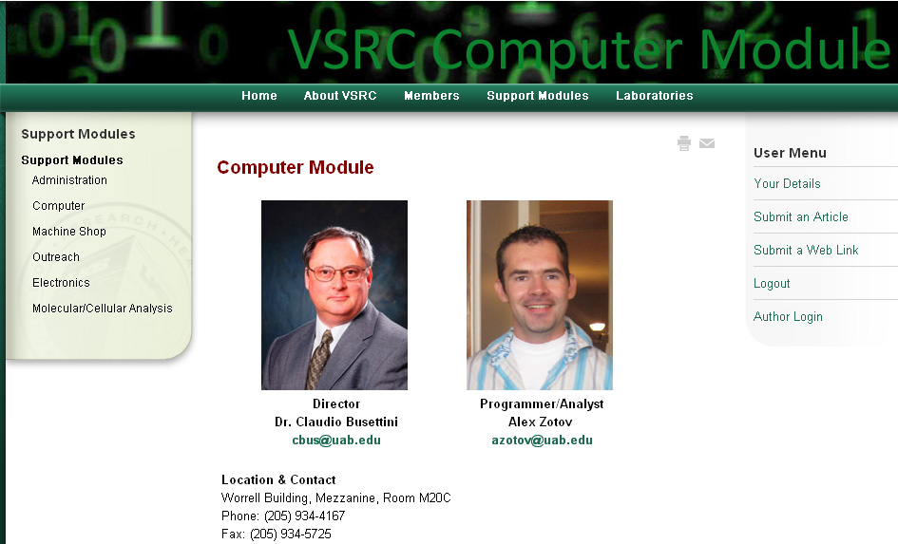
Above is the completed page, and below is a step by step tutorial of creating a similar page.

- There is page title “Computer Module” on the top, pictures of the director and the programmer arranged left to right, and contact information below. First, let’s create a 2x3 table using Insert a New Table button. Set cell padding to 5 for convenience

- To merge the top and the bottom cells, highlight two cells, and click Merge Table Cells button |  | 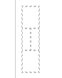
- Click on the top cell, and type page title (“Computer Module”). Highlight the text, change Font Size (14) and text color (dark red) |  | 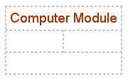
- Click in the cell in the next row to insert an image and click Insert/Edit Image. In the new window (Fig 2), click Upload. In the Upload window (Fig 3), click Add and find an image in file browser to upload. Repeat if you need to upload multiple images. Once all images are selected, click Upload. Close Upload window. In the Insert Image window, select image from the list of files available and click Insert.  Repeat if you need to insert multiple images.  If you need to adjust size of images, click an image and click Insert/Edit image button. In the top portion of the new window, change dimensions and click Update. |  | 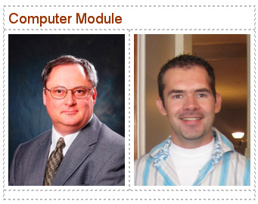
- To insert text under the images, click to the right of one of the images, not highlighting an image but placing a type cursor in a cell and press Enter. That moves the cursor below the image. Change text alignment and style if you need to (in our case, I change alignment to center and style to bold) and type text.
To create an email link, select email, and click Insert/Edit link and in URL field of the new window, type “mailto:myemail@uab.edu” with no quotes replacing myemail@uab.edu with email address.
- The last thing is just typing and formatting contact information in the bottom cell.
- Page is ready. Don’t forget to click Save button right above the formatting tools.

If you need to upload any files other than images, like doc, PDF, spreadsheets, please contact me, and I will be happy to help you.
Possible Errors:
Upload Size Error in Upload Image Window. Images larger than 1Mb cannot be uploaded and cause Upload Size Error. You can use Photoshop on your computer to reduce images size and try to upload it again.

Please feel free to contact me if you have any questions or need help

Alex Zotov
Programmer/Analyst
VSRC Computer Module, UAB
azotov@uab.edu
tel: 205 934 4167
cell 256 225 7607

