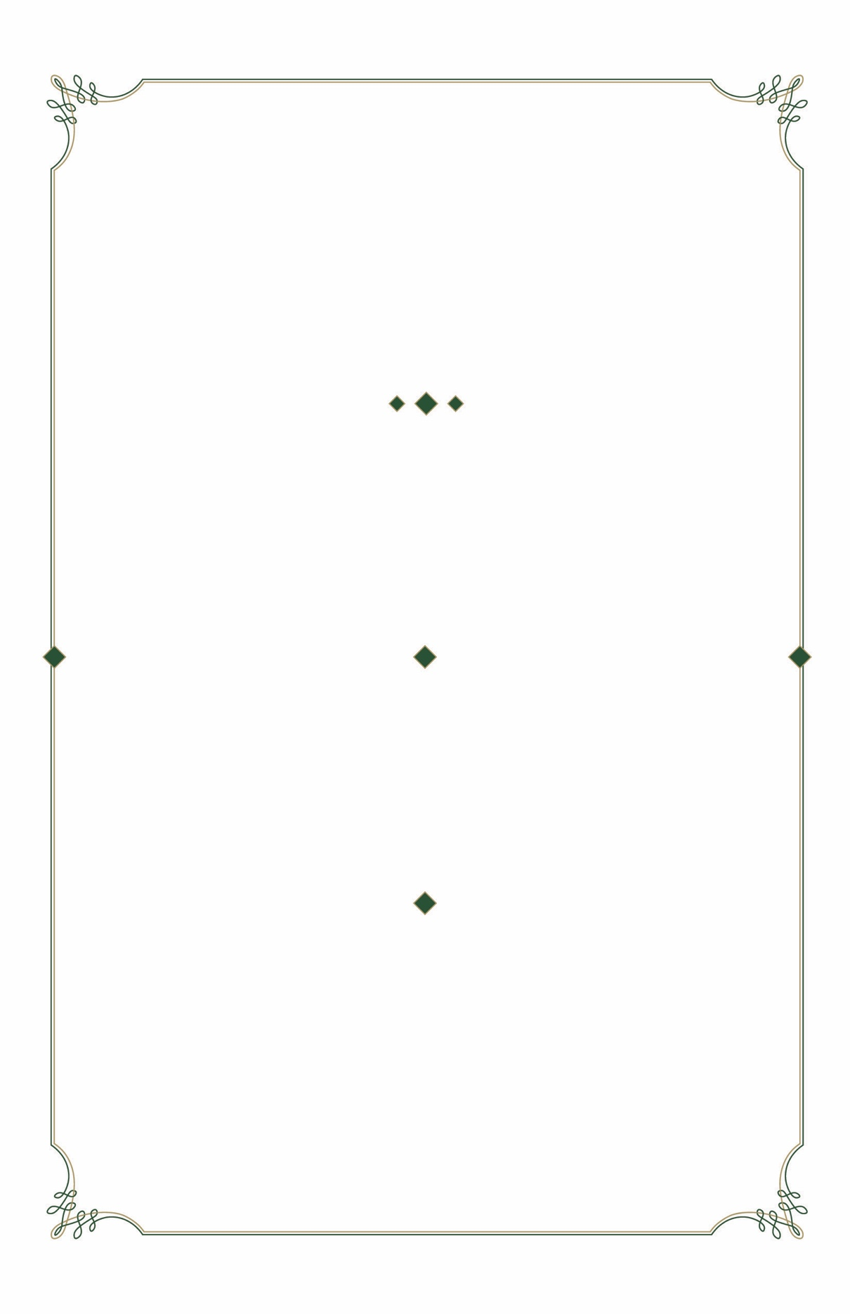

*invite you to attend*

A DONOR APPRECIATION RECEPTION

*To thank you for your*

*generous support of*

T H E U N I V E R S I T Y O F

A L A B A M A A T B I R M I N G H A M

*invite you to attend*

A DONOR APPRECIATION RECEPTION

*To thank you for your*

*generous support of*

T H E U N I V E R S I T Y O F

A L A B A M A A T B I R M I N G H A M

W E D N E S D A Y

N O V E M B E R 2 9, 2 0 1 8

6 : 0 0 PM – 8 : 0 0 PM

U A B W O O D W A R D H O U S E

4 1 0 1 A L T A M O N T R O A D

W E D N E S D A Y

N O V E M B E R 2 9, 2 0 1 8

6 : 0 0 PM – 8 : 0 0 PM

U A B W O O D W A R D H O U S E

4 1 0 1 A L T A M O N T R O A D

*please reply to* 205.975.0756

*or* [uabevents@uab.edu](mailto:uabevents@uab.edu)

BUSINESS ATTIRE

VALET PARKING AVAILABLE



**P R E S I D E N T & M R S . R A Y L . W A T T S**

T H E U N I V E R S I T Y O F

A L A B A M A A T B I R M I N G H A M

**P R E S I D E N T & M R S . R A Y L . W A T T S**

T H E U N I V E R S I T Y O F

A L A B A M A A T B I R M I N G H A M

*please reply to* 205.975.0756

*or* [uabevents@uab.edu](mailto:uabevents@uab.edu)

BUSINESS ATTIRE

VALET PARKING AVAILABLE

