The University of Alabama at Birmingham
Department of Music

Chamber Music @ AEIVA
Abroms-Engel Institute for the Visual Arts
Thursday, March 10, 2016
5:00 Refreshments and gallery viewing
5:30 Concert
Program
The Featherheart Lawren Brianna Ware Randall Thompson

The Memory of Snow Ron Wray

The Well Adriana Perera

Three Pieces on Art by Celaya Matthew Scott Phillips
I. The Sigh
II. El Otro Muelle
III. The One I Forgot

The Faithful Tom Reiner

Follows from Hummingbirds Holland Hopson

Acceptance of Longing Kenneth Kuhn

Pei-Ju Wu, violin
Hillary Tidman, flute
Brad Whitfield, clarinet
Laura Usiskin, cello
Chris Steele, piano

Special thanks to AEIVA, the Birmingham Art Music Alliance, the UAB Department of Music, the Music Performance Trust Fund, and the Dean of the College of Arts and Sciences for making this event possible.

PROGRAM NOTES

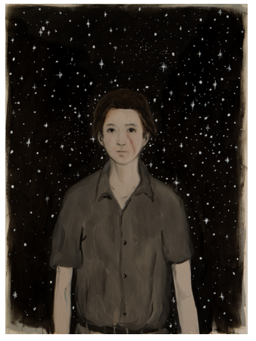
The Featherheart, 2010, Oil and wax on canvas, 60 x 44 in.

The Featherheart - Lawren Brianna Ware
My composition was inspired by Mr. Enrique Martinez Celaya's work, "The Featherheart" (and thus, my composition is named after this piece of art). The painting depicts (what I believe to be is) a young woman who has a scar on her left cheek. Behind her, one can see the dark night sky and stars. If you look closely, her scar seems to be in the shape of a feather. To me, the woman seems to be one who has a past that is full of sadness, trials, and many difficulties. She may have even have a history of abuse (thus, the scar on her cheek). However, there seems to be a glimmer of hope in her face for a brighter future.

I wanted to create a piece that was calm, ethereal, and emotional. I wanted to convey what I believe is the woman's story: one of sadness and hurt, but also one of hope. I chose the instrumentation of solo clarinet and piano. The clarinet's wide range of notes and dynamics is representative of the woman's voice. The piano accompaniment is meant to feel free and ethereal. The descending pattern that begins the piece (and later returns in both the piano and the clarinet), along with the tuplets/glissandi, are intended to represent a floating feather. It is also representative of the twinkling stars that are in the background of the painting.

The Memory of Snow - Ron Wray
This work was inspired by Celaya's use of snow in several paintings and his interest in memory.

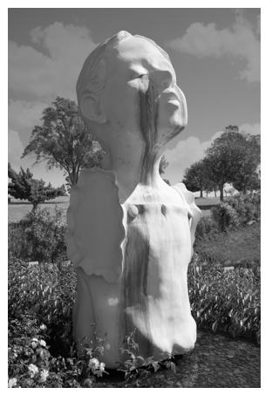
The Well, 2014, Bronze, 152 x 65 x 59 in.

The Well - Adriana Perera
As I examined Enrique Martínez Celaya’s work, my attention was called particularly to his sculpture “The Well.” I perceived a little girl in a gigantic scale, with a suffering yet hopeful expression with her face lifted, as it pain and desire could kiss each other. That perception connected with a musical idea that I put on paper some years ago. I rewrote it, adding a different pattern to the piano accompaniment -in

order to echo the tears flowing- and the form of the musical idea was adjusted into a more flexible configuration.

Three Pieces on Art by Celaya - Matthew Scott Phillips
This piece is a musical interpretation of three of Celaya’s paintings: “The Sigh,” “El Otro Muelle,” and “The One I Forgot.” They attempt to capture in music the emotional, and esthetic qualities inherent in the paintings, as well as replicate, to some extent, the symbolic, and representative aspects of the works.

The Faithful - Tom Reiner
"The Faithful" intrigues me how it depicts a bird in a thicket. I did some research online and found a talk that Celaya gave at the L.A. Louver on November 15, 2012. The talk is over an hour long. He discussed his painting "The Faithful" among many other things. Celaya explained that the work has a reference to the poet Harry Martinson. Martinson's father died when he was six and then his mother abandoned him and went to America. Martinson spent his childhood in several foster homes. He kept waiting for a ticket to come so that he could join his mother. Martinson became a sailor at the age of sixteen with the intent of coming to America to find his mother. The idea of being faithful and hopeful all those years is how the concept of "the faithful" relates to the painting. As I started working on the piece it became clear that you cannot have faith without doubt. Perhaps having pure faith can eliminate doubt but doubt may still enter your thoughts from time to time. My piece presents a sketch of what it is like to vacillate between alternating thoughts of faith and doubt.

Follows From Hummingbirds - Holland Hopson
Follows From Hummingbirds draws on imagery of Celaya’s set of small paintings, Hummingbirds (1997). The music is assembled from a group of interrelated gestures that suggest birds in flight, a passing thought, a ghostly memory. The sonic gestures are surrounded by silence, similar to
the way Celia’s hummingbirds are surrounded by the space of the raw linen on which they’re painted.

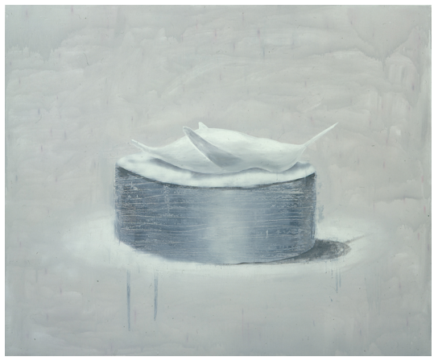
Acceptance of Longing, 1997, Oil on canvas, 60 x 72 in.

Acceptance of Longing - Kenneth Kuhn
I went to the martinezcelaya.com website and viewed all of the pictures looking for inspiration. One picture in particular, "Acceptance of Longing" immediately reminded me of a basically abandoned piano suite I composed over forty years ago as that work has a similar theme. I completely reworked themes from the first two movements from that discarded piano suite and blended them into the work I am submitting. Like the painting the opening clarinet theme representing the bird is clearly longing for acceptance and after some very dramatic feelings played by the cello is accepted by a playful flute theme. The two interact and attain a musical climax and the work peacefully closes with a strong sense of all is well.

Artists’ Biographies
Chris Steele held previous positions at the University of North Carolina School of the Arts as Staff Pianist, at the University of North Carolina at Greensboro (UNCG) as both Lecturer of Music Theory and Ear Training, and as Faculty Fellow for the UNCG Grogan College Music Learning Community. At UNCG he studied with Andrew Harley and James Douglass and held assistantships in both accompanying and music theory/ear training. At The Florida State University, he studied with Carolyn Bridger.

An active performer, Steele is a member of the UAB Chamber Trio and has collaborated with members of the Alabama Symphony Orchestra and the Greensboro Symphony Orchestra. As a proponent of new music, he is a member of the Birmingham Art Music Alliance, and has performed at the Society of Composers Region IV Conference and the Mid-South Chapter of the National Association of Composers Concert. He has also presented lecture-recitals on the late compositional style of Gabriel Fauré, including at UNCG’s biennial Focus on Piano Literature Symposium.

Flutist Hillary Tidman is currently the Assistant Principal Flute of the Alabama Symphony Orchestra, a position to which she was appointed in 2013 at the age of 20. She previously performed with the Des Moines Symphony Orchestra and the Civic Orchestra of Chicago. Hillary holds a Bachelor of Music in flute performance from Northwestern University, where she studied with John Thorne, Walfrid Kujala, and Richard Graef

Laura Usiskin has performed throughout North America and Europe in such venues as the Kennedy Center, Alice Tully Hall, Palazzo Chigi Saracini, Boston’s Symphony Hall, Weill Hall, Miller Theatre, Barge Music, and many others. She was an Artist-In-Residence with the Montgomery Symphony Orchestra, where she performed concertos, recitals, and sat principal of the cello section. While in Montgomery, she served as Founder and Executive Director of the Montgomery Music Project, a program that provides intensive string music instruction to underserved children. The program has served more than 200 children throughout the region. Other recent achievements include section positions with the New Haven and Jacksonville Symphony Orchestras, a principal position with the Orchestra Iowa, and performances of the complete Bach Cello Suites. Ms. Usiskin received her Bachelor of Arts in Neuroscience and Behavior from Columbia University, Master of Music from The Juilliard School, and Doctor of Musical Arts from the Yale School of Music. She is currently on faculty at the University of Alabama-Birmingham and Birmingham-Southern College.

Brad Whitfield, native of Birmingham, Alabama, joined the Alabama Symphony Orchestra as A​ssistant Principal/Second Clarinet in December 2015. He recently c​ompleted a four-year fellowship with the New World Symphony in Miami Beach, Florida, under the musical direction of Michael Tilson Thomas. D​uring his fellowship, he toured with the orchestra to the Harris Theater, Carnegie Hall, and the Kennedy Center. He h​as also performed with the Cleveland Orchestra, North Carolina Symphony, and the C​entral City Opera.

Brad has spent t​he past few s​ummers playing with the Verbier Festival Orchestra i​n Verbier, Switzerland where he has performed under conductors such as Zubin Mehta, ​C​harles Dutoit, Valery Gergiev, Gianandrea Noseda, and Esa-Pekka Salonen. In addition, he has performed as a member of the T​anglewood Music Center, Spoleto Festival U.S.A., P​acific Music Festival, M​usic Academy of the West, and the National Repertory Orchestra.

Brad completed his Bachelor of Music at Northwestern University and his Master of Music at the University of Southern California. His principal teachers include Yehuda Gilad, Steve Cohen, and Danny Granados, ​former Principal Clarinet of the Alabama Symphony Orchestra.

Violinist Pei-Ju Wu, a native of Taipei, Taiwan, has established a performance career as an active chamber and orchestral musician. She joined the first violin section of the Alabama Symphony Orchestra in 2013 and is a member of the Des Moines Metro Opera. Prior to moving to Birmingham, Pei-Ju was a member of the San Antonio Symphony, and performed frequently with the Houston Grand Opera, Fort Worth Symphony and Dallas Chamber Symphony. She was the former concertmaster of the Woodlands Symphony and Opera in the Heights. Interested in many genres of music, Pei-Ju toured with the Star Wars in Concert orchestra during its 2010 North America tour and performed with Peter Gabriel's New Blood North America tour.

In 2010, Pei-Ju co-founded Quartus Chamber Players, a Houston-based chamber music ensemble that focused on collaborating with local artists and educational outreach through music. During its 4-year operation, Quartus reached over 2,000 students with its educational program and brought numerous chamber music concerts of varied ensemble settings to the audience of Houston. She was a member of the Hall Ensemble while living in Fort Worth, Texas, and performed frequently with other Texas chamber music groups, such as Aperio, Music of the Americas, Virtuoso String Quartet, Mount Vernon Music and Ensemble 75.

Pei-Ju studied with Kathleen Winkler, Roman Totenberg, Shirley Givens and Rodney Friend, and received her degrees from Boston University and Rice University. She was an adjunct instructor at the Texas Wesleyan University and currently teaches at STEP Birmingham in Birmingham, Alabama.

