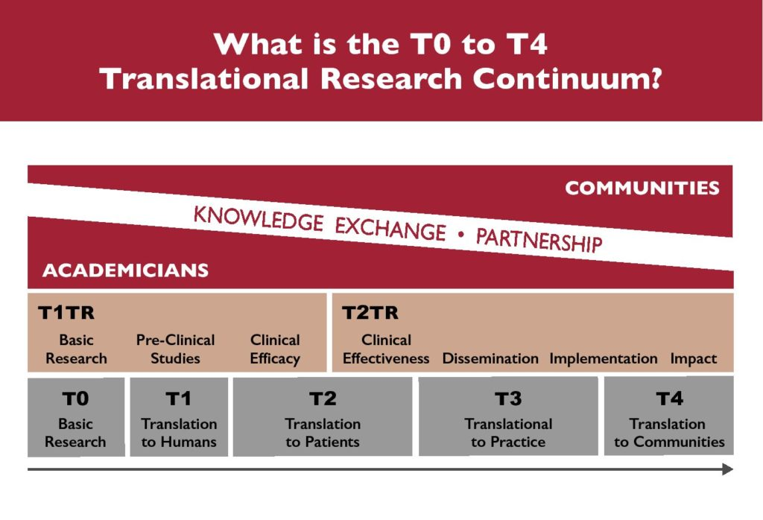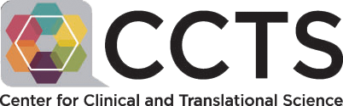

Translational Spectrum

# Request for Applications

**Post-Doctoral Dissemination & Implementation Science**

**Training Program (CCTS T32 Program)**

**Full-time mentored research training experience with stipend**

This **mentored research training program** is currently accepting applications from **post-doctoral students in health-related profession programs**. The mission of the Center for Clinical and Translational Science (CCTS) is to ***address disparities and/or diseases disproportionally represented in the Deep South****.*

## Post-doctoral students at all CCTS partner institutions holding* an MD, PhD, PharmD, DDS, DMD, DVM, and dual-degrees are invited to apply. This includes students in the following health-related professional programs:

* Medicine
* Bioengineering
* Nursing
* Pharmacy
* Clinical Psychology/Psychiatry
* Public Health/Epidemiology
* Optometry/Ophthalmology
* Physical Therapy/Rehab Medicine
* Biomedical Sciences
* Informatics

In addition to actively engaging in a 24-month mentored research experience, trainees will:

* + Experience dynamic learning with multi-disciplinary peers of excellence
  + Have access to pool of 30+ experienced mentors
  + Benefit from career-enriching training
  + Gain exposure to dissemination & implementation science didactic and experiential education

This two-year fellowship offers:

## NRSA annual stipend based on years from terminal degree (currently ranging from $56,404 – $68,604) for full-time multidisciplinary mentored research training

* **$1,500 Travel support** for ACTS national meeting
* **Tuition support** towards degree/certificate/coursework
* **Training-related expenses** available to support health insurance, child care & research related costs

**ELIGIBILITY:** Candidates must be U.S. citizens or have permanent residency status. Eligible applicants will be **postdoctoral trainees (*or soon to be) in the CCTS Partner Network who will have completed their doctoral degree by May 2024**. Candidates must be able to demonstrate a commitment to full-time research training.

**APPLICATION:** The following materials are required (submission as one PDF; see website below):

1. Current CV
2. Letters of recommendation (2), one optimally from a potential mentor
3. Three-page personal statement that addresses **a)** Reason for interest in D&I Science research, **b)** Research experience to date, **c)** Goals for research training & career development including degree attainment proposed, **d)** Project plans for research years (*2 year commitment*), and **e)** How proposed project will utilize implementation and/or dissemination science to address health inequities/diseases that disproportionately affect the Deep South. Guidance can be found on the website below.

For assistance identifying co-mentors across the CCTS partner network, please contact Jeanne/Jean (contacts below).

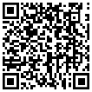**SUBMISSION OF MATERIALS:** The interested applicant will submit their application online: <https://www.uab.edu/ccts/training-academy/research-fellowships/postdoc-t-award>.

**Application materials accepted on a rolling basis with a priority deadline of March 15, 2024.**

**CONTACT:** For questions regarding eligibility, program requirements, and the application process, please contact Jeanne Merchant ([jsmerchant@uabmc.edu](mailto:rruiz1@tulane.edu) or 205.492.9744) or Jean Lambert ([jeanl@uab.edu](mailto:jeanl@uab.edu) or 205.934.5959).