Impact/Cerner Access
Go to: ONE UAB Medicine – UAB Medicine Intranet

1. Click on Information Systems


2. HSIS Self Portal
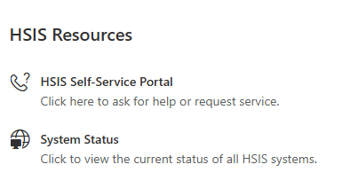

3. Request Catalog


4. Research and Clinical


5. Research Access

03202025

