Hello colleagues, if you would like to view or insert the recommended SEHS CANVAS Template please use this hand out to do so. If you have any questions about these instructions or would like technical assistance with any part of your course set up, please contact Dr. Laura Forbes, LTALBOTT@uab.edu
The first step is to import the recommended SEHS CANBAS Template into your course shell prior to copying your course content in from a previous semester. Importing the recommended SEHS CANVAS Template in and then copying in your previous course content may take a few minutes so be patient.
- Several ways to import the SEHS CANVAS Template from Canvas Commons:
Option A: Go to your course homepage, view the menu on the right, locate the second button down, and choose “Import from Commons”
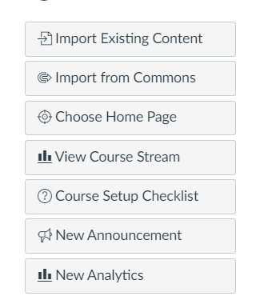
Option B: From your dashboard select the icon below the one that looks like a clock:

OR
Option C: You may go to the Learning Technologies Commons guide and follow the steps for locating Canvas Commons if you are not already familiar.
- Once you get to Canvas Commons, please remove the “undergraduate” and “graduate filters” by clicking the X’s.
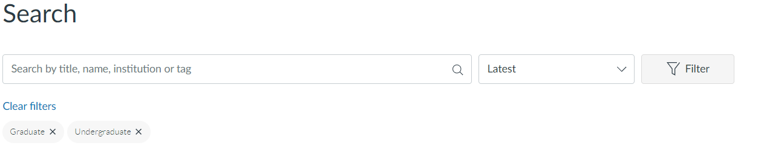
- Next, click the Filter Funnel and slide the green button OFF.
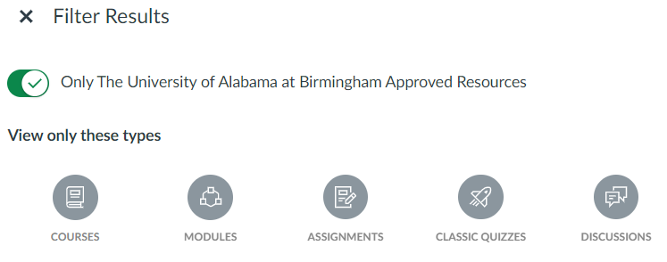
- Then in the search bar type SEHS Canvas Template.
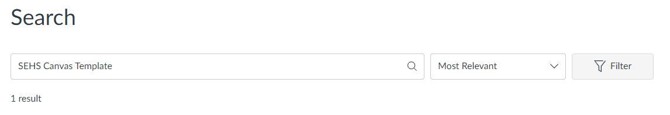
- You will then see the SEHS Canvas Template card as shown below. Click on the words SEHS Canvas Template.
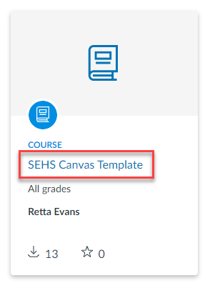
** If you already have an existing course within CANVAS you will need to import the SEHS CANVAS Template before copying over your course content.

- Now you can see a preview of the modules in the template. On the far right, click on Import/Download.
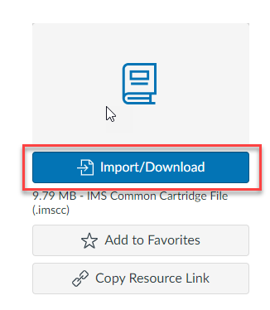
- Check the box beside only the course(s) where you want to import the template.
NOTE: There is an ALL button at the top. DO NOT select all. This will literally add the template to all of your courses in all semesters (current, future, and past).
At the bottom of the course list. Click on Import into Course.

- Wait 5 minutes.

- Go to your course.

- If you are building a course from scratch, then the home page will be the correct landing page. If you are going to re-build a course in the new template, you will likely need to go in and change the landing page. To do so go to Pages, then view all pages and set the ‘eLearning Homepage copy’ as the front page.

Your home page should look like this:
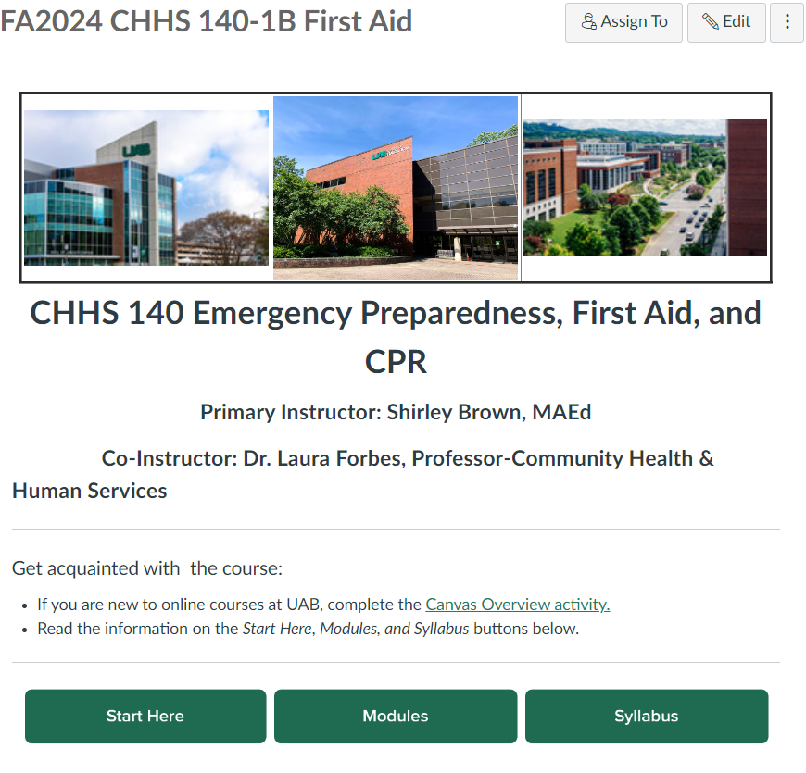
- If you go to your homepage, and it’s showing Modules, Syllabus, or something else other than a homepage, click on Choose Home Page on the right, select Front Page, and save.
