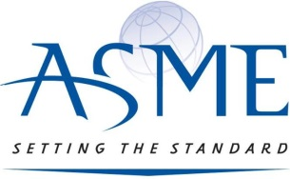
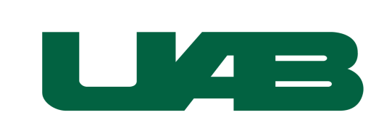

ASME’s 33rd Annual Brent Newman Memorial
Egg Drop Contest at the Education and Engineering Complex
Friday, April 5, 2024
REGISTRATION FORM
(Please type or print neatly)
CONTACT Information
Contact Last Name: | Contact First Name: | Contact E-mail address:
School:
Contact phone number: | School phone number: | School Division (please circle; one division per form):  Elementary Middle High
School street address:

City/State/Zip: |  | County:
Contact Signature: |  | Date:
student participant information
Number of student participants:

Number of student teams (1-5 students/team):
Please indicate the number of t-shirts needed by size: | _______Youth Small  _______Youth Medium  _______Youth Large  _______Youth XL  _______Adult Small  _______Adult Medium  _______Adult Large  _______Adult XL  _______Adult XXL

Deadline: Submit your completed registration form no later than Friday, March 1, 2024. Space is limited.

Send application to: or send digital copy to:

ASME Egg Drop 2024 eecollie@uab.edu

UAB Department of Mechanical Engineering
EEC 257
Office Use Only
Application Received

1720 2nd Avenue South
Birmingham, AL 35294-4440

