HOW TO FIND MY REQUISITIONS IN UAB PEOPLEADMIN

UAB PeopleAdmin offer users multiple options for you to search for and locate your requisitions.
- Search from Requisitions Tab

- Login to UAB PeopleAdmin;
- Click on Requisitions; then Faculty to see ALL of your requisitions; including those in DRAFT.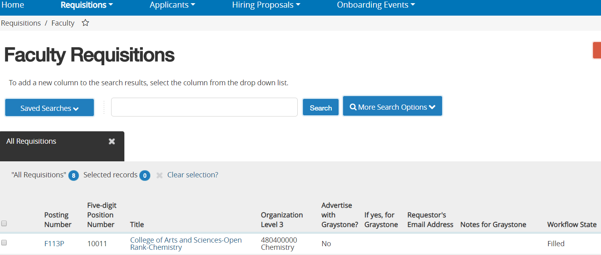

- Watch List – Add items to your Watch List as you create and submit them for approval. And, you will always be able to quickly locate where the items are in the workflow.

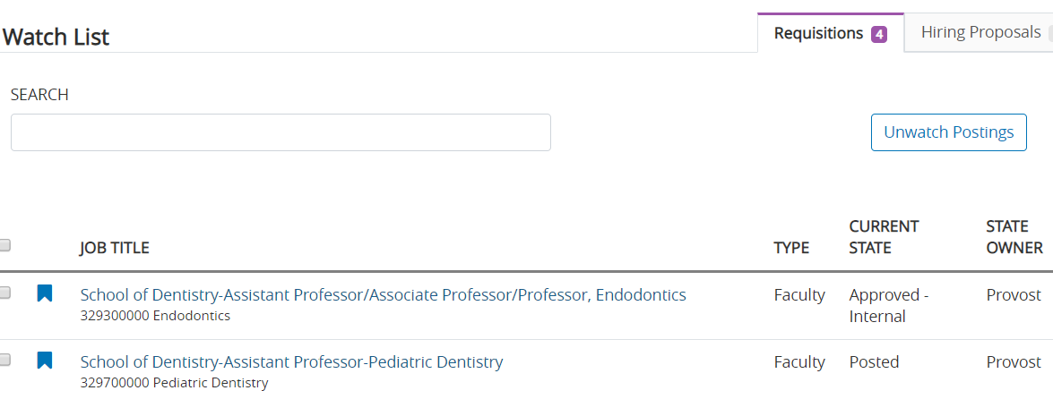

- Search by Requisition Number or Position Number. Enter the number and click search.

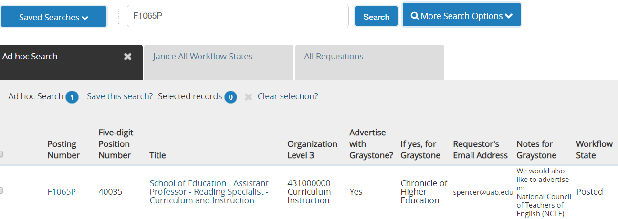

- Each Search Chair/Hiring Manager can view the Saved Search called Search Chair/Hiring Manager
Requisitions View to see all requisitions that you have access to for your unit(s). This includes requisitions that you are still working on in DRAFT.

  - Click REQUISITIONS; then FACULTY
  - Click Saved Searches, and Select (Group) Search Chair/Hiring Manager Requisitions View.
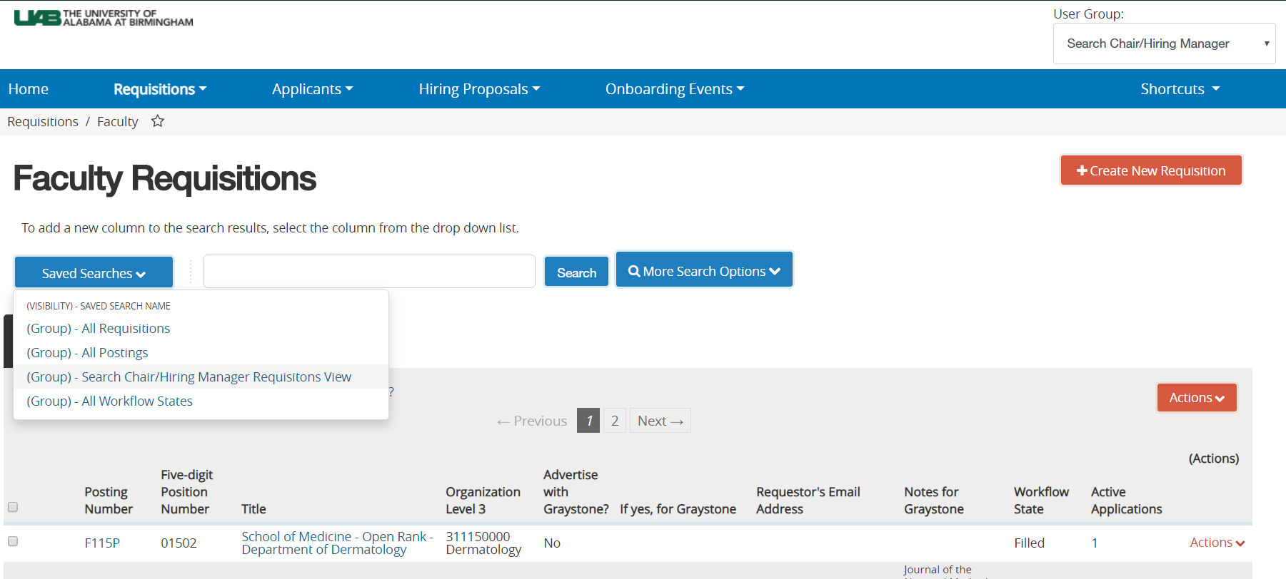

- Saved Search (A personalized view of your requisitions)
Many UAB PeopleAdmin users have created a personalized saved search so that they can view and manage specific details for their requisitions.

Supplemental Resource: Creating Saved Searches

UAB PeopleAdmin SAVED SEARCHES- Your way to customize how you view your Requisitions and Hiring Proposals in the system.

- Click on Requisitions; Faculty. Now, you are on the Requisitions Page;

- Click MORE SEARCH OPTIONS to add columns that you want on your view (i.e. open date, date filled, department).
- Click to select the column you want to add; the page refreshes and adds the column for you.

- In the Workflow State List, remove any workflow states that you do not want to include on your view. You would choose POSTED, Republished, Approved Internal to view only active requisitions for your unit. THEN, CLICK SEARCH;
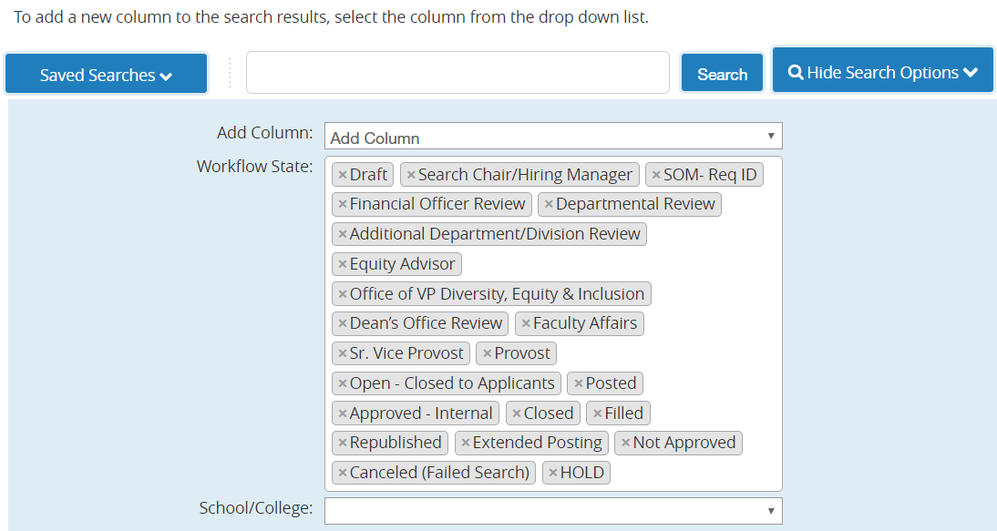
- See Ad Hoc Search underneath; then see SAVE THIS SEARCH? Click here.
- Name your search—ex: JANICE ALL WORKFLOW STATES;
  - Choose PERSONAL SAVED SEARCH.
  - Check “Make Default” if you want this to be default view; meaning each time you go to this screen, you always see your personalized view.
  - Click SAVE THIS SEARCH.

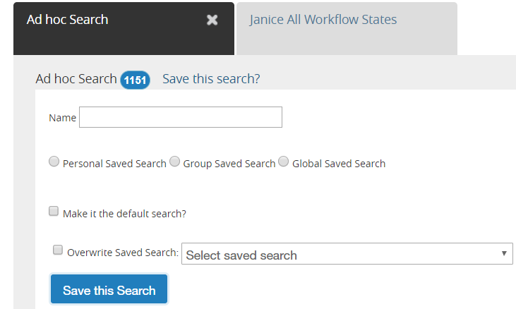

- Saved Searches also serves as a reporting tool. To download your search results; click on the ACTIONS BUTTON to the right of your screen. Choose EXPORT RESULTS to download an Excel Spreadsheet/Report.

