HOW DO I LOCATE MY HIRING PROPOSAL IN UAB PEOPLEADMIN?

UAB PeopleAdmin offers users multiple options to search for and locate your Hiring Proposals.
Option 1: Search from Hiring Proposal Tab – List of All Hiring Proposals
- Login to UAB PeopleAdmin to access your Dashboard. Click on the SSO Authentication Link which takes you to the UAB Single-Sign for UAB PeopleAdmin.

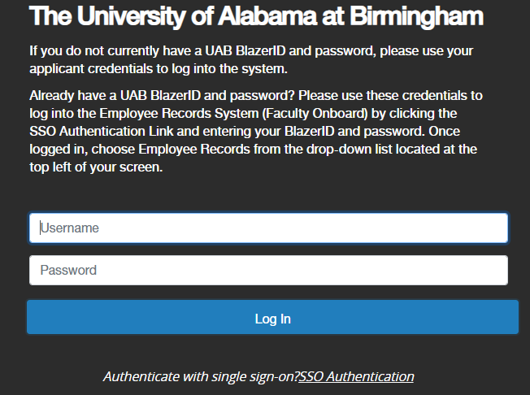

- Now, you’re on your PeopleAdmin dashboard or homepage. Click on HIRING PROPOSALS from the Navigation bar.
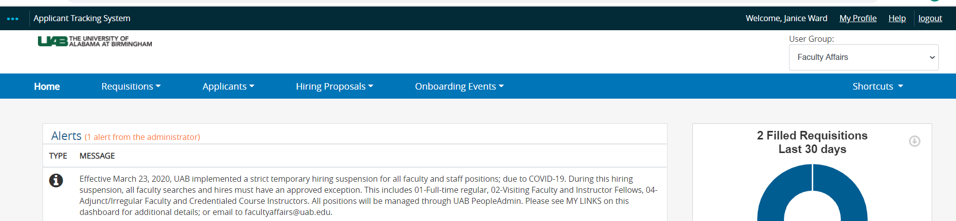
- Click on Faculty from the Dropdown options;
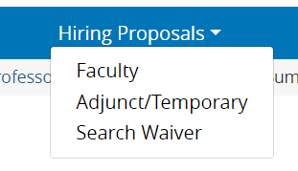
- You will see ALL Hiring Proposals for your unit(s). Note: If you have already set-up a default search (i.e. Active Hiring Proposals), you will only see those Hiring Proposals when you complete this step.
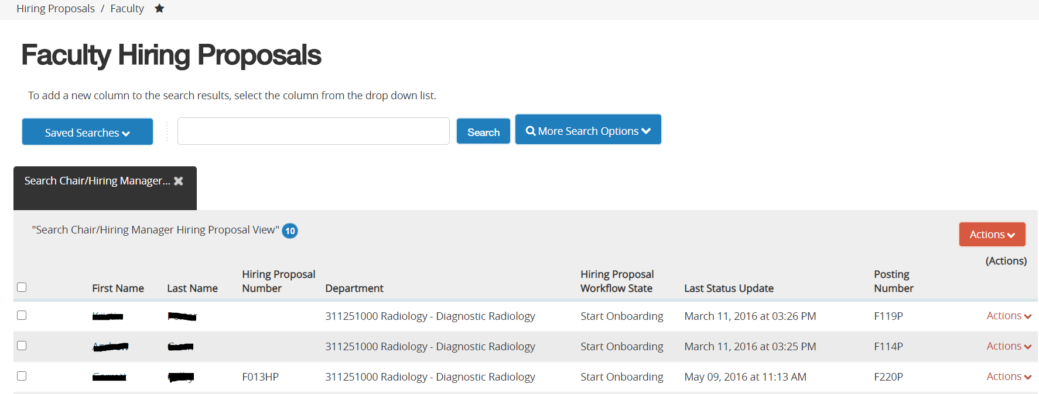

- From your list of Hiring Proposals, locate your Hiring Proposal and, click on the Candidate Name or Hiring Proposal Number to open it.
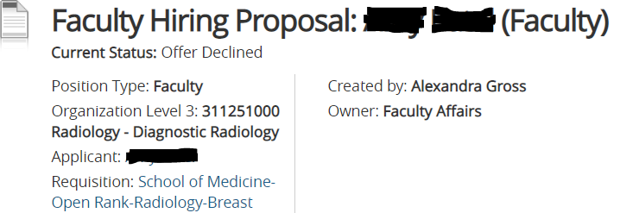
- From the Hiring Proposal Tab, you can also search by Hiring Proposal Number or candidate name. ENTER the Hiring Proposal in the Search Field, CLICK on Search.
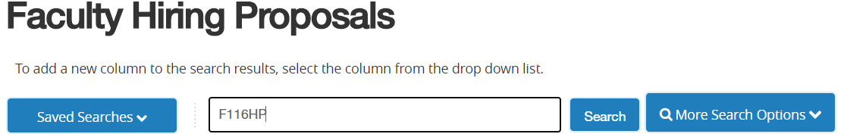
- You will see the Hiring Proposal that you selected.
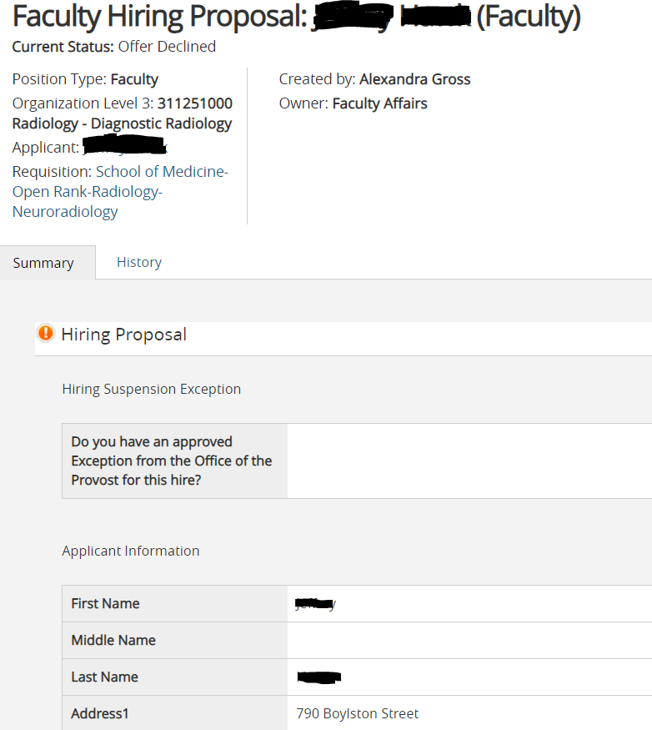
Option 2: From the Hiring Proposal Tab - (By Workflow State)

- From the PeopleAdmin dashboard or homepage, CLICK ON HIRING PROPOSALS from the navigation bar.
  - Click on Faculty from the Dropdown Menu.
- Now you’re on the FACULTY HIRING PROPOSALS page.
  - Click More Search Options to reveal all Hiring Proposal Workflow States.

  - Be sure that all workflow states are visible in the Search Options; so that you can easily locate any Hiring Proposals for your unit(s) and ORGS. This includes Hiring Proposals that are in DRAFT.
  - You can remove any of the Workflow States that you do not wish to include in your search.
  - Click on the (x) next to the Workflow State Name to remove it from the search filter. Then, CLICK Search.
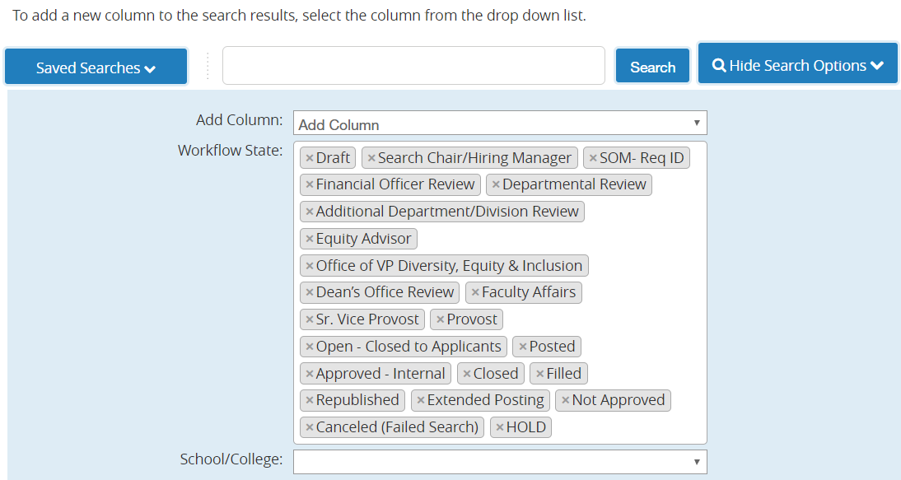
  - To add workflow states to your search filter, click within the workflow state dialog box to see available options. If the workflow state is not already in your list, it will not be highlighted. See below. Click to add this option to the list of workflow state options.

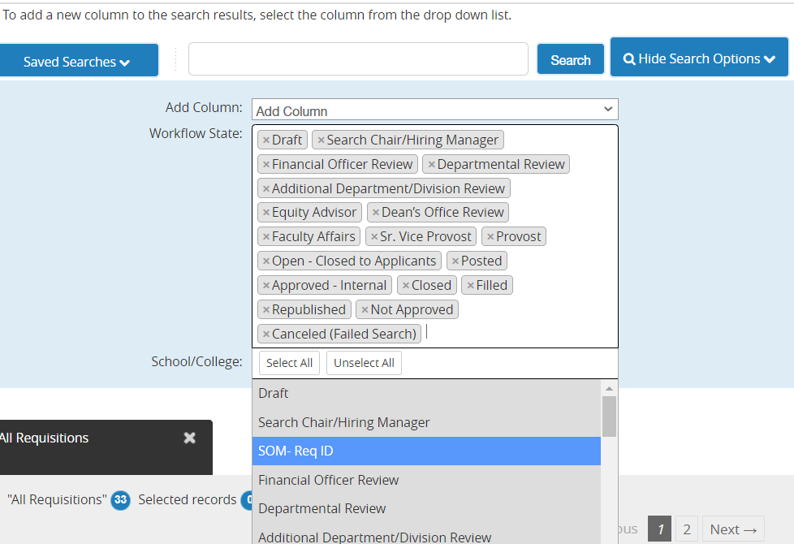
Option 3: Locate Hiring Proposal from our Watch List

- From your PeopleAdmin dashboard or homepage, scroll to the bottom of your screen to see items that you’ve added to your Watch List.

- See your Watch List located at the bottom portion of your dashboard.

- Hiring Proposals that you have pinned or added to your Watch List can easily be located here. You can see the status of each item.

- Click the Job Title (blue link) to open the Hiring Proposal.
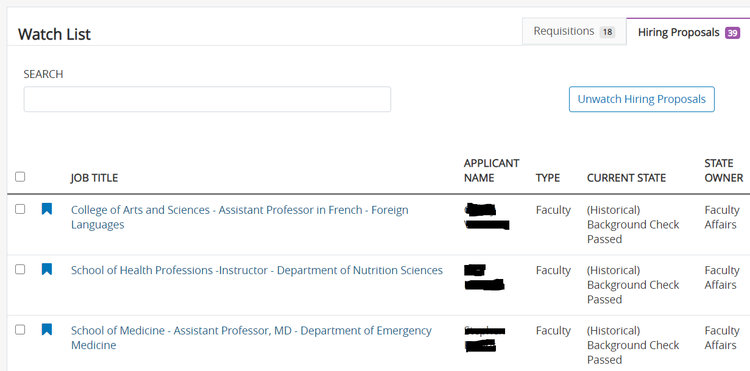

SEARCHING FOR HIRING PROPOSALS USING “SAVED SEARCHES”

UAB PeopleAdmin SAVED SEARCHES function allows you to customize how you view your Requisitions and Hiring Proposals in the system.

To create a Saved Search:

- After logging in, you’re on your PeopleAdmin dashboard or homepage.
- CLICK ON HIRING PROPOSALS from the navigation bar.
- Click on Faculty from the DROP DOWN MENU.
- Now, you’re on the Faculty Hiring Proposals Page. Click MORE SEARCH OPTIONS to add columns that you want on your view (i.e. open date, date filled, department).

- Click to select the column you want to add. The page refreshes and adds the column for you.
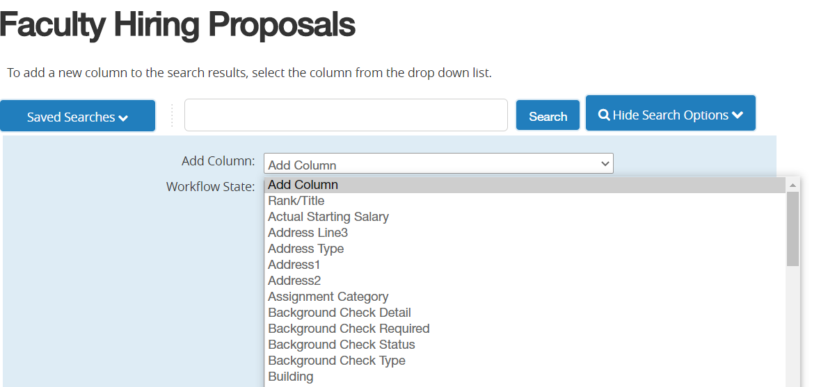
- See Ad Hoc Search. Then, click on SAVE THIS SEARCH.
- Name your search—ex: JANICE ALL WORKFLOW STATES;
  - Choose PERSONAL SAVED SEARCH.
  - Check “Make Default” if you want this to be your default view; meaning each time you go to this screen, you always see your personalized view.
  - Click SAVE THIS SEARCH.

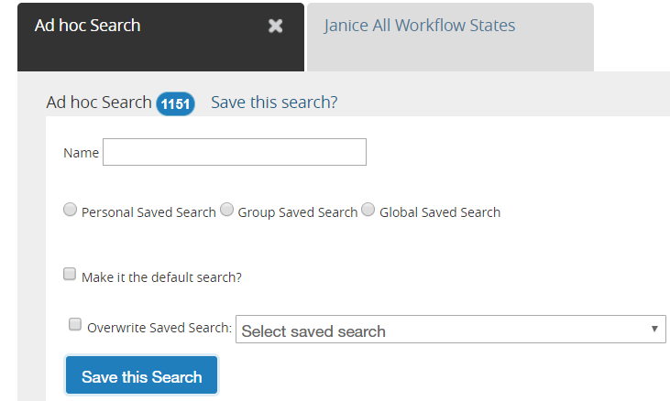

- Saved Searches also serves as a reporting tool. To download your search results; click on the ACTIONS BUTTON to the right of your screen. Choose EXPORT RESULTS to download an Excel Spreadsheet/Report.

