INSITE – VIEW FM

COMMON FUNCTIONS – TABLE OF CONTENTS

- STANDARD QUERY
- MULTIPLE DRAWING QUERY
- AREA CALC MODE
- DIMENSIONS
- SPECIFIC DIMENSION
- TEXT
- SPACE LABEL FORMAT
- DELETE
- REDLINING
- ROOM NUMBERING PROCESS
- ADDING NEW BUILDING OR RENOVATION TO INSITE

STANDARD QUERY:
A standard query can be used to highlight a specific room, organization, or use.

- Click on the icon that looks like a magic wand and (3) bars.
- The STANDARD QUERY box will appear.

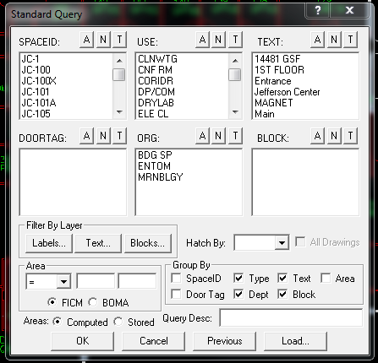

- As an example, let’s say you want to know all of the offices that are listed under Marine Biology. Under the ORG box. Click on MRNBLGY and click OK.
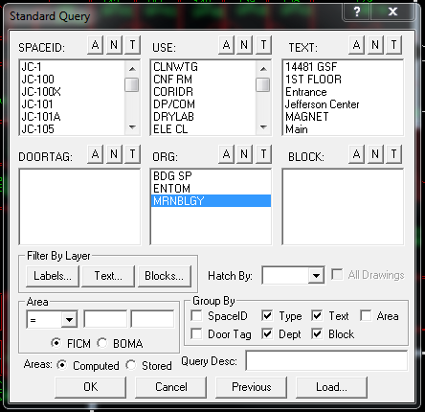
- All of the offices occupied by Marine Biology will be highlighted. A legend will appear in the top left corner indicating the number of spaces included in this org, as well as, the overall square footage.
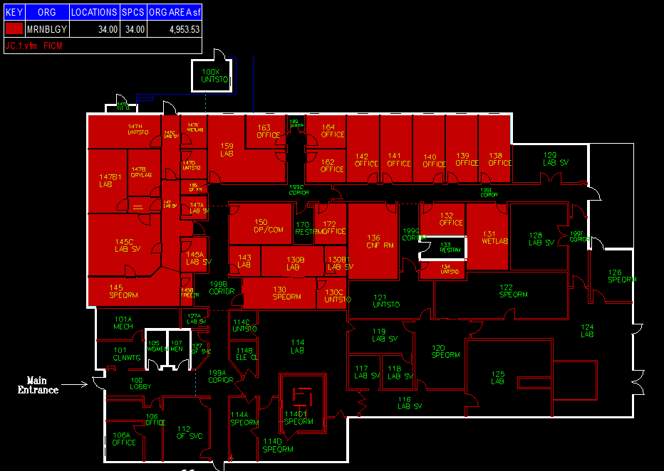
MULTIPLE DRAWING QUERY
- If you want to query multiple floor plans for a specific org or use
- Go to the buildings folder and select the facility you would like to query.
- Open all floorplans for that building
- Select Query
- Select box for All Drawings
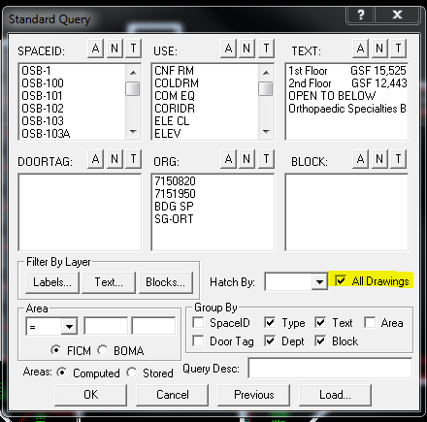

- Select the items you would like to query and click OK
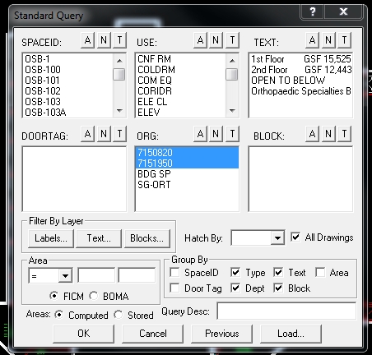
- Visual FM LT will create a new document showing the totals of all of the floors combined.
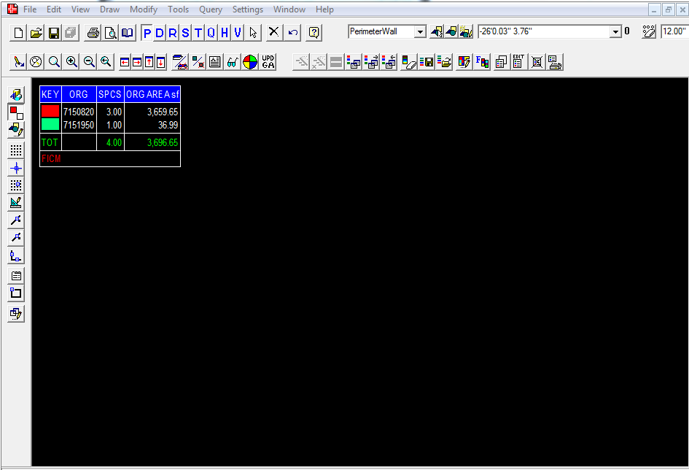
- Minimize, print or save the newly created document.
- Navigate back through the floorplans and it will highlight the query on each floor.
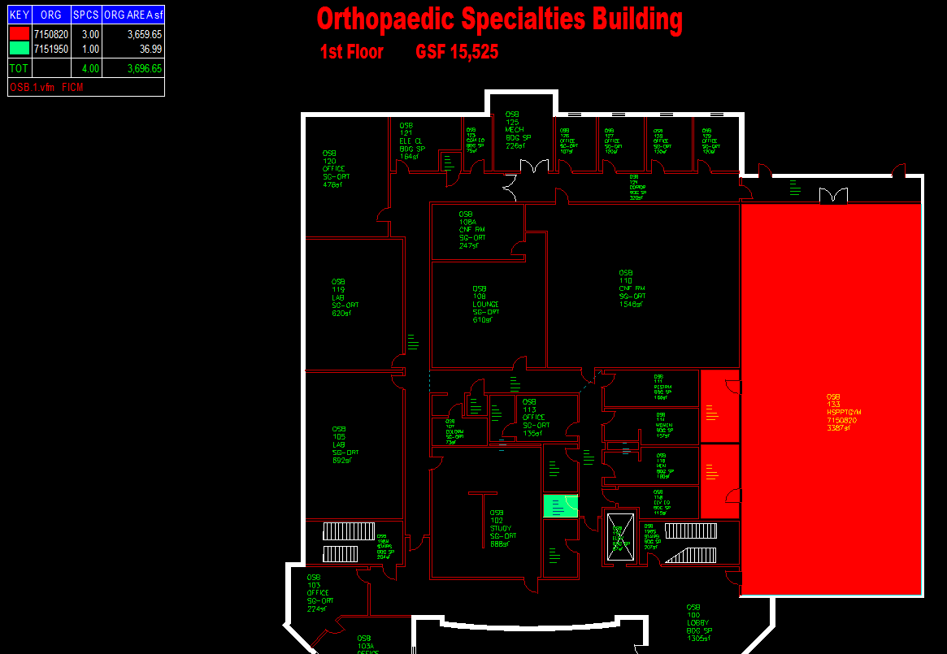
- Helpful Hint: Clear the Query
  - To clear the query or start over with a new query click the button that has a large eraser and color bar.

AREA CALC MODE
- In order to create a legend that coincides with the Area Calc Mode you will need to change your preferences.
- Click the button that looks like a pencil with (2) windows
- The APPLICATION PREFERENCES box will appear.
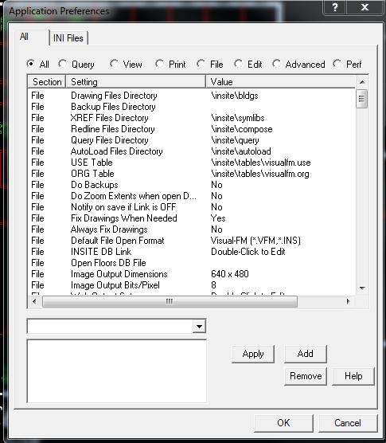

- Click the dot next to QUERY
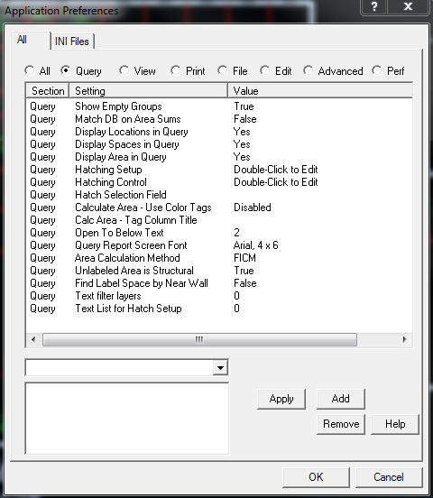
- Click the line that reads “CALCULATE AREA- USE COLOR TAGS.
- In the drop down menu, select PROMPT FOR TEXT.
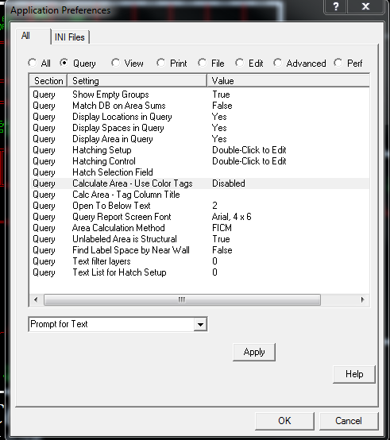
- Click “APPLY”
- Select the button that looks like a multi-colored floorplan
- Left click in a room to start the AREA CALC MODE. A text box will appear at the top of your screen prompting you to enter a label. As an example, type RESEARCH
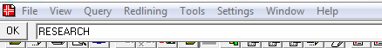

- Click “OK”
- You will see that space highlighted in red. A legend will also appear in the top left of the screen.
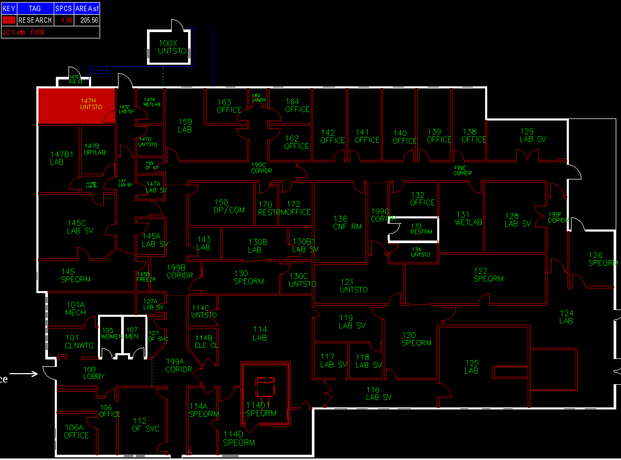
- Continue to left click any room that may fall under research.

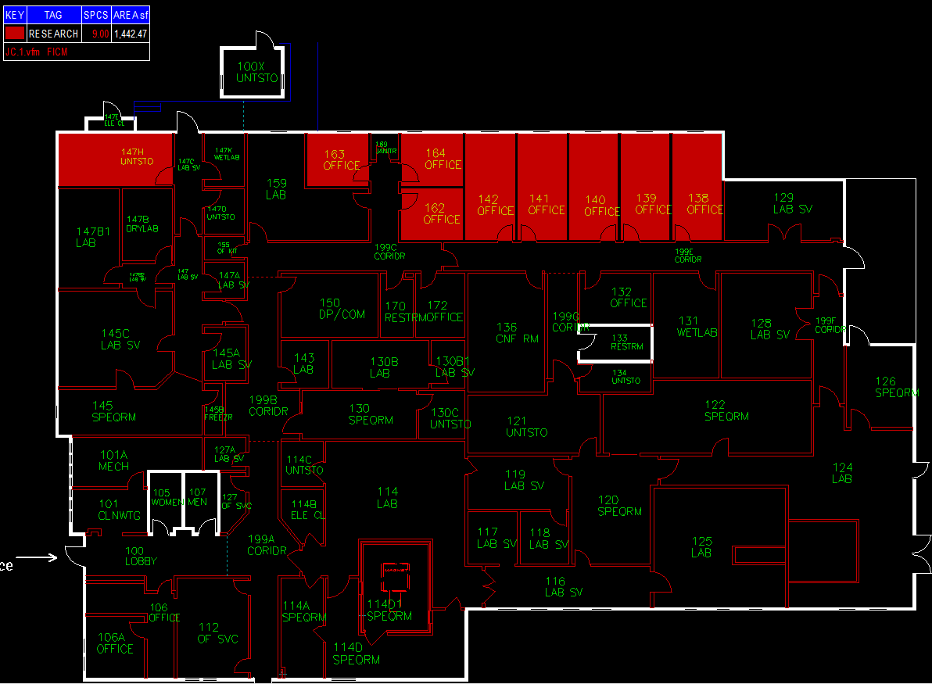
- When you have selected all necessary spaces, right click on your mouse. The text box will reappear at the top of your screen, prompting you to type the next label. As an example, type LABS
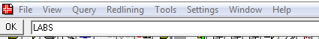
- A different color KEY will appear on the legend for the LABS TAG.
- Left click in the necessary rooms. These rooms will be highlighted in green.
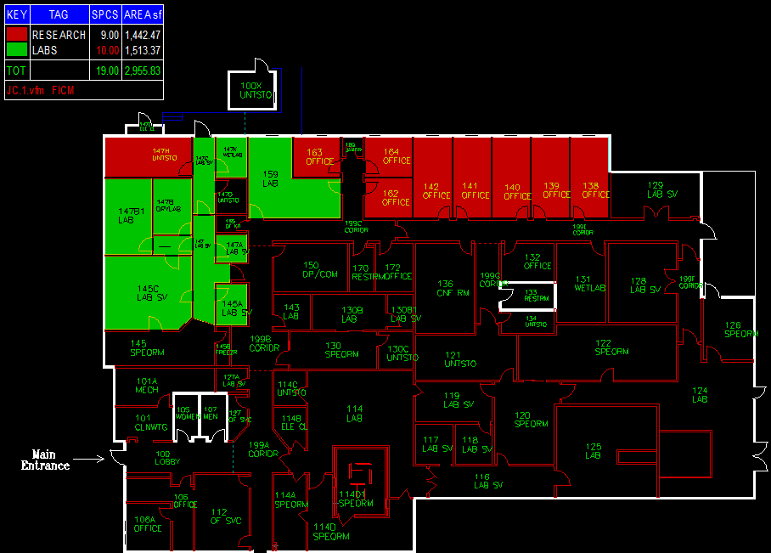
- Continue these steps as needed.

DIMENSIONS:
- To add a dimension, select Dimension in the drop down menu.
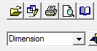
- Make sure the “P” function is active.
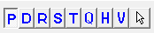
- Hover your cursor over the starting point for the dimensions and left click on your mouse. A circle will appear.
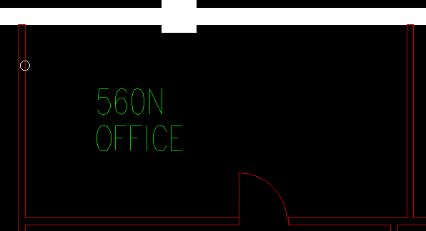
- Hover over the end point for the dimension and press the number “5” on your keyboard. Another circle will appear parallel to the first circle, creating a straight line for your dimension.
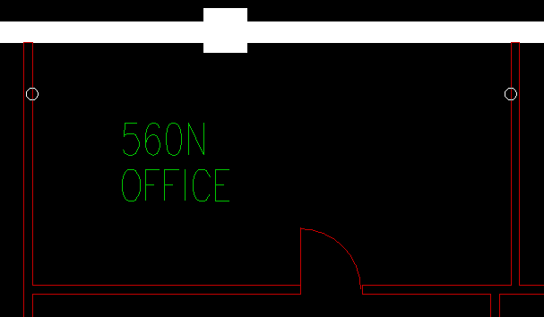
- Press the letter “A” on your keyboard. This will add your dimension to the floorplan.
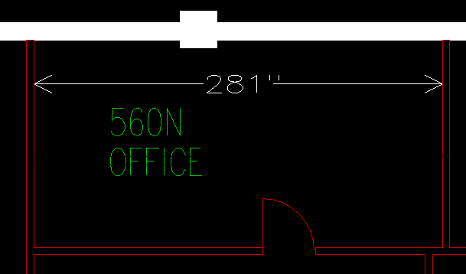

- Helpful Hint: Feet and Inches
  - Typically, dimensions will appear in inches only. If you would like to see the dimension in feet and inches, please do the following:
    - On the Main Menu bar – Go to SETTINGS and then click UNITS
    - The Application Preferences box will appear
    - Select LINEAR in the MEASURMENT TYPE drop down menu
    - PRIMARY UNITS should be feet with a ‘ marker
    - SECONDARY UNITS should be inches with a “ marker. Check the USE box.
    - Click OK
    - Your settings should look like this:
    - 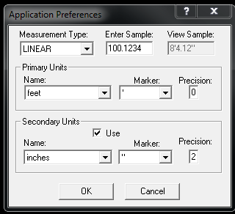

- Helpful Hint: Deleting Circles
  - If you have clicked on the wrong spot to start your dimension (or added too many circles), clear them by clicking on the button that looks like an eraser surrounded by circles. Click as many times as needed to clear the circles.

SPECIFIC DIMENSION:
To add a dimension with a specific length, 5’-0” for example, follow these steps:
- Select the starting point for your dimension by hovering on a specific location. Left click on your mouse. A circle will appear.
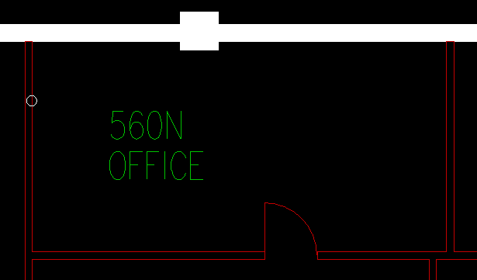
- Move your cursor in the direction of where the dimension needs to be (right, left, up or down).
- Press the number “5” on your keyboard. A second circle will appear parallel from the starting point of the dimension.
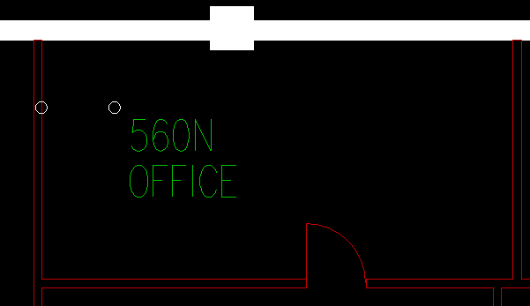
- Press the number “1” on your keyboard. A command bar will appear at the top of your screen prompting you to enter the actual distance or angle.
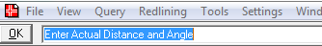

- Type 5’0” and press “ENTER” on your keyboard. The second circle will move to be 5’-0” from the first circle.
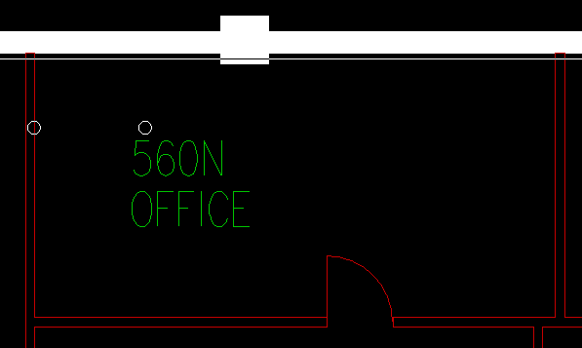
- Press the letter “A” on your keyboard. This will add the dimension to the floorplan.
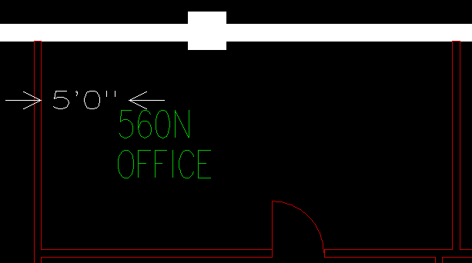

TEXT:
To add text to the floorplan, follow these steps:
- Select “TEXT” in the drop down menu.
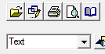

- Make sure the “P” function is active.
- Enter the desired height of the text the in the menu bar. 1’-0” is, typically, a good size.
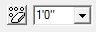
- Left click where you would like to add your text. A circle will appear.
- 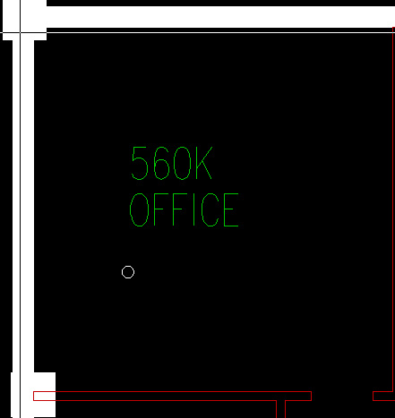
- Press “A” on your keyboard. An “ADD TEXT” box will appear. Type your text in the “TEXT:” box and click OK.
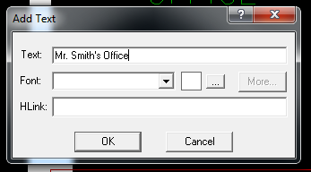

- The text will appear on your floorplan.
- 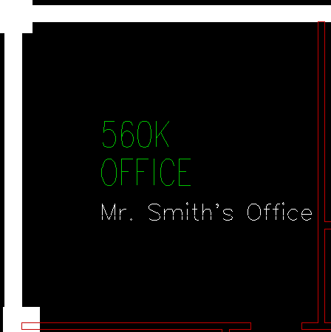

- Helpful Hint: Moving the Text
  - Make the “D” icon active.
  - Hover the cursor over the text and left click. This will “grab” the text.
  - Move the text to the desired location and left click. This will “drop” the text.

SPACE LABEL FORMAT:
To view or hide facility name, room number, room use or org follow these steps:
- Click the View menu and select Set Lbl Fmt
- The Application Preference window will open.
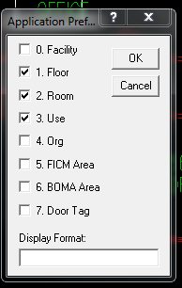

- Check any of the information that you choose to see on the space label for each room.
  - Please note: We do not use BOMA or Door Tag information
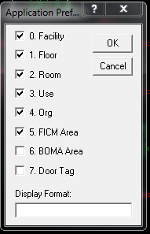
- Click OK
- The space label will change to show selected items.

DELETE
- To delete a line, text, or etc., hover your mouse over the item you wish to delete.
- Press the letter “D” on your keyboard.
- To undo the deletion, press the letter “O” on your keyboard.

REDLINING
Since you cannot make changes to the drawings, redlining allows you to add notes, dimensions, blocks and more to the drawings. You can then save the redline and import it back to the drawings as needed.
Please note: you cannot save these redline drawings to the buildings folder, you will need to create a folder in a separate directory.
- Add any dimensions, blocks, text or etc to a drawing.
- Click the Redlining menu and Save As to your directory.
  - You will notice that the file name will end with a .red indicating that it is a redline drawing.
- Close out of the drawing.
- Reopen from the shared buildings folder.
- Click the Redlining menu
- Select Insert All.
- Navigate to the location of the saved redline drawing
- Select the redline drawing and click OPEN.
- Your previous notes will be inserted into the drawing.

ROOM NUMBERING PROCESS
- Once the architect’s drawing for a new building or renovation is near 100% complete, please send me (2) to scale drawings.
  - For smaller renovations an e-mailed PDF is acceptable.
- I will add room numbers to the drawing and send them back to you.
- Please have the architect update their drawings to include the UAB room numbers.
  - Cubicles also receive room numbers. I understand that furniture drawings are not always a part of the architect’s plans, but please send (2) copies of the furniture plans when they are available for numbering.
- Once they have updated the drawings, please send (2) to scale copies back to me to be stamped for final approval.
- I will send a copy of the stamped drawings back to you.
- Norm Carr will use the stamped drawing to create room signage.

ADDING NEW BUILDINGS OR RENOVATIONS TO INSITE

- Once the CAD plans for a new building or large renovation are finalized, please send me the AUTOCAD file so I can add the drawings to Insite.
  - For small renovations, a PDF is fine. I can go to the site and field measure when the construction is near completion.
- Room uses and org assignments will also be required to complete the drawings.
- If modular furniture is to be added, please send the drawings as soon as possible.
- Once construction is completed, I will walk through the space to make sure the floorplan and room numbers are accurate. It is best for me to complete the walk through before the end users move into the space.
- After everything is verified, I will upload the drawings to the shared buildings folder and the database.

