Socrative Overview
Socrative helps teachers engage & assess the class with educational activities on laptops, smartphones and tablets. In the background, we track student performance and provide real-time data to help teachers, parents, schools and districts personalize and improve learning.

Socrative works from any device
You and your students have many options for accessing Socrative. Access it via the website using a computer or any web-enabled mobile device. For the mobile devices, you can either just access the website, or you can download the free iOS or Android app.

Try it out for yourself – It’s super simple
To experience it yourself, on your ‘teacher’ device, go to http://t.socrative.com. On your ‘student’ device, go to http://m.socrative.com. Yes, it’s just that easy. In class, you go to the ‘t’ website and send your students to the ‘m’ website. If you or your students have the app, just run the app.gu

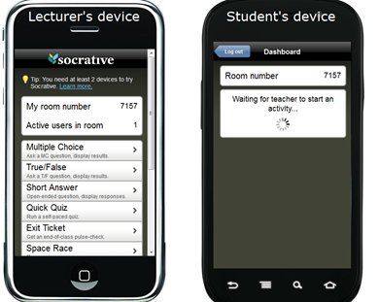
Connecting student devices to the teacher’s device
On the lecturer’s device, you see “my room number”. When students run the app or visit http://m.socrative.com, they’ll be asked to enter a room number. They just enter the number you have on your device.

You can change that number if you’d like. Just select “Change room number”. The number doesn’t have to be a number. It can be text, say, your name or the name of your course. Whatever you choose will be remembered both on your device and your students’ devices. The student’s device will show “Waiting for teacher to start an activity” until you, well, start an activity.

Multiple Choice and True or False Questions
Pose a multiple choice question orally, place it in your presentation slides or write it on the board. Simply tap “Multiple Choice”, and the students will be given A through E options. Your Teacher Screen will then show the student selections in columns. Now you can discuss whole class results instantly! A great extension is to let students ask the questions. Follow the Same process for the True or False!
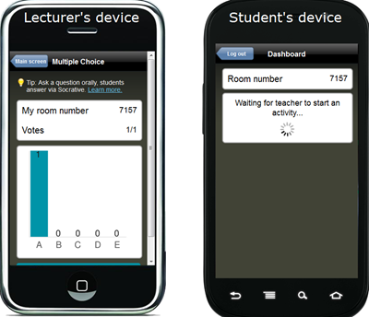
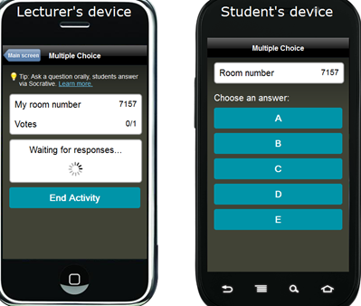

Short Answer Questions
Pose a short answer question to your students. On your device, tap “Short Answer”. That generates a response box on the student’s device.
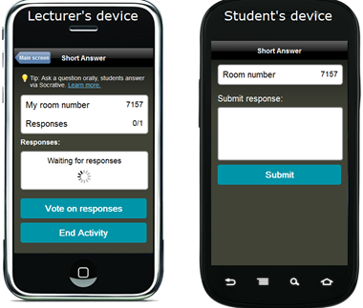
Here the student entered “I have no idea what the answer is.”
That appears on your device, and the student’s device goes back into waiting mode.

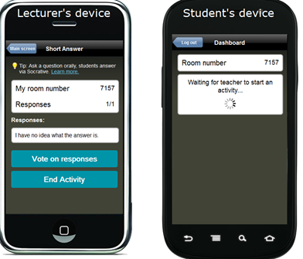

Now, if you’d like, you can have students vote on the responses by tapping “Vote on responses.” Each student device will have the short answer responses as buttons. Your device will show tally of the student votes.

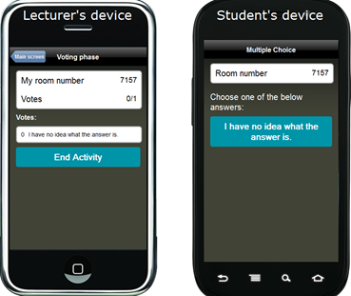

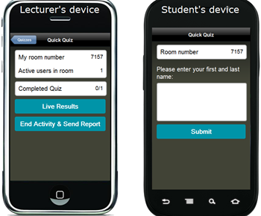
Quiz (Self-Paced)
In a quiz, you give students a set of pre-planned questions. After a student submits one question, they move onto the next one, and the next until they’re finished. It’s student paced. The first question will automatically be their name.
Here you can see that there is one active user in the room. We know that because that’s how many devices have entered the Socrative room number. At this point, no one has completed the quiz.

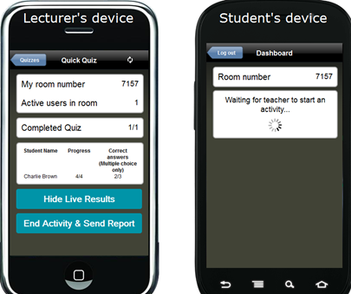
The student has answered all 4 questions in the quiz. On the lecturer’s device, click “Live Results” to see who has responded and how they scored. Once everyone has completed the quiz, click “End Activity & Send Report.” An Excel spreadsheet, with all of the data from the quiz, is available for download or you can choose to have it emailed to you. Multiple Choice questions will be graded for you and a total score will be provided for each student. The quizzes will also be available in the Manage Quizzes section of your teacher dashboard.
Excel Data Report. The green-filled boxes are correct answers; the red-filled are incorrect.
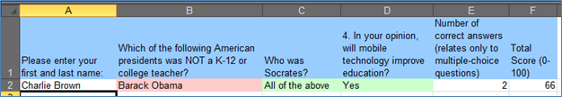
Quiz (Teacher-Paced)
A teacher paced quiz lets you control the pace of the questions. Students will all answer the same question at the same time, and your device will aggregate the student responses in real time. You have the option to hide and unhide the live results. If it is a short answer question, your screen will show each line of student entered text. If the question is a multiple choice, you will see a tally of the students’ responses visualized in a chart of columns (below). To move to the next question, you select “Send Next Question To Students”. At the end of this activity you will also receive a detailed data report of student answers.
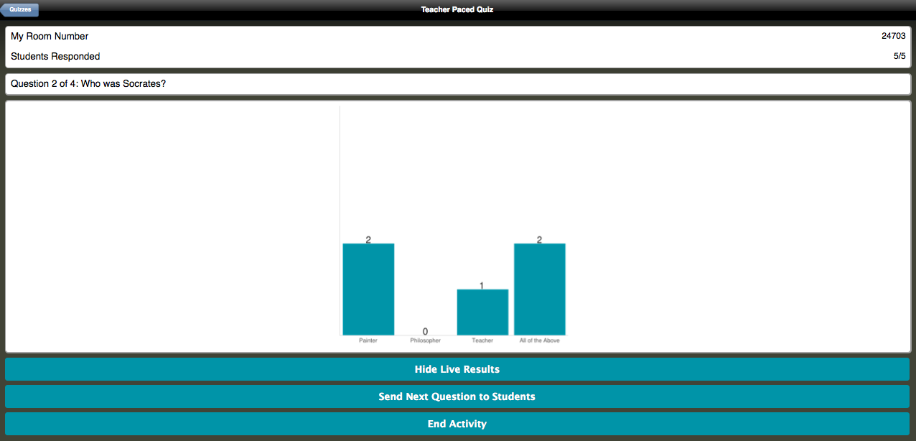
Space Race
Students compete in small groups (maximum: 10) to answer your pre-loaded multiple-choice questions. The team that gets the farthest right in the allotted amount of time wins. When you’ve decided time is up, click the “end activity & send report” button at the bottom of your screen (not shown). You’ll be emailed an Excel spreadsheet with the results.
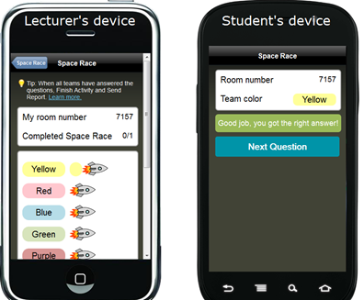

Creating Quizzes
Quizzes are made up of Multiple Choice questions, Short Answer Question or a combination of the two. You can design your own quizzes in two ways. For both methods you access the Manage Quizzes tab. You run your self-made quizzes by selecting Start Quiz on your main screen.
CREATE A QUIZ – This simple method allows you to do all the work within Socrative and activate the quiz shortly after creation. Select Manage Quizzes > Then select Create Quiz
- Start by choosing a name for your quiz.
- Then simply click on Short answer or Multiple choice, fill in the question, and then simply select the next question type and so on and so on.
- Once you are finished press SAVE. All done!
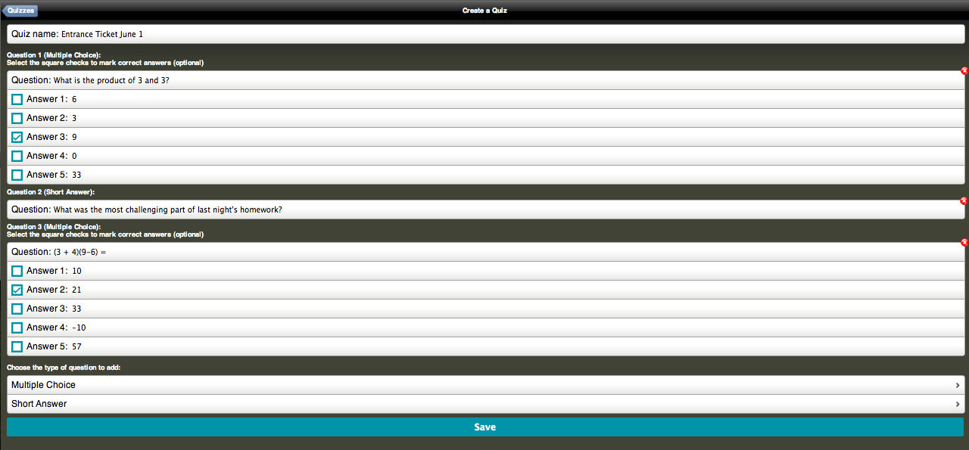
IMPORT QUIZ - The second method involves completing an Excel template which you can download after you select Import Quiz. Select Manage Quizzes > Then select Import Quiz
- Complete the Excel template and Save it in your computer
- Select Import Quiz > Import Quiz From Excel then Browse and choose your Saved quiz.
- Press Import and once it’s completed you’ll find it in your Quiz Drop Down box.
- NOTE: You can always edit the quiz within Socrative once its imported.
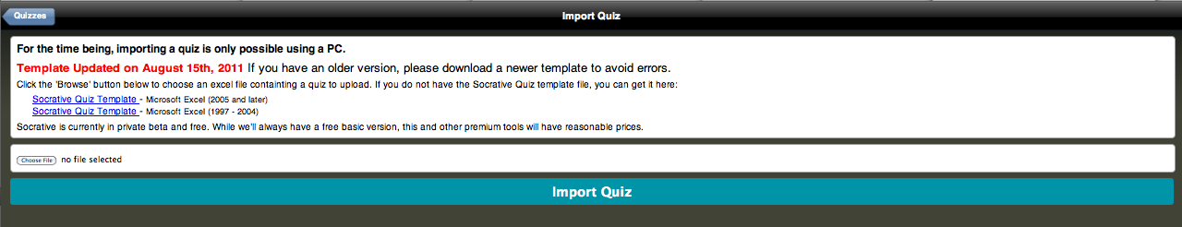

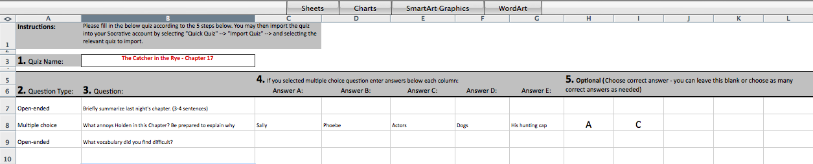

Sharing Quizzes
When you are creating quizzes, there is a box, pre-checked, that enables you to share a quiz.
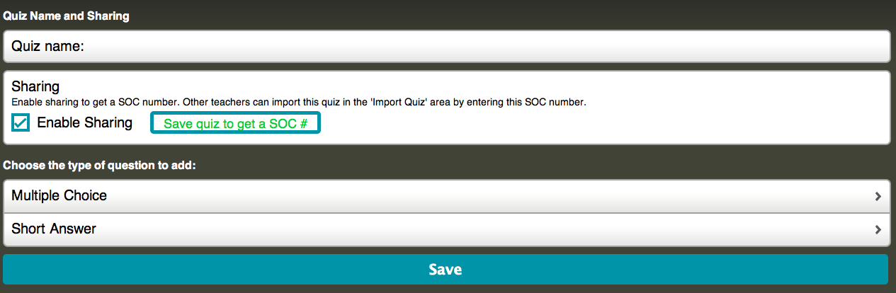
After you save your new quiz, you will be provided with a code (SOC-XXXX).
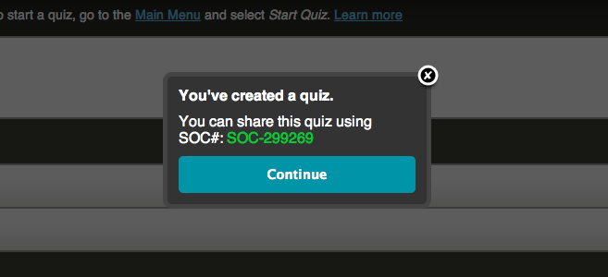
Import a Shared Quiz – This functionality allows you to add a community member’s quiz to your library in a few easy steps.
- Identify the SOC # of your colleagues quiz. (e.g. SOC-299269)
- Select Manage Quizzes
- Select Import Quiz
- Choose Import Shared Quiz
- Enter the SOC-XXXX
- Select Import Quiz and you’re done.
