Contents

Windows 7 Opening Kronos for the first time for Time Editors 2

Windows 7 Opening Kronos for the first time for Time Stampers (HTML Link) 2

Windows XP Opening Kronos for the first time for Time Editors and Stampers 3

Errors 5

Error: ‘You do not have permission to access the requested resource’ sometimes in Windows 7: 5

Error: Broken Link 9

Error: No link on Desktop for XP Users 9

Error: Latency 9

**\*NOTE* Users will call about latency. If/when they do please follow the steps outlined under ‘Errors’ entitled ‘Latency’ to fix this problem.**

# Windows 7 Opening Kronos for the first time for Time Editors

Click the link on the desktop:

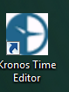

Kronos takes a while to open initially. Please wait about 60-90 seconds.

You may see a Java message such as the one bellow. Click the check box for ‘Do not as again until the next update is available.’ And click ‘Later’.

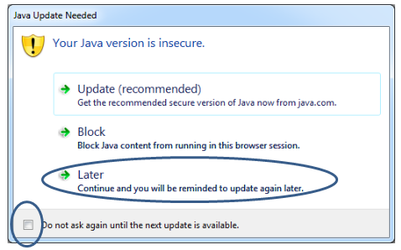

Typically, this will work. If you have an issue at this point, please read the ‘Errors’ portion of this document.

# Windows 7 Opening Kronos for the first time for Time Stampers (HTML Link)

To open the Kronos HTML link for Kronos Time Stampers, go to their ‘Favorites’ by selecting the ‘Star’ in the upper right hand corner:

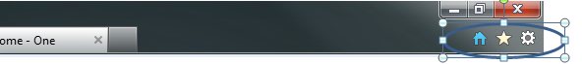

Select ‘UAB Medicine’ folder 🡪 ‘Directories & Resources’ folder 🡪 Select the link ‘Kronos Time Stamp-HTML’:

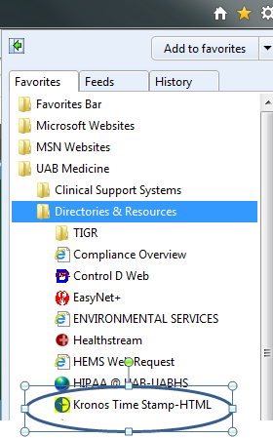

# Windows XP Opening Kronos for the first time for Time Editors and Stampers

For XP Users (editors and Time Stampers) should have the icon on their desktop. If the Icon is not on their deskop, refer to the ‘Errors’ portion of this document.

For Editors:  


For Time Stampers:



For the time stampers, Kronos should open as usual.

For the editors, follow the additional steps:

Once you click on ‘Kronos Time Editor’ many things will run and windows will open. Allow these windows to stay open and eventually Kronos will open. This is a onetime occurrence to install Java. Go ahead and logon:

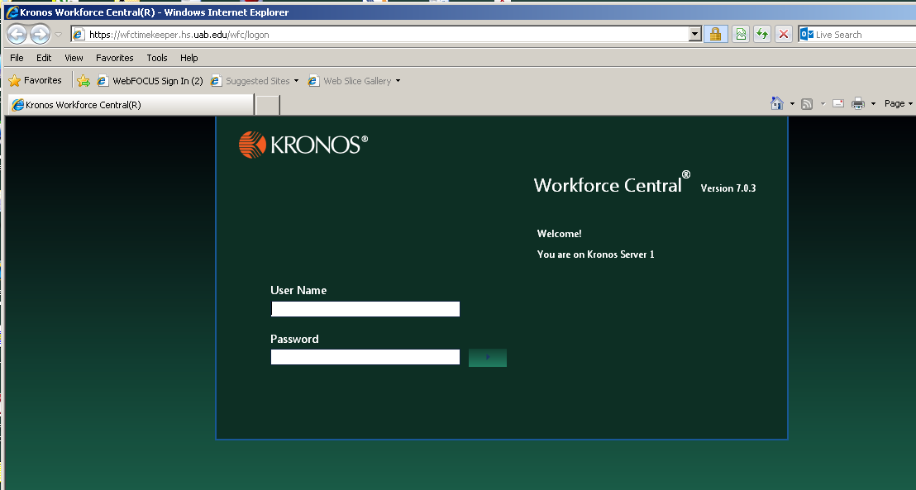

Once you log on, there MAY be a prompt. **DO NOT CLICK UPDATE, click the check box ‘Do not ask again until next update is available’ and then click LATER** :

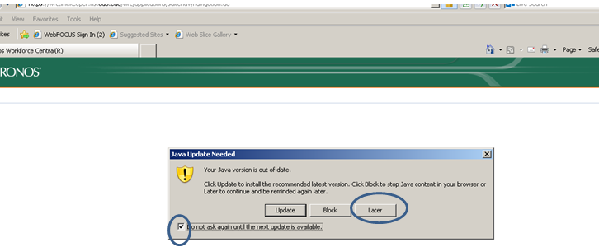

NOW Kronos will take a while to open, BE PATIENT this is a ONE time thing.

# Errors

## Error: ‘You do not have permission to access the requested resource’ sometimes in Windows 7:

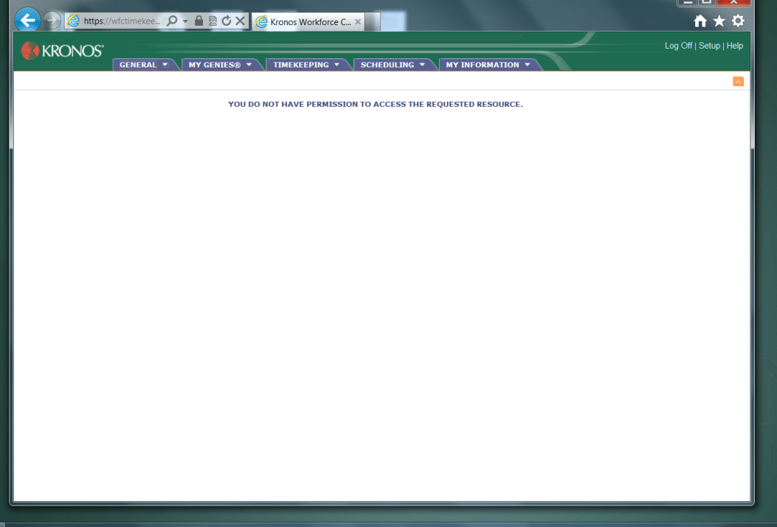

If this happens, please do the following:

Go to ‘Control Panel’ and ‘Programs and features’. Make sure Java 7 update 51 is installed. The problem may stem from having multiple versions of Java installed, such as Java 6 update 17:  
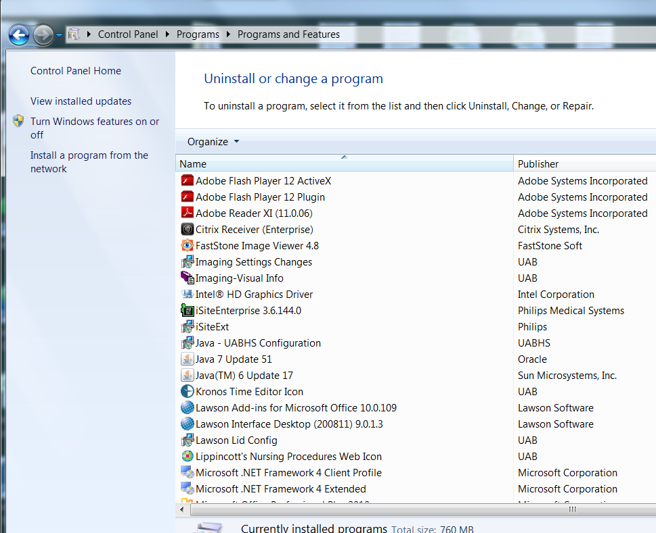

If this is the case, go to the browser and select ‘Tools’ (FYI, you may have to press ‘ALT’ for the ‘Tools’ selection to appear. Now click ‘Manager Addons’:  
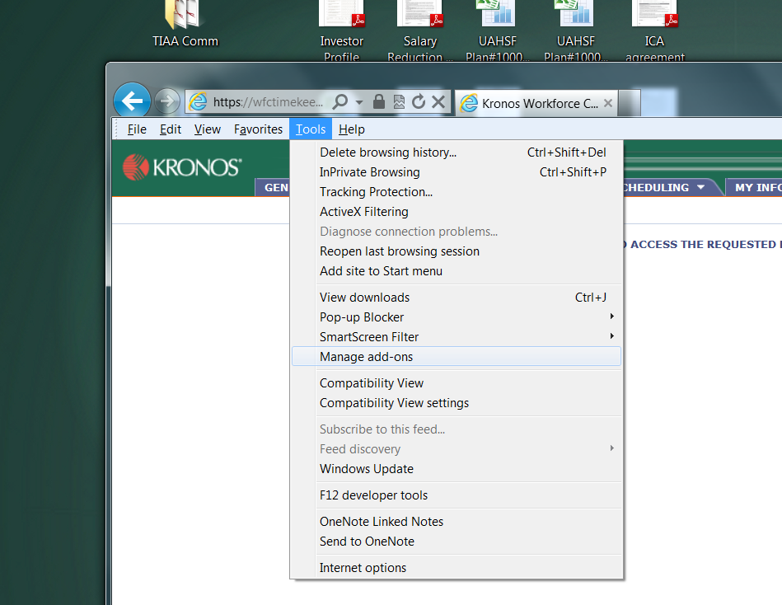

In the ‘Show’ drop down box, select ‘All add-ons’:

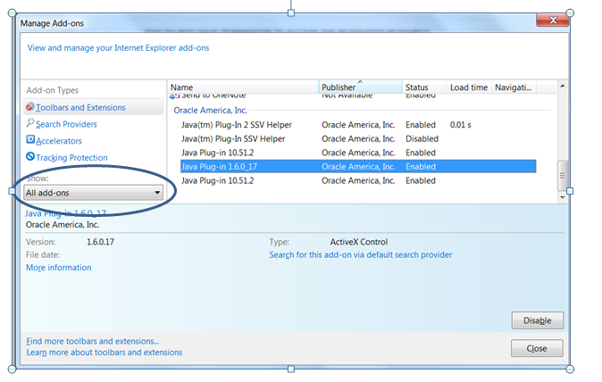

If Java Plug-in 1.6.0_17 (or any other version of Java), you must disable it by clicking on the Plug-in and clicking ‘Disable’:

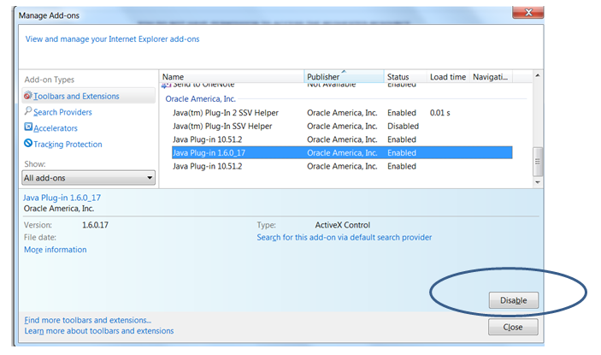

Once you do that, the plug-in should show as disabled.

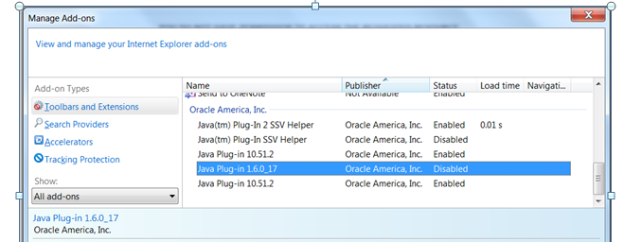

Once you do that, restart your browser and reopen Kronos.

## Error: Broken Link

If a user previously placed a link on their desktop on their own, then the link may not work. Check the link for the correct address.

For **Editors** it should be: <https://wfctimekeeper.hs.uab.edu/wfc/logon/>

For **Time Stampers** it should be: <https://wfctimekeeper.hs.uab.edu/wfc/applications/wtk/html/ess/logon.jsp>

## Error: No link on Desktop for XP Users

If an XP user does not have the Kronos links on their desktop, then there is a possibility that their Novell username/password is not synced with their AD username and password. Check to see if they have any other ‘pushed’ icons.

If their accounts are not synced, the Kronos icon push will not occur. You will have to sync the accounts for the icons to push. After this, follow the ‘Windows XP Opening Kronos’ Instructions.

## Error: Latency

When a user calls about latency, you will have to change a setting in java. Note that in control panel, I have ‘View by: Small icons’ selected.

Go to Start 🡪 Control Panel 🡪 and select ‘Java’

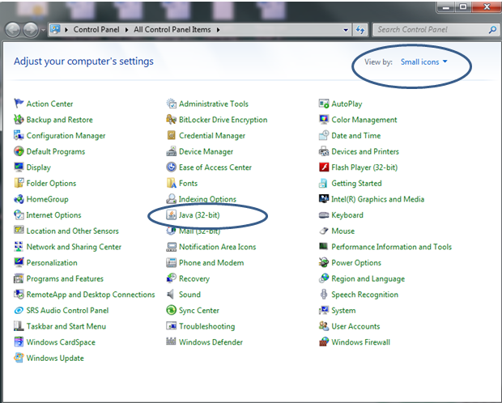

Go to the ‘Advanced’ tab and scroll down to ‘Check for certificate revocation using’ and click the ‘Certificate Revocation Lists (CRLs)’ radio button then click ‘OK’:  
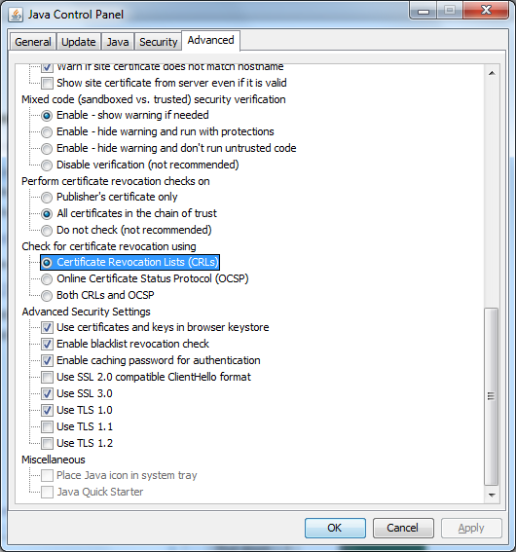

Restart the browser and Kronos should be much faster.