

**Visiting Student**

**Rotation Application**

The UAB Heersink School of Medicine and the UAB Hospital Graduate Medical Education Office, in collaboration with the UAB Office of Diversity and Inclusion, are providing support for fourth-year medical students to participate in a variety of four-week rotations at our academic medical center.

## Eligibility

■ Fourth-year medical student in good standing at an accredited U.S. allopathic or osteopathic medical school

■ Students must self-identify as under-represented in medicine (URiM)*

■ Students must have completed all core clerkships

■ Students must have successfully passed USMLE Step 1

## Scholars Receive

■ $2,000 stipend toward travel, food and housing

■ Networking opportunities with faculty, residents and students interested in your success

## How to Apply

Please send the following to Hannah Martin, UAB Heersink School of Medicine, Pediatric Clerkship Coordinator, [hmmartin@uabmc.edu](mailto:hmmartin@uabmc.edu)

■ Personal statement (500 words max)

■ CV

■ Application form (below)

■ Standard application through VSAS required

■ Letter of recommendation from faculty member at applicant’s medical school

**Applications must be received by May 29th, 2022.**

**Participation in a visiting student rotation does not guarantee an invitation for a residency program interview. Invitations to interview are provided at the discretion of the residency program.**

## Questions

Please contact the GME office at [diversitygme@uabmc.edu](mailto:diversitygme@uabmc.edu) or Hannah Martin at [hmmartin@uabmc.edu](mailto:hmmartin@uabmc.edu). Scan the QR codes below to learn more about the program and the Office of Diversity and Inclusion

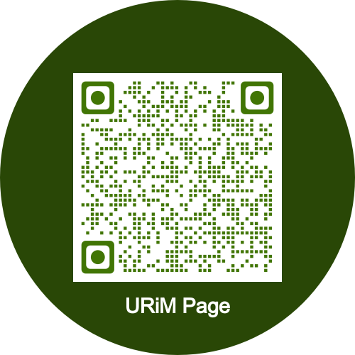 

**Visiting Student Rotation Application**



Name:

Street address:

Zip:

Medical School:

Matriculation Date:

Expected Graduation Date:

Email:

Race/Ethnicity*: ☐ African-American

☐ Hispanic ☐ Native American ☐ Pacific Islander ☐ Alaska Native ☐ Other:

*\*Check all that apply*

USMLE Step 1 Score:

USMLE Step 2 CK Score (If applicable):

I am applying to an away rotation for the following department or program (Please circle one):

■ Anesthesiology

■ Diagnostic Radiology & Interventional Radiology

■ Emergency Medicine

■ General Surgery

■ Neurology

■ Neurosurgery

■ Obstetrics & Gynecology

■ Otolaryngology

■ Pediatrics

■ Physical Medicine & Rehabilitation

■ Psychiatry