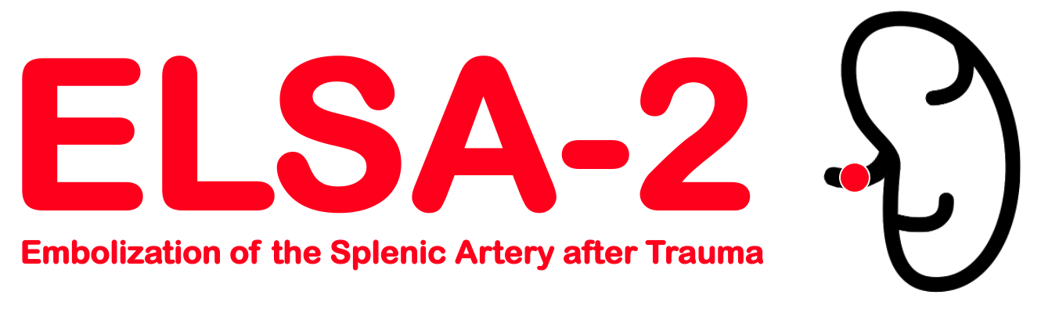

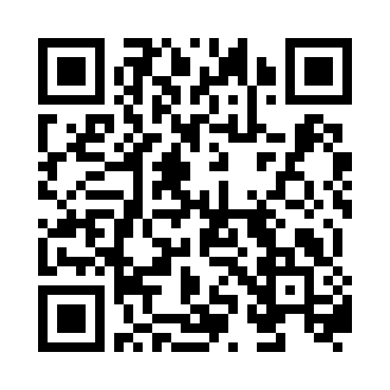

Scan with camera for direct link to REDCap database or use link:

[**https://redcap.dom.uab.edu/redcap_v12.2.10/index.php?pid=985**](https://redcap.dom.uab.edu/redcap_v12.2.10/index.php?pid=985)

**ONLY PI or Sub-I consent subjects**

* Clean ready to use consents are located inside cabinet.
* Please put signed consents in pink binder and write subject info in log.
* Put a post it note on screen fail consents to inform coordinator.
* [ELSA2@uabmc.edu](mailto:ELSA2@uabmc.edu) or 205-996-1082.

|  |  |  |
| --- | --- | --- |
| **Principal Investigators** | **Sub-Investigators** | **Coordinators** |
| Andrew Gunn, MD | UAB Site PI- |  |
| Jan Jansen, MD |  |  |
|  |  |  |
|  |
|  |
|  |
|  |