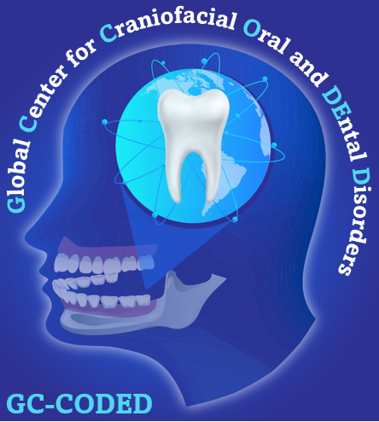
REQUEST FOR PILOT & FEASIBILITY PROJECT APPLICATIONS
The UAB Global Center for Craniofacial Oral and Dental Disorders (GC‐CODED) is pleased to announce the availability of two pilot and feasibility grants for up to $50,000 each. Strong preference will be given to proposals addressing genetic disorders of the dentition and craniofacial region, oral cancer, oral microbiome, and orofacial pain with the goal of future extramural funding from the National Institute of Health/National Institute of Dental and Craniofacial Research (NIH/NIDCR), or other external funding agencies.
ELIGIBILITY
The P&F awards are intended to support UAB faculty and scientists who are eligible to obtain NIH/extramural funding for craniofacial research. We strongly encourage applications from emerging investigators or established investigators with a strong funding record, but who are new to the field of oral, cranial, and dental research.

HOW TO APPLY Please prepare a single PDF proposal that includes:
• Project Title and Summary (1 page limit)
• NIH style Bio-sketch (5 page limit)
• Specific Aims (1 page limit)
• Research Strategy (1 page limit)
• Explanation of how funds will expand work and support the development of a more competitive proposal for submission (1 page limit)
• Bibliography (1 page limit)
• Detailed budget and justification

* Indirect costs are not allowed. If approved, the funds cannot be awarded until all UAB administrative approvals (IRB, IACUC, etc) have been provided.

Submit your proposals HERE by February 28, 2026.

REVIEW CRITERIA
Proposals will be evaluated for scientific merit, programmatic relevance, and potential for NIH/NIDCR funding. Funding decisions will be announced in April.

QUESTIONS
Please contact Dr. Amjad Javed (javeda@uab.edu) for any eligibility and research related questions, and Amber Jackson (anj@uab.edu) for the application submission process.

