Drosophila Model Services (Core Leader: Girish C. Melkani, PhD)
https://sites.uab.edu/melkani-lab/
1. Sleep and Circadian (Using DAM activity monitor): $250 per 5-day run in 24-hour light-dark, light-light or dark-dark cycle (n=32 flies, per DAM). Charges will be per Dam Basis. An Excel sheet of 15 sleep/activity parameters followed by Prism quantification with one- or two-way statistical analyses. We also have the option to run experiments simultaneously using DAM and videography using Ethoscopes (Check for the rate).
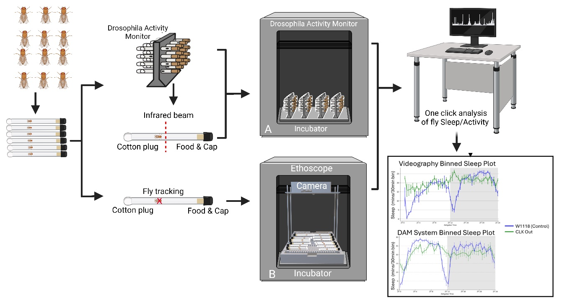
2. Learning and memory (Olfaction Aversion Training): $250 per run (n=50 per genotype). Analyses in an Excel sheet followed by Prism quantification.
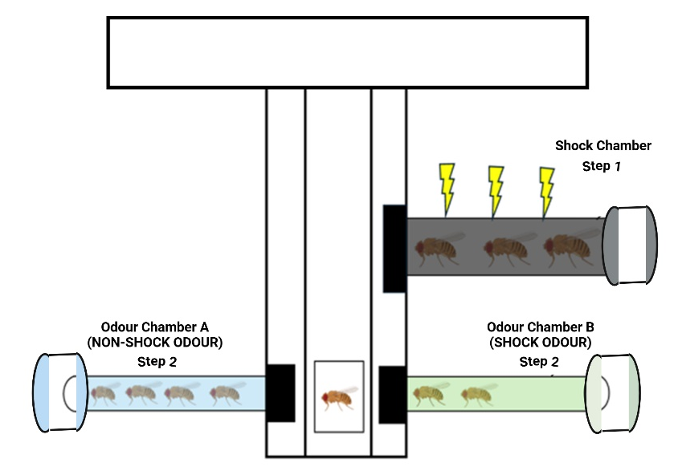
3. Cardiac physiology: $250 per run (n=30 per genotype). An Excel sheet of eight cardiac parameters. Statistical Analysis $100/run.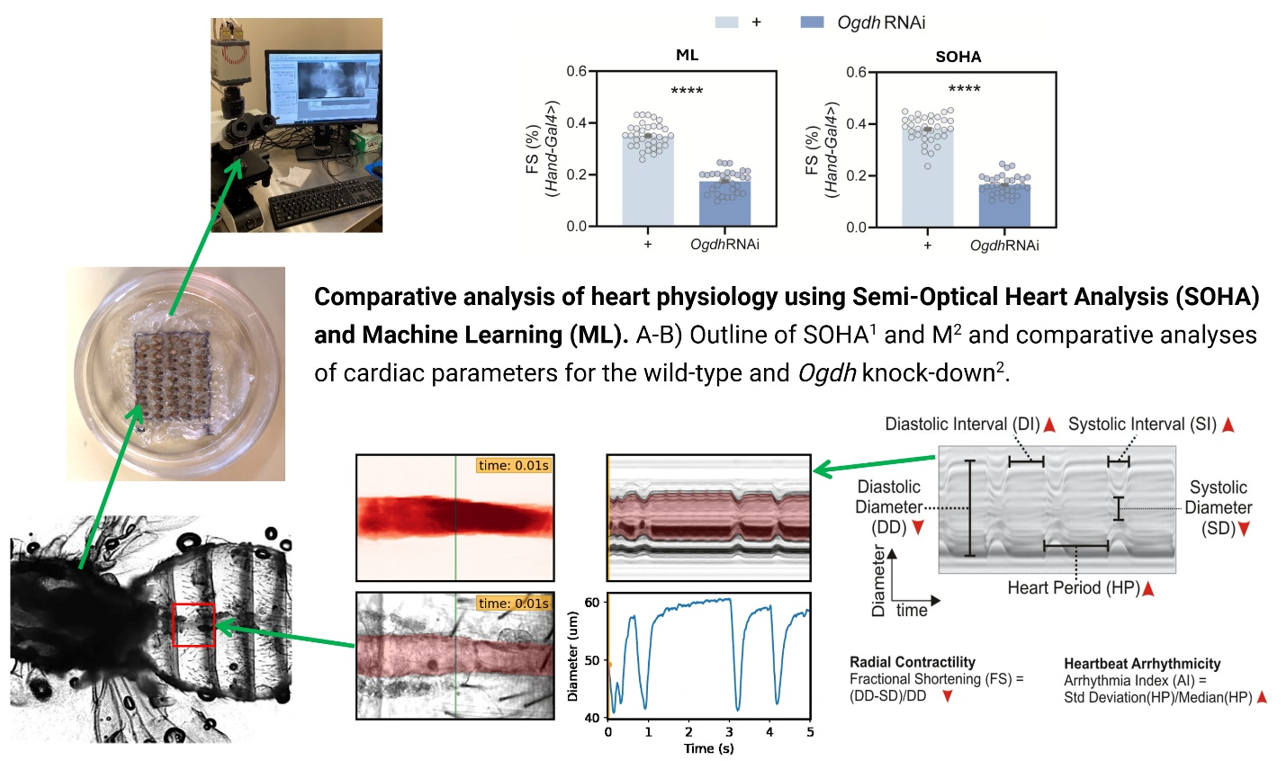

4. Intestinal barrier dysfunction/Gut integrity (Smurf assay): $50 per run (n=10 flies/genotype without Stat-GFP). Data on Excel sheet along with images
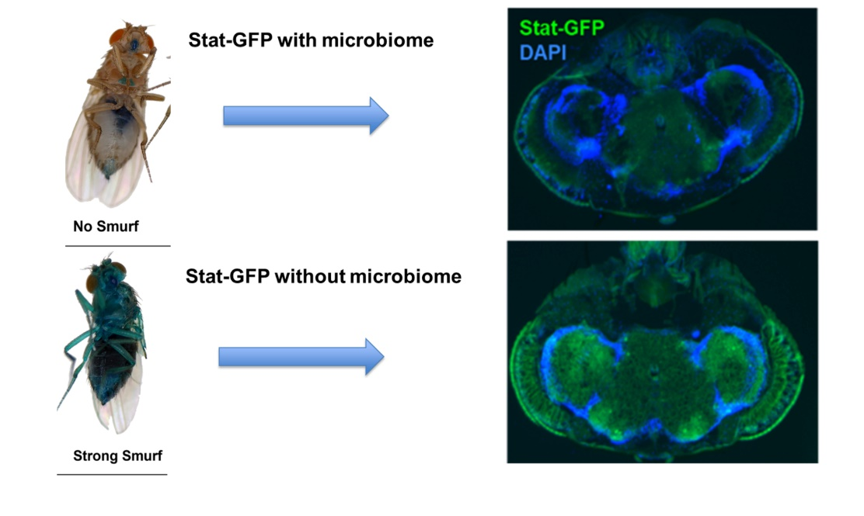
5. Locomotor function (geotaxis performance): $200 per run (max 200 flies, n=40-50 flies per genotype).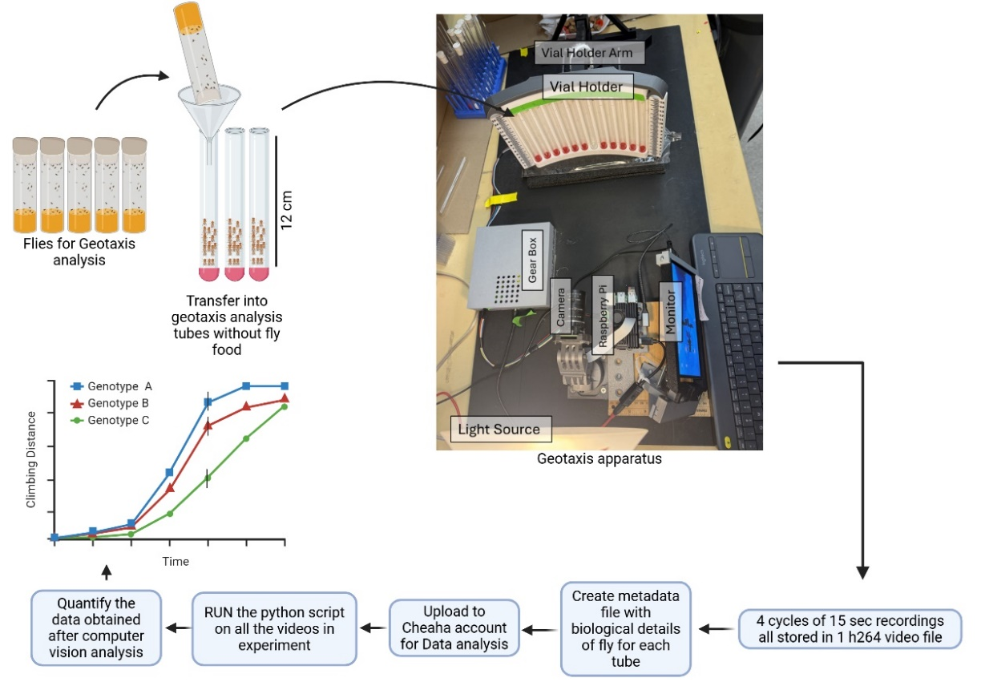
6. Muscle function (flight performance): $200 per run (max 200 flies, n=40-50 flies per genotype
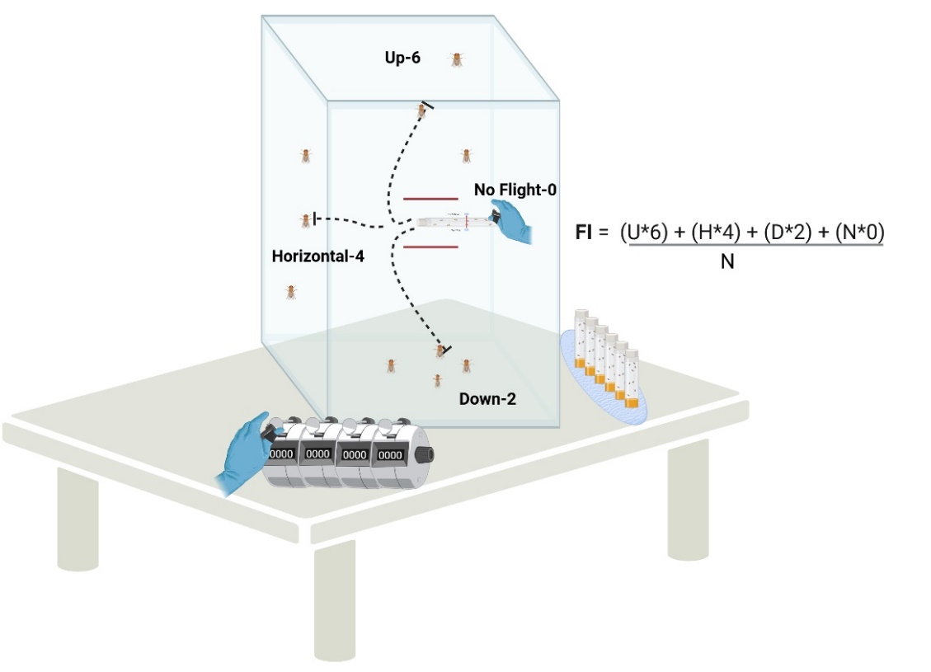
7. Brain, Muscle, or Abdomen Cryosectioning and Staining: $250/genotype. Sucrose saturation, putting them OCT block, and collection on Slides after cryosectioning (section size 20-30 microns thick section on a positively charged slide. $250/genotype, 5 males or females. If you want us to stain, image, and quantify. Check with me.
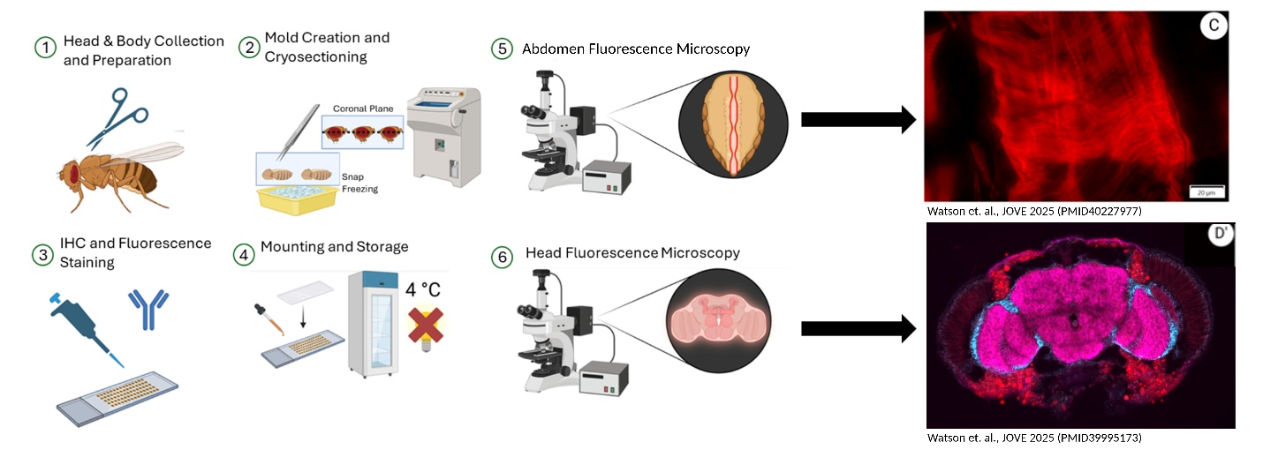
8. Potential drug/known drug: charges will vary by the number of conditions (Check).
9. Genetics & Life span: Costs vary by experiment design, please discuss. This includes ordering the flies, maintaining the stocks, tissue-specific knockdown or overexpression, aging, life span, and interventions (Exercise and time-restricted feeding).

