REGARDS
EXAMINER PACKET

VISIT _ID

PLACE BARCODE LABEL HERE

PLEASE WRITE PARTICIPANT ID HERE:

_____________________________________

Participant lives in New York State

**SEND TO VERMONT WITH BIOLOGICAL SPECIMENS KIT**

DATE AND TIME OF IN-HOME VISIT
REGARDS SSuRF IN-HOME EXAMINATION

- Date: / / Example: 03/15/2013

Month Day Year

2. Time: |  |  |  |  | Please Record in Military Time. Example: 1pm = 1300

3. CHECK BOX TO Verify Visit ID barcode is affixed to form YES NO (didn’t have one)

3.a Verify that Participant ID is written on the front of all forms Yes No

PHYSICAL MEASURMENTS

- Height : . . inches Examples: 5 . 1 1 . 2 5 = 5 feet 11 ¼ inches

6 . 0 6 . 5 0 = 6 feet 6 ½ inches

- Weight . pounds Example:

1 | 7 | 5

. 2 5 pounds

- Waist Circumference . inches Example:

 | 4 | 5

. 2 5 inches

- Neck Circumference . inches Example: 1 8 . 2 5 inches
(Note to examiner: Should be taken 2” above clavicle bone)

- Circumference of LEFT arm . inches Example: 1 9 . 7 5 inches

.

BLOOD PRESSURE & PULSE

Examiner Instructions:
-If possible use left Arm to record the first set of blood pressure and pulse information
-If the participant’s arm circumference is over 13 inches, use a large adult size cuff
-Record the cuff bladder width of the sphygmomanometer cuff used. This can be done before the visit by having the cuff bladder (internal not external) measurements written on each cuff.
-Record the pulse obliteration level. This is obtained by inflating the cuff until pulse is no longer palpable (i.e. while palpating the radial pulse at the wrist, inflate the cuff.) When the pulse is no longer felt, rapidly deflate the cuff and record the pulse obliteration level.
-Without removing the cuff, inflate to 20 mmHg above the pulse obliteration level. Deflate cuff SLOWLY (approximately 2 mmHg/second) and record blood pressure in item 3.
-Pause 30 seconds and repeat the same procedure on the same (left) arm, and record the 2nd blood pressure in Item 4.
-Pause 30 seconds and repeat the same procedure on the right arm, and record the 3rd blood pressure in Item 5.

Please measure the width of the bladder of the cuff that was used on this participant.

- Cuff Size: . inches Example: 1 1 . 2 5 inches

- Pulse Obliteration Level: Always use LEFT arm if available. mmHg

3. | First Blood | 4. Second Blood
 | Pressure  (left arm): | Pressure  (left arm):

4
5. Third Blood

Pressure
(right arm):

PHLEBOTOMY

- Has participant fasted? Yes No (Please check one.)

- Number of hours since participant last ate: hours

- In the past two weeks, has the participant had any of the following? (Please check all that apply.)

Fever Cold, Sore throat Bronchitis Sinus Infection Pneumonia Antibiotics YES
NO

- Has the participant ever experienced fainting spells while having blood drawn? YES NO

- Venipuncture Position: Seated Supine (Please check one.)

- Start time of venipuncture: Please Record in Military Time.

Example: 1pm = 1300

- Elapsed Time until tourniquet released: Seconds

- End time of venipuncture: Please Record in Military Time.

Example: 1pm = 1300
Hour Minutes

(Note to examiner: Inform the participant they may have something to eat at this time)

- Were complete samples drawn? If no or partial samples, why?
Yes No Partial Refusal Hard Stick Other: Please State Reason
Tiger Top 9mL Serum
Purple Top 3mL EDTA
Purple Top 10mL EDTA
Blue Top 4.5mL Citrate
Tiger Top 9mL Serum
Purple Top 10mL EDTA

- Quality of venipuncture: Clean Traumatic

- If traumatic, why? (Choose one or more if applicable)

Vein Collapse Hematoma Excessive draw duration Hard Stick Leakage at puncture site

12. Were blood or urine samples collected in the state of New York? YES NO

BLOOD PROCESSING- Please refer to the Blood Processing Guide included in the examiner kit

TUBE | SERUM/PLASMA | PACKED CELLS | COMPLETED | COMMENTS/NOTES
Tiger Top 9mL Serum | Transfer Plasma to (first) Red Mailer Tube | Discard to Biohazard
Purple Top 3mL EDTA | DO NOT Centrifuge | Not Applicable
Purple Top 10mL (EDTA) | Transfer Plasma to (first) Purple Mailer Tube | Pour into Clear Cap  Mailer Tube
Blue Top 4.5mL Citrate | Transfer to Light Blue Mailer Tube | Discard to Biohazard
Tiger Top 9mL Serum | Transfer Plasma to (second) Red Mailer Tube | Discard to Biohazard
Purple Top 10mL (EDTA) | Transfer Plasma to (second) Purple Mailer Tube | Pour into Clear Cap  Mailer Tube
- Start time of blood processing: Please Record in Military Time.
Example: 1pm = 1300

- End time of blood processing: Please Record in Time.

Example: 1pm = Military 1300

URINE COLLECTION

(Note to examiner: While urine is being collected, please check that all labels are affixed to all forms and all lab tubes.)

- Was a urine specimen completed? Yes No
If no, why? Refusal Other (Please state reason)

- Time of Urine Collection: Please Record in Military Time.

Example: 1pm = 1300

- Processing of urine specimen:
Container Type | Transferred To Plastic Mailer Tube | Completed | Remarks
Plastic Collection Cup | Urine Culture tube | Yes
Yellow mailer Tube Yes _____________________________

ECG

1. | Was an ECG completed? | Yes |  | No
 | If no, why? Refusal | Other |  | (Please state reason)
2. | Processing of ECG:
 | ECG mounted: |  | Yes |  | No |  | If no, why?
 | Serial number recorded on strips |  | Yes |  | No |  | If no, why?
 | Visit ID # placed on the strips |  | Yes |  | No |  | If no, why?

- ECG Start Time: Please Record in Military Time.

Example: 1pm = 1300

REALM-SF
Instructions for Administering the REALM-SF
  - Give the participant a copy of the REALM-SF form which is on the back of the Brief Measures Report Card. Hold the card at an angle so that the participant is not distracted by your scoring.

B. Say: "I want to hear you read as many words as you can from this list. Begin with the first word and read aloud.
When you come to a word you cannot read, do the best you can or say, 'blank' and go on to the next word."

C. Score answers BELOW by placing an “X” in the appropriate box if the word is correctly read by the participant.

D. If the participant takes more than 5 seconds on a word, say "NEXT" and point to the next word, if necessary, to move the participant along. If the participant begins to miss every word, have him or her pronounce only known words.

  - Menopause

  - Antibiotics

  - Exercise

  - Jaundice

  - Rectal

  - Anemia

  - Behavior

  - Flu

  - TOTAL CORRECT:

EXAMINER MAY USE THE SPACE BELOW FOR NOTES:

DIGITAL SYMBOL TEST T

Materials Needed
Participant worksheet, Stopwatch, Pencil without eraser

Specific Instructions for Administering and Scoring the DSC
-Read instructions provided verbatim and demonstrate as indicated.
-Do not proceed with the test until the participant understands and correctly completes the sample items. If the participant makes a mistake on the sample items, correct the error immediately. Instructions can be repeated up to 2 times.
-Begin timing once the sample items are completed and you say “Go.”.
-Testing time = 90 seconds.
-Boxes must be done in sequence (left to right).
-If the participant begins working out of sequence (e.g., doing all of the 1’s), redirect them only on the first omitted item. Give no further- assistance except (if necessary) to remind the participant to continue until instructed to stop.

Administration
1. Demonstration Items

Place the DSC Participant Worksheet in front of the participant. Point to the key at the top of the page and say,
“Look at these boxes. Each box has a number in the top part (point across the numbers from 1 to 9) and a special mark in the bottom part (point across the symbols). Each number has its own mark (point to 1 and its symbol, then to 2 and its symbol).”

Point to the demonstration items and say, “Down here, the boxes have numbers in the top parts but are empty in the bottom parts. You are to draw the marks that belong in the empty boxes, like this.”

Point to the first demonstration item (6) and say, “Here is a 6. The 6 has this mark (point to the key to show its corresponding symbol), so I draw that mark in the box, like this (write the symbol).”

Point to the second demonstration item (8) and say, “Here is an 8. The 8 has this mark (point to the key to show its corresponding symbol), so I draw that mark in the box (write the symbol).”

Point to the third demonstration item (3) and say, “Here is a 3. The 3 has this mark (point to the key to show its corresponding symbol), so I draw that mark in the box (write the symbol).”

Proceed to Sample Items.

2. Sample Items

Hand the participant a pencil without an eraser and say, “Now you do these (point to the sample items). Stop when you get to this line (point to the heavy line that separates the sample items from the test items).”

If the participant completes the sample items correctly, say, “Now you know how to do them.”

[If the participant makes a mistake on a sample item, correct the error immediately. Use the item to review the use of the key. Continue to help the participant, if necessary, until the participant correctly completes the sample items.]

Do not proceed with the test items until the participant understands the task. If it is clear that the participant will not be able to understand the task with further instruction, discontinue the test and note reason for discontinuation.

When the participant has successfully completed the sample items, proceed to Test Items.

3. Test Items

Say, “When I say ‘Go,’ do these the same way. Start here (point to the first test item), go in order, and don’t skip any. Work as fast as you can without making mistakes until I tell you to stop. Are you ready?...Go.”

Begin the stopwatch and allow 90 seconds. If necessary, remind the participant to go in order and continue working. Give no further assistance.

At 90 seconds, stop the stopwatch and say, “Stop.”
--------------------------------------------------------------------------------------------------------------------------------------------------------------------
If participant did not attempt test or failed, select why:

Participant unable due to physical limitations Participant not able to understand instructions

Participant Refused Other (Specify):________________

DSC Participant Worksheet

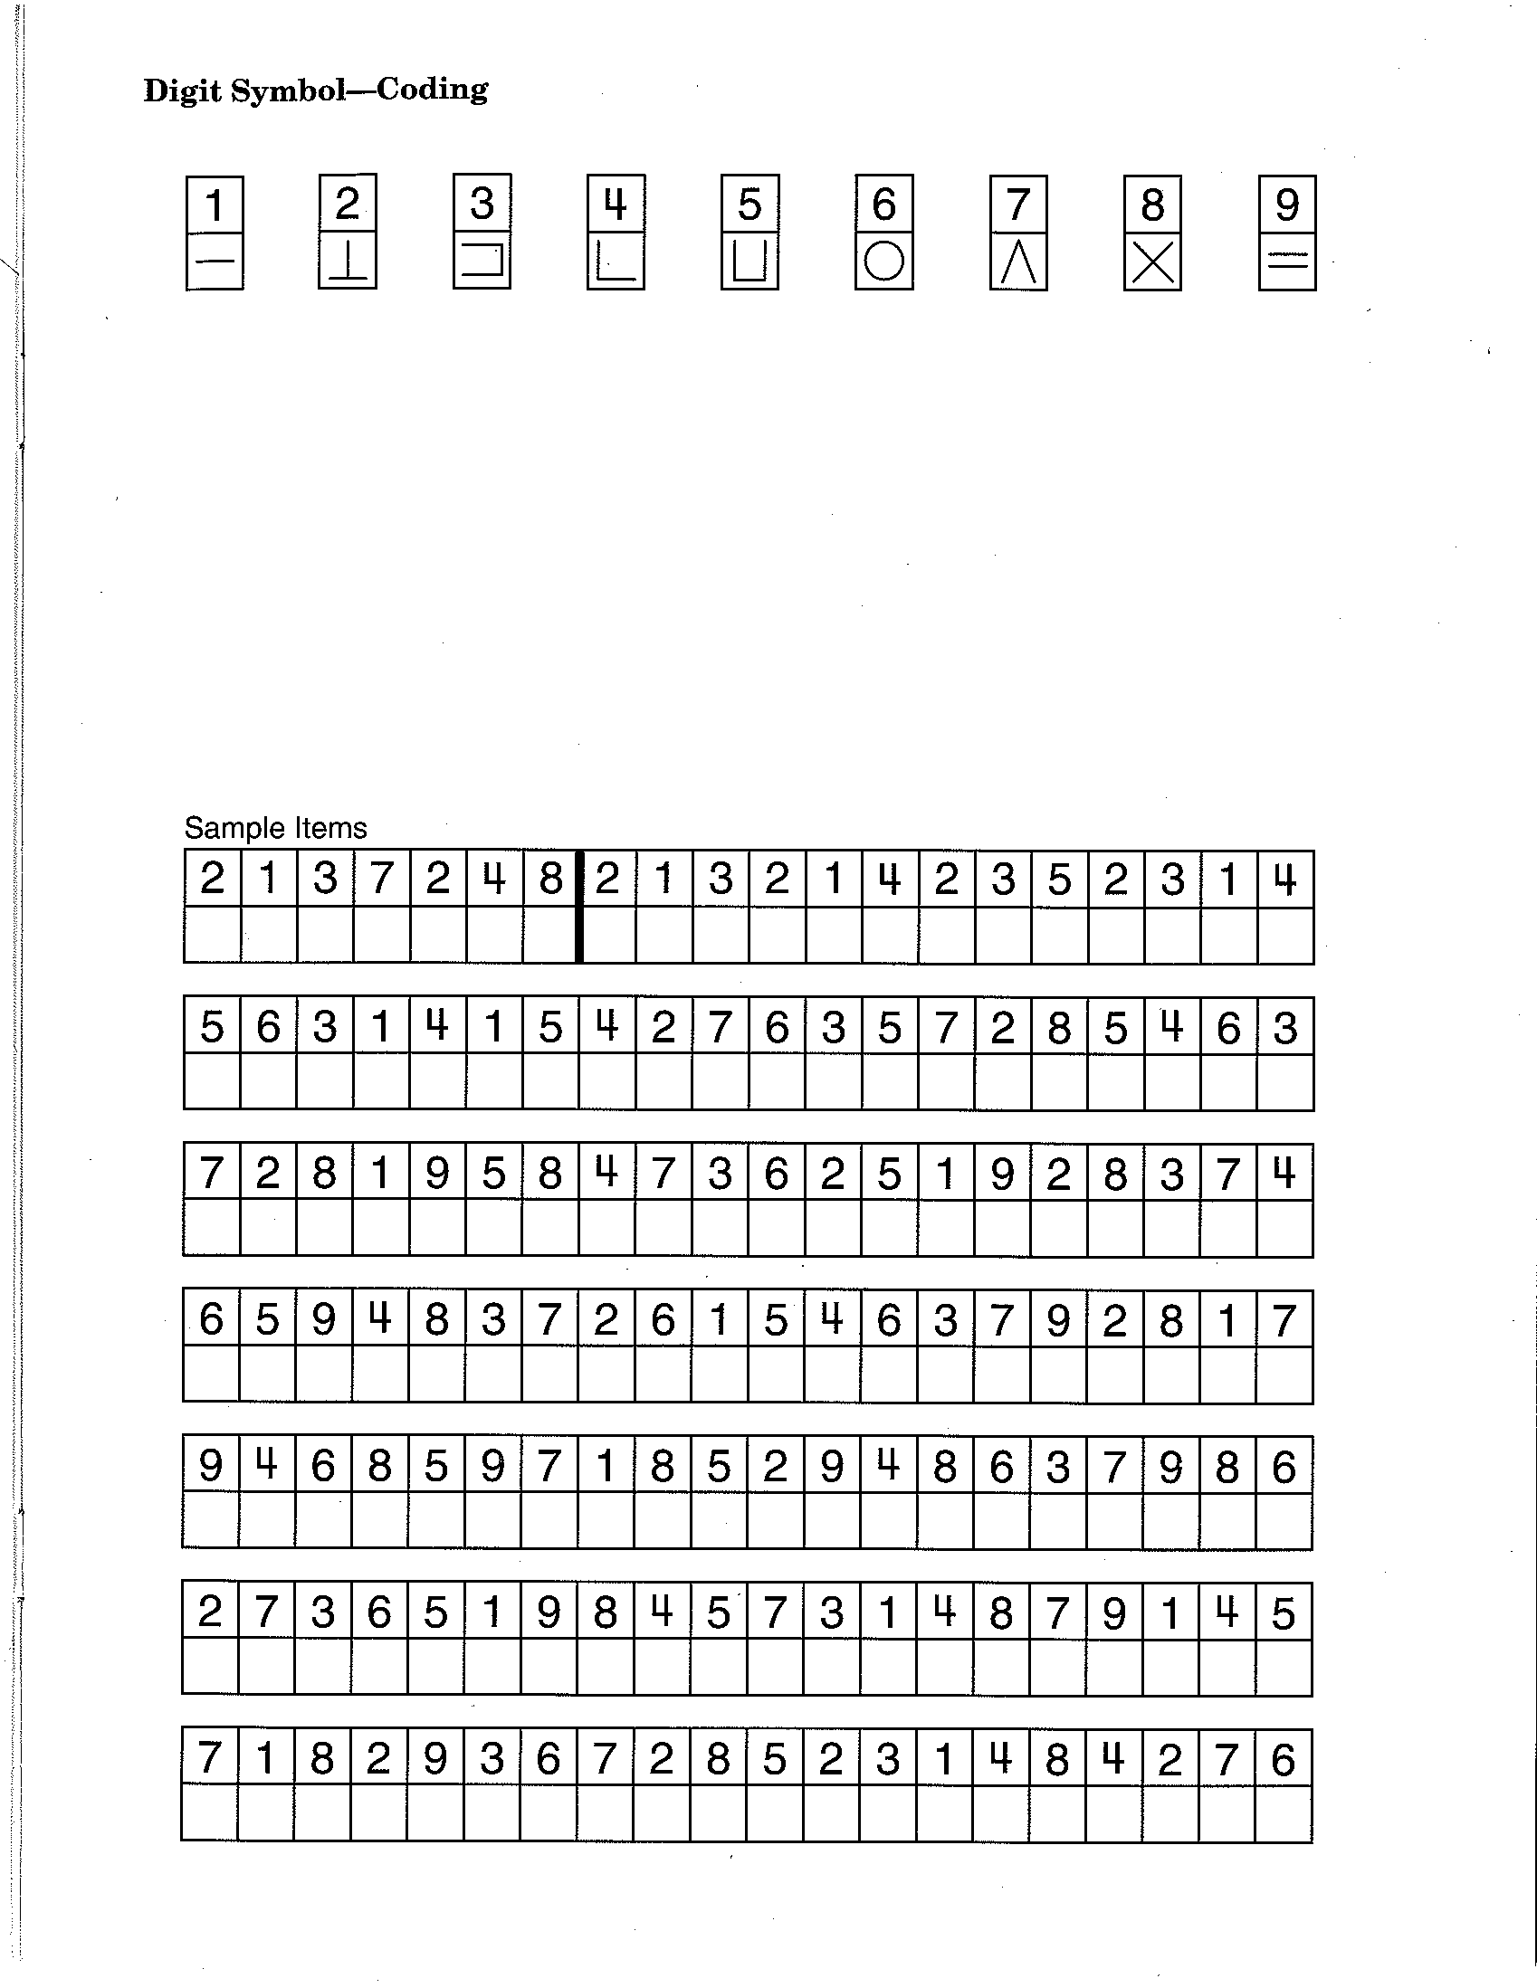

TIMED WALK

Equipment : A stopwatch and a marked walking course (A ribbon cut to 8 feet in length).

Marking the Course
The walking course should be unobstructed and include at least an extra foot on each end. The course should preferably be laid out on a hard surface. A carpet is acceptable if this is the only surface available. Avoid laying the course out over the edge of a rug, a throw rug, or any irregular surface that could cause the participant to trip. Try to find a space that is at least 10 feet long for laying out the 8 foot course.

**IF UNABLE TO CONDUCT TIMED WALK DUE TO LIMITED SPACE, PLEASE SKIP TO THE CHAIR STAND TEST
and INDICATE BY CHECKINGTHIS BOX: (not enough space for timed walk test)

To mark the course, place ribbon on the floor to measure 8 feet. Use the two adhesive labels to mark the starting line and end line for the course. You can move small furniture with the permission of the owner. After the course is marked, the ribbon should be removed as it could present a fall risk.

Administering the Test
If possible, women wearing high heels should change into another pair of shoes before performing the gait speed test. Participants are instructed to walk at their usual speed, and timing is stopped when the first foot completely crosses the 8 foot mark. The walk is conducted twice and both times are recorded on the form.

Press the start button to start the stopwatch when the participant steps over the starting line. Wait until the participant actually begins to move before starting the watch. Do not start the watch when you say “begin.”

The position of the examiner is critical for the walk. It is recommended that you walk behind and to the side of the participant. However, if you are too close you will set the pace. If you are too far behind you will not be in a good position if the participant falls. You also need to be in a good position to observe the foot crossing the finish line. The best position to maintain during the walk is to the side and slightly behind, outside of the participant’s visual field.

Record the time when the participant’s first foot completely crosses the 8 foot line. This is the time to stop the watch.
Record the time to the nearest hundredth of a second (i.e., two decimal places).

The walk is performed two times. After the first time is recorded, the participant is asked to turn around and repeat the test. The second time is then recorded on the form.

Special circumstances
A cane or walker may be used during the walk, but if people with such devices can walk short distances without them, they should be encouraged to do so.

Script and demonstration:
The following script should be used to introduce and demonstrate the walk.
- “Now I am going to observe how you normally walk. If you use a cane or other walking aid and you feel you need it to walk a short distance, then you may use it. This is our walking course. I want you to walk to the other end of the course at your usual speed, just as if you were walking down the street to go to the store.”

- Demonstrate the walk for the participant.

- “Walk all the way past the other end of the tape before you stop. I will walk behind you. Do you feel this would be safe?”

- Have the participant stand with both feet touching the starting line.
“When I want you to start, I will say: "Ready, begin."

- When the participant acknowledges this instruction say: "Ready, begin."

- Press the start/stop button to start the stopwatch when the participant begins to move.
Walk behind and to the side of the participant.

- Stop timing when one of the participant’s feet is completely across the end line.

- “Now I want you to turn around and repeat the test. When I want you to start, I will say: "Ready, begin."
When the participant acknowledges this instruction say: "Ready, begin.” Complete the walk test as before.

TIMED WALK RESULTS

1. Time for First Gait Speed Test . Seconds

- If participant did not attempt test or failed, select why:

Participant tried but unable Participant couldn’t walk unassisted

Not attempted, examiner (you) felt unsafe Participant not able to understand instructions

Participant Refused Other (Specify):________________

- Aids for first walk? None Cane Other (Specify):_______________

- Time for Second Gait Speed Test . Seconds

- If participant did not attempt second test or failed, select why:

Participant tried but unable Participant couldn’t walk unassisted

Not attempted, examiner (you) felt unsafe Participant not able to understand instructions

Participant Refused Other (Specify):________________

- Aids for second walk? None Cane Other (Specify):_______________

- What is the time for the shorter of the two walks? . Seconds

EXAMINER MAY USE THE SPACE BELOW FOR NOTES:

CHAIR STAND

Equipment/Set Up
Use a standard chair with arms and with a seat height of approximately 17 inches for all assessments, regardless of the height of the subject. Place the back of the chair against a wall to prevent movement during the test.

Procedure
Instruct and demonstrate the following protocol before asking the subject to perform the test:
Script: Now I’m going to demonstrate how to do this test.
- Sit as far back as possible in the chair seat. Keep feet firmly planted on the floor approximately hip width apart and the back of lower legs away from the chair. Keep knees bent at a 90-degree angle with arms crossed over the chest. (An individual of average or taller height will be able to sit with their upper back against the back of the chair. Individuals of shorter than average height will not be able to touch the chair back while maintaining proper position and are not required to touch the chair back during testing).
Script: “When you stand up, come to a full standing position each time, and when you sit down, sit all the way down each time. I will demonstrate two chair stands to show you how it is done.”
- Rise two times as quickly as you can, counting as you stand up each time.
- Indicate that any chair stands done with improper technique, e.g. not standing all the way up, not sitting all the way back, lifting feet off the floor, etc. will not be counted.
- Allow the participant the opportunity to try one chair stand to be sure when they stand up the back of their legs are not touching the chair.

Begin the Test
Script: "When I say ‘Go,’ stand five times in a row, as quickly as you can, without stopping. Stand up all the way, and sit all the way down each time. “Ready, Go!"
- Start timing as soon as the participant begins to stand from the chair.
- Count: "1, 2, 3, 4, 5" as the participant stands up each time.
- Stop timing at the fifth stand.

**If the participant is unable to complete the chair stands correctly (e.g., is not coming to a full stand), stop the procedure, repeat the demonstration, wait 1 minute, and begin the procedure again.

**If the participant stops before completing five stands, confirm that they cannot continue by asking: Optional script: "Can you continue?”
If they say yes, continue timing. Otherwise, stop the stopwatch.

**If subjects are unable to stand up one time without assistance than they can use their hands to assist them in rising and returning to the seated position while following all other procedures as described above. Make sure to note that hands were used when recording the assessment data.

CHAIR STAND RESULTS:

- Completes 5 stands without using arms . seconds
- Rises using arms
Stop Test.
Go to next exam.
- Participant refused
- Not attempted, unable
- Attempted, but unable to complete Number completed without using arms

- TOTAL SCORE for the REPEATED CHAIR TEST

  - Participant unable to complete 5 chair stands or complete stands in >60 seconds (0 points)

  - Chair stand time is 16.70 seconds or more (1 point)

  - Chair stand time is 13.70-16.69 seconds (2 points)

  - Chair stand time is 11.20-13.69 seconds (3 points)

  - Chair stand time is 11:19 seconds or less (4 points)

PARTICIPANT’S SOCIAL SECURITY NUMBER
(Note to the Examiner: Remind the participant that we need the Social Security number for…….”

- Record Participant’s Social Security Number: - -

- Check this box if participant did not want to give Social Security Number: (Refused)

SPECIMEN AND PAPERWORK SHIPMENT

TO VERMONT:
Specimens: Red(2), Purple(2), Light Blue (1), Yellow(1), Clear(1), Urine Culture (1) Mailer tubes and Whole

Completed

Blood Plastic 3mL EDTA Tube Yes

Examiner Administered Forms, including:
Consent Form: Send to Vermont Yes
Medical Release: Send to Vermont Yes
In-Home Visit Form: Send to Vermont Yes
Medications Form: Send to Vermont Yes

EKG Strip: All Mounted EKG Strips Send to Vermont Yes

LEAVE WITH PARTICIPANT:
Participant Packet Leave with the participant to complete Yes
Food Questionnaire Packet Leave with the participant to complete Yes
Brief Measurement Report Leave with the participant Yes
Consent Packet Leave with the participant Yes
Mailing Envelope Leave with the participant Yes
REGARDS ID CARD (not applicable in Pilot) Leave with the participant Yes
REGARDS Gifts Leave with the participant Yes

Examiner Comments:

EMSI Branch Office:

City and State

EMSI Examiner:
Employee ID#: Examiner Name:

EMSI Examiner Signature:

End Time of Visit (Please record in Military time):

*************************************************************************************************************************************************************
*************************************************************************************************************************************************************

Verify address on work order. Does the participant address match the address on the work-order? Yes No

IF NO, record any changes to address here:

Participant Last Name, Date:

REGARDS MEDICATIONS FORM

EMSI STAFF: PLEASE READ, "As you know, the REGARDS study is interested in the prescription medications its participants are taking. We are particularly interested in medications your doctor prescribed for you and were filled by a pharmacist. These include vitamins, pills, dermal patches, eye drops, creams, salves, and injections. The letter you received about this appointment asked you to have them available. Participant retrieves medications.

Have you taken any medications in the past 2 weeks? [Please place an “X” in the box beside the appropriate response(s)]
YES [Complete information below]

NO (why not? ____________________) [Attempt to obtain additional medications and complete information below on those available]

YES -------------->

NO [END FORM]

Are these all the medications that you have taken in the past 2 weeks?

Prescription Drugs | Strength  (5mg, etc.) | Directions (such as, “1 tablet twice a day”)  Check box if taken only as needed
Check if none
1.
2.
3.
4.
5.
6.
7.
8.
9.
10.
11.
12.
13.
14.
15.
16.
17.
18.
19.
20.
21.
22.
23.
24.
25.

CURRENT MEDICATIONS

Medications Form, Cont’d

Over-the Counter Medications  (such as ibuprofen) | Strength  (5mg, etc.) | Directions  (such as, “take as needed for pain”)
Check if none
1.
2.
3.
4.
5.
6.
7.
8.
9.
10.
11.
12.
13.
14.
15.
Herbs, Vitamins, Minerals, Etc.  (such as St. John’s Wart) | Strength | Directions  (such as, “one tablet per day”)
Check if none
1.
2.
3.
4.
5.
6.
7.
8.
9.
10.
11.
12.
13.
14.
15.

